FOR IMMEDIATE RELEASE
AUGUST 19, 2022

SARA KAYS RELEASES FAN-FAVORITE TRACK “WATCHING TV”

ACCLAIMED SINGER-SONGWRITER TO SUPPORT ALEC BENJAMIN AND MAX ON TOUR THIS FALL

LISTEN TO “WATCHING TV” | WATCH OFFICIAL VISUALIZER

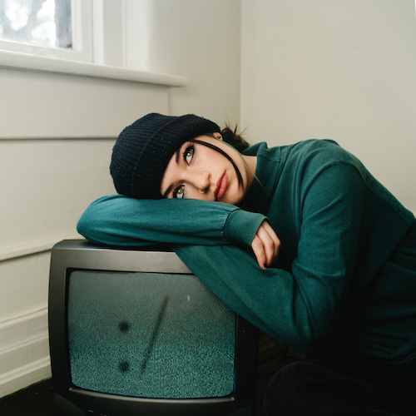
DOWNLOAD HI-RES ARTWORK

RIAA gold-certified singer-songwriter Sara Kays has finally shared her latest single, “Watching TV,” with the world, available now HERE. Fans have been eagerly awaiting the song since it was added to Sara’s live set list. An official visualizer is now live at Sara’s official YouTube HERE.

“I wrote ‘watching tv’ about a breakup I went through 2 years ago,” says Sara Kays. “It caught me so off guard because we had just been hanging out and watching tv together the night before like everything was normal. I’ve been wanting to write a song about the feeling that breakup gave me since it happened, and I finally managed to do that with this song.”

“Watching TV” follows Kays’ earlier releases from this year including “Math” and “When You Look At Me,” the latter of which was named by Cosmopolitan as one of “11 Sad Songs From 2022 That’ll Legit Have You Weeping.” The acclaimed Nashville-based musician first shared an early demo of “When You Look At Me” on her hugely popular TikTok and almost immediately earned more than 1.7M views and close to 500K likes. In trademark fashion, Sara was inspired by the response and quickly hit the studio to record an official version of the song.

Kays – who recently wrapped her biggest headline tour to date after supporting Alec Benjamin across North America earlier this year – will join Alec Benjamin again for a few dates this fall in addition to supporting MAX on his upcoming headline tour, beginning October 17 at The Observatory in Santa Ana, CA and traveling through mid-November. For complete details and ticket information, please visit www.sarakays.com/tour.

2021 proved a landmark year for Kays, with multiple highlights including her first-ever headline tour, international performances supporting Cavetown in the UK, and her late night TV debut performance of the RIAA gold-certified breakthrough hit, “Remember That Night?” on The Late Show with Stephen Colbert (streaming HERE).

Having cultivated an intensely engaged and supportive audience on TikTok nearing 2M followers, Sara is disarmingly raw about everything from body image to mental health as proven on her 2021 Struck By Lightning EP. Observations, thoughts, and truths straight from the Notes app on her phone inform diary-style stories spotlighted by gentle acoustic guitar, soft ukulele, and a keyboard murmur. Profiled for Billboard’s “Emerging Artists Spotlight” and named among People’s “Talented Emerging Artists Making Their Mark on the Musical Landscape,” the Indiana-born artist teased the EP’s arrival with “Backseat Rider,” “Traffic Lights,” “Future Kids,” and “Picture Of You.” In addition to her collaboration with Cavetown on the title track, which arrived alongside a music video co-starring both artists (watch HERE), the EP features the bitterly honest “Freeze” and is highlighted by her viral breakup anthem, “Remember That Night?,” joined by an official video now approaching 13.5M views via YouTube HERE.

WHAT CRITICS ARE SAYING ABOUT SARA:

“Sara Kays’ music has something to offer for everyone.” – PEOPLE

“Sara Kays knows what it takes to craft heartfelt lyrics spun with velvet, tight-knit arrangements that simply elevate the already high-flying material.” – AMERICAN SONGWRITER

“Normalizing life’s struggles that often seem easier to avoid, Sara has carved out a unique space…quickly creating a community through her message.” – FLAUNT

“Sara Kays has cultivated a devoted following by wearing her heart on her sleeve. The rapidly rising artist's growing fanbase is a testament to her understated gift for empathetic songwriting.” – ONES TO WATCH

“One Of Pop Music’s Breakout Stars” – HUFFPOST

SARA KAYS ON TOUR 2022

SEPTEMBER
16 – Raleigh, NC – The Ritz**

OCTOBER
9 – Portland, OR – Crystal Ballroom**
10 – Eugene, OR – McDonald Theatre**
17 – Santa Ana, CA – The Observatory*
19 – Sacramento, CA – Ace of Spades*
21 – Portland, OR – Crystal Ballroom*
22 – Seattle, WA – Showbox*
23 – Vancouver, BC – Hollywood Theatre*
27 – Las Vegas, NV – House of Blues*
28 – Los Angeles, CA – The Wiltern*
29 – San Francisco, CA – The Fillmore*

NOVEMBER
1 – Phoenix, AZ - Crescent*
2 – Albuquerque, NM – El Rey*
4 – Salt Lake City, UT – The Depot*
5 – Denver, CO – Summit Music Hall*
8 – Dallas, TX - Echo*
9 – Austin, TX - Empire*
10 – Houston, TX – House of Blues*
13 – Atlanta, GA – Buckhead Theatre*
15 – Fort Lauderdale, FL – Revolution Live*
17 – Orlando, FL – Plaza Live*
19 – Tampa, FL - Orpheum*

*DATES w/ MAX
**DATES w/ ALEC BENJAMIN

CONNECT WITH SARA KAYS:
TIKTOK | TWITTER | INSTAGRAM | facebook | YOUTUBE | PRESS ASSETS

PRESS CONTACT:
ANDREW.GEORGE@ATLANTICRECORDS.COM

