FOR IMMEDIATE RELEASE
AUGUST 19, 2022

SAINT PHNX SHARE NEW SINGLE “FRIENDS”

ACCLAIMED SCOTTISH ALT-POP BROTHER DUO RETURN WITH HIGHLY ANTICIPATED NEW SINGLE

LISTEN TO “FRIENDS” | WATCH OFFICIAL LYRIC VIDEO

“When the day breaks your heart, and there's shouting in your head, we know we can drown it out, drinking with our friends!”
-SAINT PHNX

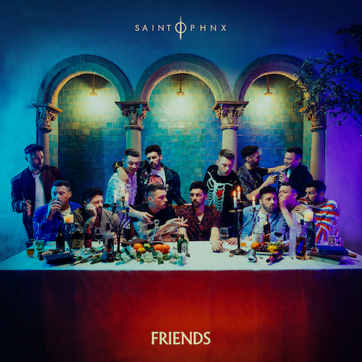
DOWNLOAD HI-RES ARTWORK

“If you love feel-good music with substance, you love SAINT PHNX.”
– FLAUNT

Glasgow, Scotland-based alt-pop brother duo SAINT PHNX have shared their eagerly anticipated new single, “Friends,” available now via Atlantic Records at all DSPs and streaming services HERE. Featuring traditional Scottish bagpipes and sentimental lyrics, “Friends” has all the makings of a roundtable drinking song.

“Friends” marks the first new music from SAINT PHNX following their chart-topping Atlantic Records label debut EP, HAPPY PLACE, available for streaming and download HERE. The EP proved an immediate sensation upon its arrival earlier this year, ascending to #1 on the Official Scottish Albums Chart fueled in part by such standout singles as the inspiring “Angel” and the breakthrough title track, “Happy Place,” both joined by official music videos streaming now at YouTube. In addition, SAINT PHNX recently played to a crowd of 10,000 at TRNSMT and just sold out their upcoming show at Barrowlands eight months in advance.

A touching ode to SAINT PHNX’s late father, “Happy Place” premiered last summer and quickly struck a chord with listeners around the globe, earning over 20M streams to date and top 20 placement on a variety of streaming charts worldwide. Along with its popular success, the track was met by widespread support from friends and fellow artists (including Yungblud, Lewis Capaldi, Catie Turner, and Jamie Miller), as well as such publications as FLAUNT, Wonderland, and more. “With a palpably uplifting energy, ‘Happy Place’ has an incredibly unique vibe to it,” wrote American Songwriter. “With such a distinctive message of hope, grounded by the profound sadness of losing a parent, the song boasts an incredibly complex emotional palette, marrying the joys and sorrows of life into a single, beautiful expression.”

In addition, HAPPY PLACE includes a further version of “Happy Place” featuring guest vocals from longtime friend – and fellow Atlantic recording artist – Jasmine Thompson, streaming now HERE; the track is joined by an official performance video, streaming now via YouTube HERE.

ABOUT SAINT PHNX
A brotherly bond drives the music of SAINT PHNX. The Glasgow duo of Stevie and Alan Jukes feel everything twice as hard together. Those mutual feelings inform the pair’s skyscraping alternative pop uplifted by towering hooks, eloquent songcraft, and energetic instrumentation. Since 2016, they’ve hustled hard, performed countless gigs, and even touched down on U.S. soil to write in Las Vegas. The duo served up their single “KING” and eventually garnered over 19M Spotify streams and counting. In between touring with Yungblud and opening for everyone from Lewis Capaldi to Imagine Dragons, they unveiled their independent full-length debut, DDMN, in 2020. In the middle of their international rise, their dad was diagnosed with the terminal lung condition, pulmonary fibrosis. The brothers had initially encouraged him to move to a warmer client, but he chose to stay in Glasgow, bought land in the Tinto Hills, and built a house. He turned the room above the garage into a studio where Stevie and Alan wrote, recorded, and remained close to him. During this time, they recorded “Happy Place” as dad cheered them on. They played it for him on his death bed, and now it tells their story together on the grandest scale possible. After gathering tens of millions of streams, touring with some of the biggest bands in the world, and receiving acclaim from Clash, Alternative Press, and more, the group welcome everyone into their family on a series of 2021 singles for Atlantic Records.

# # #

DOWNLOAD HI-RES IMAGES

CONNECT WITH SAINT PHNX
SAINTPHNX.COM | INSTAGRAM | TWITTER | FACEBOOK | YOUTUBE

For press inquiries, please contact:
Jessica Nall // Jessica.Nall@atlanticrecords.com

