FOR IMMEDIATE RELEASE
AUGUST 17, 2022

MULTI-PLATINUM PRODUCER/ARTIST SONNY DIGITAL RELEASES
LATEST SINGLE “BACK 2 BACK (FEAT. CEO TRAYLE)”

FOLLOW UP TO “VET” SINGLE AVAILABLE NOW

FOURTH SINGLE AFTER PREVIOUSLY RELEASED SINGLES “GUESS WHAT (FEAT. SSGKOBE)” AND “SINCE 91 (FEAT. $SLUGG)

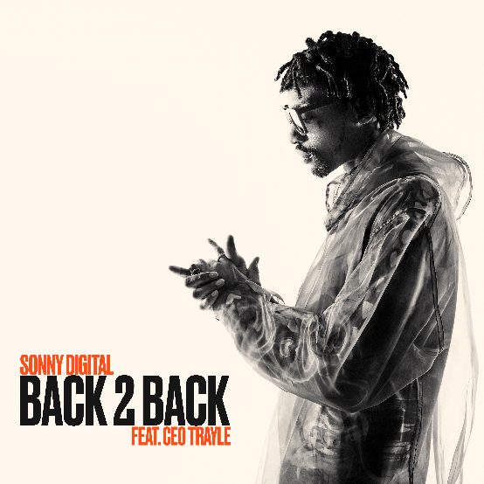

Multi-platinum rapping ass producer/artist Sonny Digital has announced the release of “Back 2 Back (Feat. CEO Trayle)” – now available for streaming. The single features prolific Atlanta-based rapper and CEO/founder of 1080 Trademark Records, CEO Trayle’s understated flow. The track also features blazing production from Franchise (“Vet” & “Guess What” ft. SSG Kobe), ISSY! &M15. On this track, Sonny humbly brags about his consistency in the game for over a decade, proclaiming “Niggas ain’t on shit. Just making hits and getting plaques” as he continues to solidify himself as a rapper on the rise.

When asked about how the single came to be: “My boy Trayle linked up with me in the studio and we were just talking our shit, talking about consistency. I’ve been making hits back-to-back for a long time and there’s more where that came from,” said Sonny. The rapping ass producer/artist has been on a dynamic single run releasing the singles “Vet,” “Since 91 (Feat. $LUGG)” and “Guess What (Feat. SSGKOBE)” all available for streaming now. The recently signed Generation Now artist is one of the leading producers in the game, a visionary force boasting a stacked CV that includes GRAMMY® Award-nominated, RIAA platinum certified, and chart-topping collaborations with superstars spanning Travis Scott, Meek Mill, Wiz Khalifa, Lil Uzi Vert, Ty Dolla $ign, Yung Thug, PnB Rock, Future, ILoveMakonnen, 21 Savage, 2 Chainz & Kanye West, Beyoncé, and many more.

MORE ABOUT SONNY DIGITAL
Moving forward at a relentless pace, Sonny Digital unlocks one sound only to find another and so on and so forth. This perpetual forward motion has assured his place at the forefront of the culture as an innovator behind the board and on the mic. As a kid, Sonny taught himself how to craft music on his brother’s old school MPC as a hobby. Later, he transitioned over to the family computer, downloading Fruity Loops, and learning how to cook up beats. During 2011, he earned a breakthrough placement with YC’s gold-selling “Racks” [feat. Future]. This opened the floodgates for a series of influential anthems, including Future’s Billboard Hot 100 breakout “Same Damn Time,” 2 Chainz’s double-platinum “Birthday Song” [feat. Kanye West], ILoveMakonnen’s GRAMMY® Award-nominated platinum-certified “Tuesday” [feat. Drake], 21 Savage’s platinum-certified “Red Opps,” Travis Scott’s platinum-certified “STARGAZING,” and Don Toliver’s “After Party,” among dozens of others. In between a series of solo singles, he ignited his 2016 G.O.A.T. EP as well as Black Goat [2017] and Black Goat 2 [2020] with Black Boe. Lyrical Lemonade hailed the latter as “a dynamic, potent offering.” Receiving further critical acclaim, The FADER mused, “It’s almost not fair for Sonny Digital to be as good of a producer as he is and then be nice on the mic too.” Not to mention, his audience burgeoned when he introduced the world-famous “Club Digital” on Clubhouse. However, the Atlanta rapper, producer, and force of nature continues to break ground on his 2022 full-length debut album for Generation Now/Atlantic Records ignited by the single “Guess What” [feat. SSGKobe].

ABOUT CEO TRAYLE
CEO Trayle has a rare sense of vision. The prolific Atlanta-based rapper and CEO/founder of 1080 Trademark Records sees the music industry the way a great point guard does a basketball court. He understands cause-and-effect, knowing how dropping one frosty, minimalist single will shape the perception around his next project. But occasionally he exceeds even his own expectations. His breakout single, “OK Cool,” a deadpan rebuke to an ex, earned more than 60 million streams, even though Trayle didn’t foresee it as a blockbuster when he made it. The momentum from that track, and its Gunna-assisted remix, paved the way for The Collection, a thrilling, visceral release that showcases the 28-year-old MC’s multi-genre fluency. The Collection shows why Trayle has been so confident in his approach for a decade now while proving he’s still adding depth. From the Memphis-inspired menace of “Mr. Door Kicker” to the breezy swagger of “Dior Store,” Trayle is operating at the highest creative level of his career. Before signing to 10K Projects, he developed a passionate following thanks to his gravelly delivery, equal parts hushed and horrifying. Hearing Trayle rap is reminiscent of watching Michael Myers or Jason Voorhees follow a target—even when they’re moving slowly, you’re still scared.

# # #

CONNECT WITH SONNY DIGITAL
OFFICIAL
TWITTER
INSTAGRAM
YOUTUBE
FACEBOOK

FOR ALL INQUIRIES, CONTACT
SYDNEY.MARGETSON@ATLANTICRECORDS.COM

