WALLOWS RETURN WITH “AT THE END OF THE DAY”

“AT THE END OF THE DAY” FOLLOWS THE BAND’S PREVIOUSLY RELEASED SINGLES “I DON’T WANT TO TALK” AND “ESPECIALLY YOU”

HERALDS HUGELY ANTICIPATED SOPHOMORE ALBUM,
TELL ME THAT IT’S OVER, OUT FRIDAY, MARCH 25

EPIC WORLD TOUR BEGINS APRIL 1 IN SEATTLE, WA

LISTEN TO “AT THE END OF THE DAY” HERE | WATCH OFFICIAL MUSIC VIDEO HERE

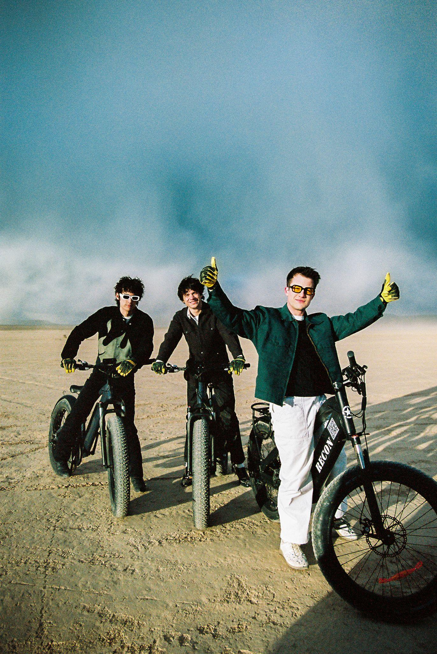
(PHOTO CREDIT: DILLON MATTHEWS)

Multi-platinum alt-rock trio Wallows have unveiled their latest single, “At the End of the Day,” available now HERE; the official music video also premieres today, watch HERE. Teaming up with Jason Lester (Animal Collective, Ashe, Madison Beer, Rostam) for the third time, the video sees Wallows on a road trip exploring the many facets of Las Vegas with stops at the Pinball Hall of Fame, Fremont Street, Peppermill, A Little White Wedding Chapel, and the Jean/Roach Dry Lake Beds. No trip to Vegas would be complete without a run in with Elvis either.

On the meaning and inspiration behind the single Dylan Minnette says, “‘At the End of the Day’ is about being very invested in a relationship with someone and fearing it may ultimately be doomed but you just want that person to be happy no matter what.”

“At The End of The Day” heralds Wallows’ eagerly anticipated new album, Tell Me That It’s Over, arriving everywhere on Friday, March 25; pre-orders are available now HERE. The new LP will be available both digitally and in several physical formats, including CD, CD box set with exclusive t-shirt, white vinyl (available exclusively at wallowsmusic.store), yellow cassette, Urban Outfitters exclusive light blue vinyl, Amazon exclusive orange vinyl, and standard yellow vinyl.

Produced by 3x GRAMMY® Award-winner Ariel Rechtshaid (Vampire Weekend, Haim, Adele), Tell Me That It’s Over sees Wallows continuing on their ever-evolving journey of sonic exploration, fusing a vast array of musical ideas – from lo-fi post-punk and indie-folk to early ’90s dance-pop psychedelia – into their own one-of-a-kind creative vision. Highlights include the recently released singles, “I Don’t Want to Talk” and “Especially You,” both available everywhere now. Both tracks are joined by official music videos directed by Jason Lester and streaming now via the official Wallows YouTube channel HERE.

Tell Me That It’s Over marks the long awaited full-length follow-up to Wallows’ hugely popular 2019 debut album, Nothing Happens, available for streaming and download HERE. Produced by GRAMMY® Award-winner John Congleton (St. Vincent, Sharon Van Etten), the album proved one of that year’s highest streamed debuts, fueled in part by the 2x RIAA platinum hit single, “Are You Bored Yet? (Feat. Clairo).”

Wallows – Braeden Lemasters, Cole Preston, and Dylan Minnette – are currently poised to embark on the Tell Me That It’s Over World Tour, set to get underway April 1 with a sold out show at Seattle, WA’s historic Paramount Theatre and then travel the planet through February 2023. Support throughout comes from special guests including Spill Tab, Jordana, May-A, and Hatchie, as well as two shows between the Coachella weekends with The Regrettes. A majority of dates are already sold out; a limited number of VIP packages for North American dates and “Especially You” packages for international dates are available now. For more information and ticket availability, please visit wallowsmusic.com/tour.

WALLOWS
TELL ME THAT IT’S OVER
(Atlantic Records)
Release Date: Friday, March 25

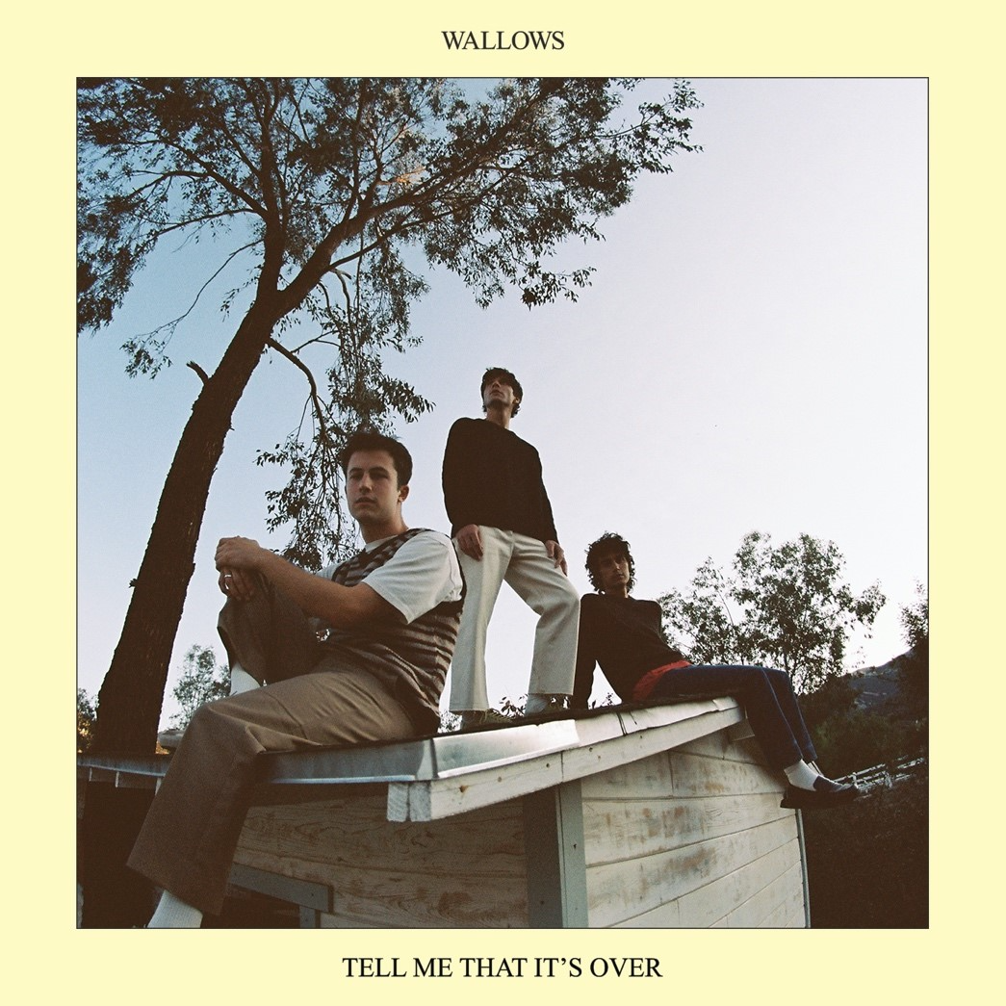

TRACKLIST
Hard to Believe
I Don’t Want to Talk
Especially You
At the End of the Day
Marvelous
Permanent Price
Missing Out
Hurts Me
That’s What I Get
Guitar Romantic Search Adventure

# # #

WALLOWS
TELL ME THAT IT’S OVER WORLD TOUR
2022-2023

APRIL
1 – Seattle, WA – The Paramount Theatre * (SOLD OUT)
2 – Vancouver, BC – The Orpheum * (SOLD OUT)
3 – Portland, OR – McMenamins Crystal Ballroom * (SOLD OUT)
4 – Portland, OR – McMenamins Crystal Ballroom * (SOLD OUT)
6 – San Francisco, CA – The Warfield * (SOLD OUT)
7 – San Francisco, CA – The Warfield * (SOLD OUT)
8 – Sacramento, CA – Ace of Spades * (SOLD OUT)
10 – Phoenix, AZ – The Van Buren * (SOLD OUT)
11 – Albuquerque, NM – Sunshine Theater * (SOLD OUT)
12 – Tucson, AZ – Rialto Theatre * (SOLD OUT)
13 – Flagstaff, AZ – Prochnow Auditorium * (SOLD OUT)
16 – Indio, CA – Coachella
18 – Pomona, CA – The Fox Theater Pomona = (SOLD OUT)
21 – San Diego, CA – Humphreys Concerts by the Bay = (SOLD OUT)
23 – Indio, CA – Coachella

MAY
15 – Austin, TX – Stubb’s Waller Creek Amphitheater +
16 – Austin, TX – Stubb’s Waller Creek Amphitheater + (SOLD OUT)
17 – Dallas, TX – The Factory in Deep Ellum + (MORE TICKETS ADDED)
18 – Houston, TX – Lawn at White Oak Music Hall +
20 – Atlanta, GA – Coca-Cola Roxy +
21 – Atlanta, GA – Tabernacle +
23 – Orlando, FL – The Orlando Amphitheater at the Central Florida Fairgrounds +
24 – Miami, FL – The Fillmore +
26 – St. Petersburg, FL – Jannus Live +
27 – St. Augustine, FL – The Saint Augustine Amphitheatre +
28 – Columbia, SC – The Senate + (SOLD OUT)
29 – Charlotte, NC – The Fillmore + (SOLD OUT)
31 – Norfolk, VA – The NorVa * (SOLD OUT)

JUNE
1 – Richmond, VA – The National * (SOLD OUT)
3 - Columbus, OH – KEMBA Live! * (MORE TICKETS ADDED)
4 – Cleveland, OH – Agora Theatre * (SOLD OUT)
6 – Indianapolis, IN – Egyptian Room at Old National Centre * (SOLD OUT)
7 – Milwaukee, WI – The Riverside Theater *
9 – Kansas City, MO – Arvest Bank Theatre at The Midland *
10 – Chesterfield, MO – The Factory at The District * (MORE TICKETS ADDED)
11 – Newport, KY – PromoWest Pavilion at OVATION *
12 – Pittsburgh, PA – Stage AE * (MORE TICKETS ADDED)
14 – New York, NY – Terminal 5 * (SOLD OUT)
15 – New York, NY – Terminal 5 * (SOLD OUT)
16 – New York, NY – Terminal 5 *
17 – New York, NY – Terminal 5 * (SOLD OUT)
19 – Manchester, TN – Bonnaroo Music Festival
21 – Washington, DC – The Anthem *
22 – Boston, MA – Roadrunner * (SOLD OUT)
23 – Philadelphia, PA – The Met *
25 – Toronto, ON – HISTORY * (SOLD OUT)
26 – Toronto, ON – HISTORY * (SOLD OUT)
27 – Detroit, MI – Masonic Temple Theatre *
29 – Saint Paul, MN – Palace Theatre *

JULY
1 – Lincoln, NE – Bourbon Theatre * (SOLD OUT)
2 – Denver, CO – Mission Ballroom *

AUGUST
26 – Reading, UK – Reading Festival
27 – Leeds, UK – Leeds Festival
28 – Liverpool, UK – O2 Academy (SOLD OUT)

NOVEMBER
5 – Auckland, NZ – Auckland Town Hall
8 – Melbourne, AU – The Forum # (SOLD OUT)
10 – Sydney, AU – Enmore Theatre # (SOLD OUT)
11 – Brisbane, AU – The Fortitude Music Hall #

JANUARY 2023
9 – Dublin, IE – 3Olympia Theatre ^ (SOLD OUT)
10 – Glasgow, UK – O2 Academy ^ (SOLD OUT)
11 – Manchester, UK – Academy ^
13 – Leeds, UK – Leeds Academy ^
14 – Birmingham, UK – O2 Academy ^
15 – Bristol, UK – O2 Academy ^ (SOLD OUT)
17 – Bournemouth, UK – O2 Academy ^
18 – London, UK – O2 Academy Brixton ^
21 – Utrecht, NL – Tivolivredenburg ^ (SOLD OUT)
22 – Brussels, BE – Ancienne Belgique ^
23 – Paris, FR – La Cigale ^
25 – Milan, IT – Magazzini Generali ^
26 – Zurich, CH – X-Tra ^
27 – Munich, DE – Muffathalle ^
29 – Berlin, DE – Astra ^
30 – Cologne, DE – Live Music Hall ^
31 – Hamburg, DE – Fabrik ^

FEBRUARY 2023
2 – Copenhagen, DK – Vega ^
3 – Stockholm, SE – Klubben Fryshuset ^
5 – Oslo, NO – Vulkan Arena ^

* w/ Spill Tab
+ w/ Jordana
# w/ Hatchie
^ w/ May-A
= w/ The Regrettes

# # #

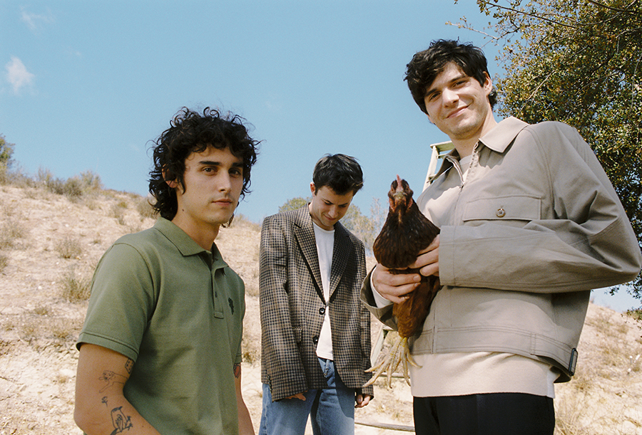
(PHOTO CREDIT: ANTHONY PHAM)

CONNECT WITH WALLOWS
WALLOWSMUSIC.COM I FACEBOOK I TWITTER I YOUTUBE I INSTAGRAM | TIK TOK | PRESS SITE

PRESS CONTACTS
luke@bbgunpress.com
sloan@bbgunpr.com
corey.brewer@atlanticrecords.com
gabrielle.reese@atlanticrecords.com

