WALLOWS RELEASE “MARVELOUS” LIVE AT TERMINAL 5 – FILMED OVER THREE OF THEIR FOUR SOLD OUT SHOWS IN JUNE

WATCH HERE

CURRENTLY ON AN EPIC WORLD TOUR WITH LIVE DATES INTO 2023

SOPHOMORE ALBUM TELL ME THAT IT’S OVER OUT NOW

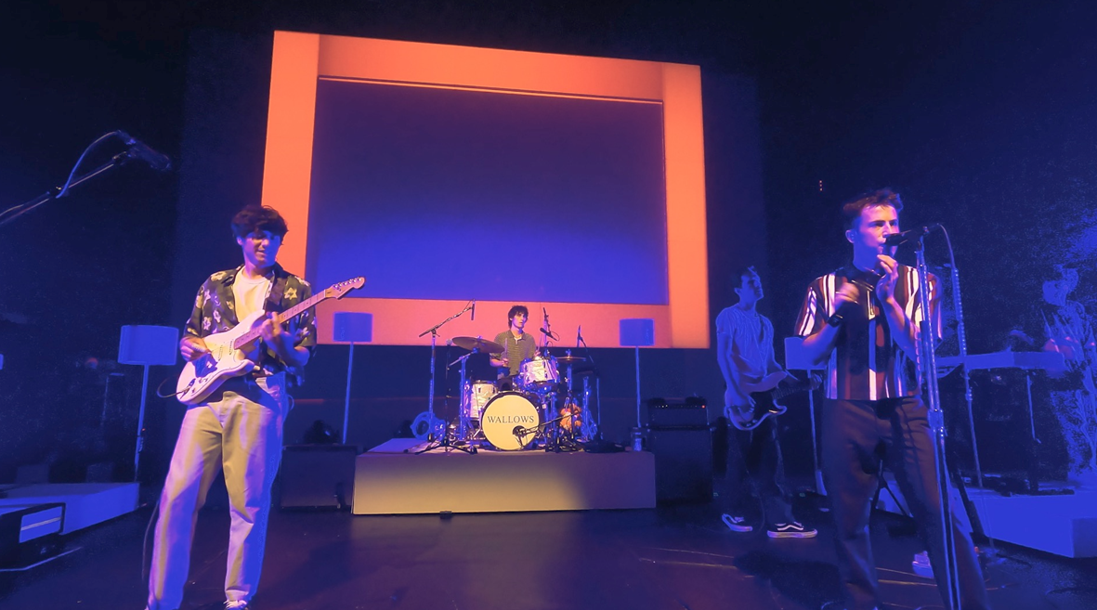

Multi-platinum alt-rock trio Wallows brought their high energy set to New York City’s Terminal 5 last month for four sold out nights, and today sees the release of a live performance video for their single “Marvelous,” captured over the last three nights of the four night residency. Watch HERE.

Wallows are celebrating the release of their Sophomore album Tell Me That It’s Over with the Tell Me That It’s Over World Tour. The tour began April 1 with a sold out show in Seattle, WA and continues through February 2023, with stops at Lollapalooza, Reading & Leeds festivals, Austin City Limits and more. A majority of dates are already sold out; a limited number of VIP packages for North American dates and “Especially You” packages for international dates are available now. For more information and ticket availability, please visit wallowsmusic.com/tour.

Produced by 3x GRAMMY® Award-winner Ariel Rechtshaid (Vampire Weekend, Haim, Adele), Tell Me That It’s Over sees Wallows continuing on their ever-evolving journey of sonic exploration, fusing a vast array of musical ideas – from lo-fi post-punk and indie-folk to early ’90s dance-pop psychedelia – into their own one-of-a-kind creative vision.

WALLOWS
TELL ME THAT IT’S OVER WORLD TOUR
2022-2023

JULY
29 – Chicago, IL – The Vic Theatre (Lollapalooza Aftershow) [SOLD OUT]
30 – Chicago, IL – Lollapalooza

AUGUST
26 – Reading, UK – Reading Festival
27 – Leeds, UK – Leeds Festival
28 – Liverpool, UK – O2 Academy * (SOLD OUT)

SEPTEMBER 2022
24 – Santa Barbara, CA – Arlington Theatre
25 - Los Angeles, CA – Shrine Auditorium and Expo Hall +
28 - Los Angeles, CA – Greek Theatre + (SOLD OUT)
29 - Los Angeles, CA – Shrine Auditorium and Expo Hall + (SOLD OUT)
30 - Las Vegas, NV – Brooklyn Bowl %

OCTOBER 2022
01 - Salt Lake City, UT – Union Event Center %
03 - Santa Fe, NM – The Bridge %
04 - El Paso, TX – Abraham Chavez Theatre % (SOLD OUT)
06 – San Antonio, TX – Aztec Theatre & (SOLD OUT)
08 – Austin, TX – Austin City Limits
09 - New Orleans, LA – Orpheum Theater %
10 - Memphis, TN – The Soundstage at Graceland %
12 - Fayetteville, AR – JJ’s Live %
13 - Oklahoma City, OK – The Criterion %
15 – Austin, TX – Austin City Limits

NOVEMBER
5 – Auckland, NZ – Auckland Town Hall (SOLD OUT)
8 – Melbourne, AU – The Forum (SOLD OUT)
10 – Sydney, AU – Hordern Pavilion (VENUE UPGRADED)
11 – Brisbane, AU – The Fortitude Music Hall (SOLD OUT)
18-20 – Mexico City, MX – Corona Capital Festival

JANUARY 2023
9 – Dublin, IE – 3Olympia Theatre * (SOLD OUT)
10 – Glasgow, UK – O2 Academy * (SOLD OUT)
11 – Manchester, UK – Academy ^
13 – Leeds, UK – Leeds Academy ^
14 – Birmingham, UK – O2 Academy ^
15 – Bristol, UK – O2 Academy ^ (SOLD OUT)
17 – Bournemouth, UK – O2 Academy ^
18 – London, UK – O2 Academy Brixton ^
21 – Utrecht, NL – TivoliVredenburg ^ (SOLD OUT)
22 – Brussels, BE – Ancienne Belgique ^
23 – Paris, FR – L’Olympia ^ (VENUE UPGRADED)
25 – Milan, IT – Magazzini Generali ^
26 – Zurich, CH – X-Tra ^
27 – Munich, DE – Muffathalle ^
29 – Berlin, DE – Astra Kulturhaus ^
30 – Cologne, DE – Live Music Hall ^
31 – Hamburg, DE – Fabrik ^

FEBRUARY 2023
2 – Copenhagen, DK – Vega ^
3 – Stockholm, SE – Fryshuset ^
5 – Oslo, NO – Vulkan Arena ^

% w/ Empath
* w/ Lucy Gaffney
^ w/ May-A
+ w/ Samia

# # #
CONNECT WITH WALLOWS
WALLOWSMUSIC.COM I FACEBOOK I TWITTER I YOUTUBE I INSTAGRAM | TIK TOK | PRESS SITE

PRESS CONTACTS
corey.brewer@atlanticrecords.com
gabrielle.reese@atlanticrecords.com

