WALLOWS ANNOUNCE SECOND US LEG OF THE
TELL ME THAT IT’S OVER WORLD TOUR

EPIC WORLD TOUR BEGINS THIS FRIDAY, APRIL 1 IN SEATTLE, WA

LONG-AWAITED SOPHOMORE ALBUM
TELL ME THAT IT’S OVER
OUT NOW

PRODUCED BY 3X GRAMMY® AWARD-WINNER ARIEL RECHTSHAID

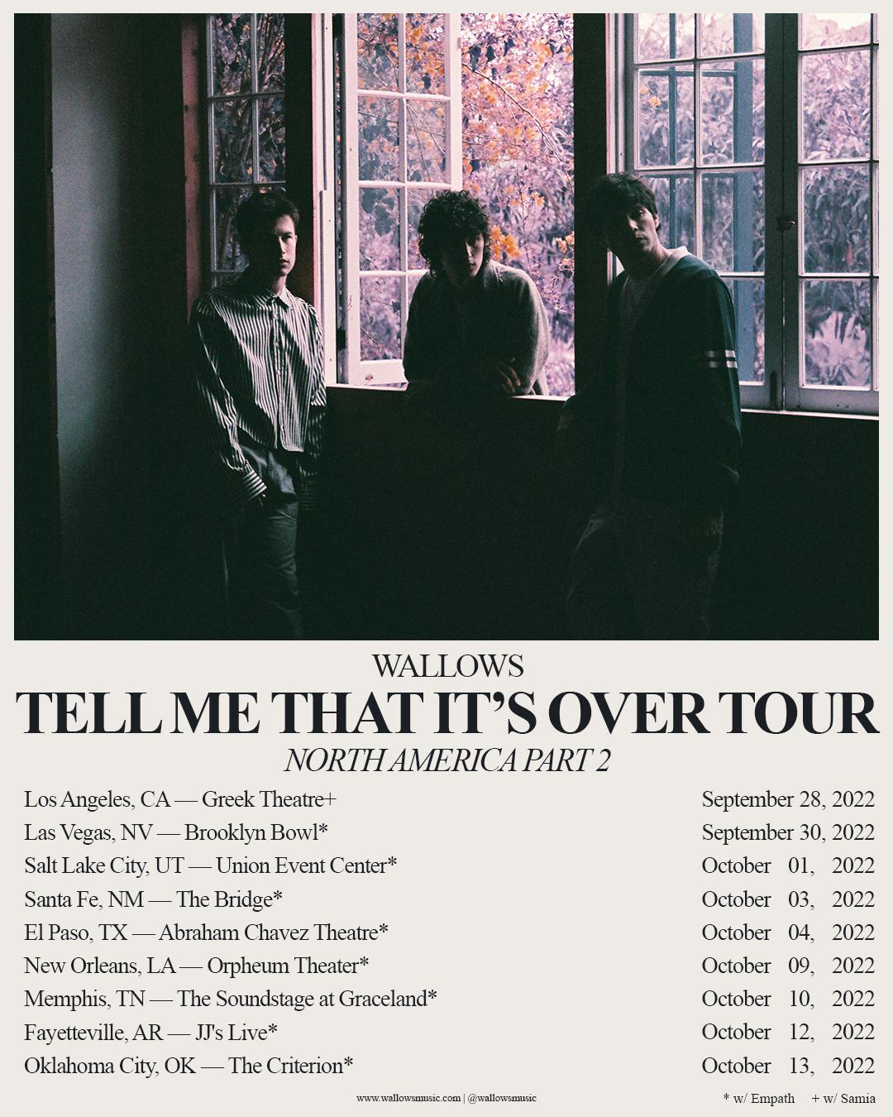

Monday, May 28th, 2022 - Today, multi-platinum alt-rock trio Wallows have announced a second US leg on the Tell Me That It’s Over World Tour. The band will kick off the second leg on September 28th, 2022 in Los Angeles with their debut performance at the legendary Greek Theatre, with special guest Samia.They will then be joined by special guest Empath for the rest of that run before capping it off on October 13th in Oklahoma City, OK. All Wallows newsletter subscribers will be able to access pre-sale tickets on Tuesday, March 29th at 10am local time and general on sale is Friday, April 1st at 10am local time. More North American tour tickets are already on sale HERE.

Last week Wallows released their much anticipated new album, Tell Me That It’s Over, listen HERE. Album single “Marvelous” also received a visual featuring band members Dylan Minnette, Braeden Lemasters and Cole Preston giving a sneak peek of their new tour production. The new video was directed and shot by Natalie Hewitt – watch HERE. This Wednesday, March 30th at 11:35pm EST/PST, Wallows will take the stage at Jimmy Kimmel Live! for an incredible performance you won’t want to miss.

Produced by 3x GRAMMY® Award-winner Ariel Rechtshaid (Vampire Weekend, Haim, Adele), Tell Me That It’s Over sees Wallows continuing on their ever-evolving journey of sonic exploration, fusing a vast array of musical ideas – from lo-fi post-punk and indie-folk to early ’90s dance-pop psychedelia – into their own one-of-a-kind creative vision. Highlights include the recently released singles, “I Don’t Want to Talk,” “Especially You,” and “At the End of the Day,” all of which are joined by official music videos directed by Jason Lester (Animal Collective, Ashe, Madison Beer, Rostam) and streaming now via the official Wallows YouTube channel HERE.

TMTIO marks the long awaited full-length follow-up to Wallows’ hugely popular 2019 debut album, Nothing Happens, available for streaming and download HERE. Produced by GRAMMY® Award-winner John Congleton (St. Vincent, Sharon Van Etten), the album proved one of that year’s highest streamed debuts, fueled in part by the 2x RIAA platinum hit single, “Are You Bored Yet? (Feat. Clairo).”

Wallows – Braeden Lemasters, Cole Preston, and Dylan Minnette – are currently poised to embark on the Tell Me That It’s Over World Tour, set to get underway April 1 with a sold out show at Seattle, WA’s historic Paramount Theatre and then travel the globe through February 2023. Support throughout comes from special guests including Spill Tab, Jordana, May-A, and Hatchie, as well as two shows between the Coachella weekends with The Regrettes. A majority of dates are already sold out; a limited number of VIP packages for North American dates and “Especially You” packages for international dates are available now. For more information and ticket availability, please visit wallowsmusic.com/tour.

WALLOWS
TELL ME THAT IT’S OVER WORLD TOUR
2022-2023

APRIL
1 – Seattle, WA – The Paramount Theatre * (SOLD OUT)
2 – Vancouver, BC – The Orpheum * (SOLD OUT)
3 – Portland, OR – McMenamins Crystal Ballroom * (SOLD OUT)
4 – Portland, OR – McMenamins Crystal Ballroom * (SOLD OUT)
6 – San Francisco, CA – The Warfield * (SOLD OUT)
7 – San Francisco, CA – The Warfield * (SOLD OUT)
8 – Sacramento, CA – Ace of Spades * (SOLD OUT)
10 – Phoenix, AZ – The Van Buren * (SOLD OUT)
11 – Albuquerque, NM – Sunshine Theater * (SOLD OUT)
12 – Tucson, AZ – Rialto Theatre * (SOLD OUT)
13 – Flagstaff, AZ – Prochnow Auditorium * (SOLD OUT)
16 – Indio, CA – Coachella
18 – Pomona, CA – The Fox Theater Pomona = (SOLD OUT)
21 – San Diego, CA – Humphreys Concerts by the Bay = (SOLD OUT)
23 – Indio, CA – Coachella

MAY
15 – Austin, TX – Stubb’s Waller Creek Amphitheater + (SOLD OUT)
16 – Austin, TX – Stubb’s Waller Creek Amphitheater + (SOLD OUT)
17 – Dallas, TX – The Factory in Deep Ellum +
18 – Houston, TX – Lawn at White Oak Music Hall +
20 – Atlanta, GA – Coca-Cola Roxy + (SOLD OUT)
21 – Atlanta, GA – Tabernacle +
23 – Orlando, FL – The Orlando Amphitheater at the Central Florida Fairgrounds +
24 – Miami, FL – The Fillmore +
26 – St. Petersburg, FL – Jannus Live +
27 – St. Augustine, FL – The Saint Augustine Amphitheatre +
28 – Columbia, SC – The Senate + (SOLD OUT)
29 – Charlotte, NC – The Fillmore + (SOLD OUT)
31 – Norfolk, VA – The NorVa * (SOLD OUT)

JUNE
1 – Richmond, VA – The National * (SOLD OUT)
3 - Columbus, OH – KEMBA Live! *
4 – Cleveland, OH – Agora Theatre * (SOLD OUT)
6 – Indianapolis, IN – Egyptian Room at Old National Centre * (SOLD OUT)
7 – Milwaukee, WI – The Riverside Theater *
9 – Kansas City, MO – Arvest Bank Theatre at The Midland *
10 – Chesterfield, MO – The Factory at The District *
11 – Newport, KY – PromoWest Pavilion at OVATION *
12 – Pittsburgh, PA – Stage AE *
14 – New York, NY – Terminal 5 * (SOLD OUT)
15 – New York, NY – Terminal 5 * (SOLD OUT)
16 – New York, NY – Terminal 5 *
17 – New York, NY – Terminal 5 * (SOLD OUT)
19 – Manchester, TN – Bonnaroo Music Festival
21 – Washington, DC – The Anthem *
22 – Boston, MA – Roadrunner * (SOLD OUT)
23 – Philadelphia, PA – The Met *
25 – Toronto, ON – HISTORY * (SOLD OUT)
26 – Toronto, ON – HISTORY * (SOLD OUT)
27 – Detroit, MI – Masonic Temple Theatre *
29 – Saint Paul, MN – Palace Theatre *

JULY
1 – Lincoln, NE – Bourbon Theatre * (SOLD OUT)
2 – Denver, CO – Mission Ballroom *
28 – 31 – Chicago, IL - Lollapalooza

AUGUST
26 – Reading, UK – Reading Festival
27 – Leeds, UK – Leeds Festival
28 – Liverpool, UK – O2 Academy (SOLD OUT)

SEPTEMBER 2022
28 - Los Angeles, CA – Greek Theatre +
30 - Las Vegas, NV – Brooklyn Bowl*

OCTOBER 2022
01 - Salt Lake City, UT – Union Event Center*
03 - Santa Fe, NM – The Bridge*
04 - El Paso, TX – Abraham Chavez Theatre*
09 - New Orleans, LA – Orpheum Theater*
10 - Memphis, TN – The Soundstage at Graceland*
12 - Fayetteville, AR – JJ’s Live*
13 - Oklahoma City, OK – The Criterion*

NOVEMBER
5 – Auckland, NZ – Auckland Town Hall
8 – Melbourne, AU – The Forum # (SOLD OUT)
10 – Sydney, AU – Hordern Pavilion # (VENUE UPGRADED)
11 – Brisbane, AU – The Fortitude Music Hall #

JANUARY 2023
9 – Dublin, IE – 3Olympia Theatre ^ (SOLD OUT)
10 – Glasgow, UK – O2 Academy ^ (SOLD OUT)
11 – Manchester, UK – Academy ^
13 – Leeds, UK – Leeds Academy ^
14 – Birmingham, UK – O2 Academy ^
15 – Bristol, UK – O2 Academy ^ (SOLD OUT)
17 – Bournemouth, UK – O2 Academy ^
18 – London, UK – O2 Academy Brixton ^
21 – Utrecht, NL – Tivolivredenburg ^ (SOLD OUT)
22 – Brussels, BE – Ancienne Belgique ^
23 – Paris, FR – L’Olympia ^ (VENUE UPGRADED)
25 – Milan, IT – Magazzini Generali ^
26 – Zurich, CH – X-Tra ^
27 – Munich, DE – Muffathalle ^
29 – Berlin, DE – Astra ^
30 – Cologne, DE – Live Music Hall ^
31 – Hamburg, DE – Fabrik ^

FEBRUARY 2023
2 – Copenhagen, DK – Vega ^
3 – Stockholm, SE – Klubben Fryshuset ^
5 – Oslo, NO – Vulkan Arena ^

New dates in BOLD
* w/ Spill Tab
+ w/ Jordana
# w/ Hatchie
^ w/ May-A
= w/ The Regrettes
*w/ Empath
+ w/ Samia

# # #
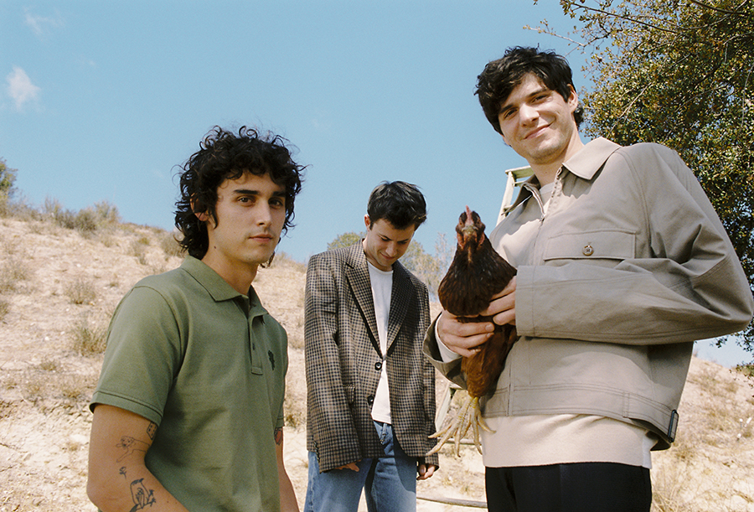
(PHOTO CREDIT: ANTHONY PHAM)

CONNECT WITH WALLOWS
WALLOWSMUSIC.COM I FACEBOOK I TWITTER I YOUTUBE I INSTAGRAM | TIK TOK | PRESS SITE

PRESS CONTACTS
luke@bbgunpress.com
sloan@bbgunpr.com
corey.brewer@atlanticrecords.com
gabrielle.reese@atlanticrecords.com

