FOR IMMEDIATE RELEASE
SEPTEMBER 16, 2022

CHART-TOPPING POP PHENOMENON BAZZI UNVEILS INFINITE DREAM

MULTI-PLATINUM SINGER-SONGWRITER SHARES LONG AWAITED THIRD SOLO ALBUM
INCLUDING “ONLY FAN (FEAT. CORDAE)” AND “DLMA </3 (FEAT. LANY)”

BIGGEST HEADLINE TOUR TO DATE KICKS OFF OCTOBER 17 IN DALLAS, TX

INFINITE DREAM AVAILABLE EVERYWHERE NOW VIA ATLANTIC RECORDS – LISTEN HERE

“HEAVEN” OFFICIAL MUSIC VIDEO OUT NOW – WATCH HERE

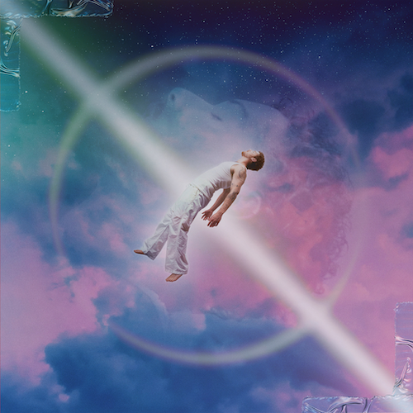
DOWNLOAD HI-RES ARTWORK

“’Heaven’…scores with both effective production details – the bob-and-weave of the percussion, the way the guitar tingles at times – as well as a chorus that Bazzi makes both sumptuous and cathartic”
– BILLBOARD

“’Heaven’ by Bazzi is a floaty, celestial pop anthem, slotting itself perfectly next to the rest of Bazzi’s discography. With a stripped back production, ‘Heaven’ highlights Bazzi’s impressive vocal range”
– V MAGAZINE

Chart-topping multi-platinum pop phenomenon Bazzi has shared his eagerly awaited third solo album, INFINITE DREAM, available everywhere now via Atlantic Records HERE. The album releases alongside the official music video for standout single “Heaven,” which made its broadcast premiere on MTV Live, MTVU, MTV Biggest Pop and on the Paramount Times Square billboards – watch at YouTube HERE.

“There’s something for everyone on this album,” shared Bazzi. “It’s a wide net, because I’m touching on so many different things. I’m becoming more of myself. I’m changing every day. I’m focusing on making the right decisions in relationships and creating great ideas. I think you’ll get to see me through my art. I can’t wait to show everyone what I’ve been up to.”

INFINITE DREAM collects 19 dazzling new tracks including “Only Fan (feat. Cordae)” and “dlma </3 (feat. LANY)”, the latter garnering 444.5K views in a teaser video on Bazzi’s TikTok. The album also features recently premiered singles and fan favorites as “Heaven,” “Will It Ever Feel The Same?,” “I Like That” (currently featured in Amazon’s hit series, The Summer I Turned Pretty), “Young & Alive,” and the powerful anthem, “Miss America,” which is accompanied by an official music video co-starring actor Dylan Sprouse and supermodels Barbara Palvin and Yovanna Ventura.

Currently boasting over 9 billion catalogue streams worldwide, Bazzi will celebrate the arrival of INFINITE DREAM with an epic North American headline tour – his biggest live run to date. Produced by Live Nation, “The Infinite Dream Tour” kicks off October 17 at Dallas, TX’s House of Blues and then continues through mid-November. For complete details, please see www.bazziofficial.com.

BAZZI
THE INFINITE DREAM TOUR
NORTH AMERICA 2022

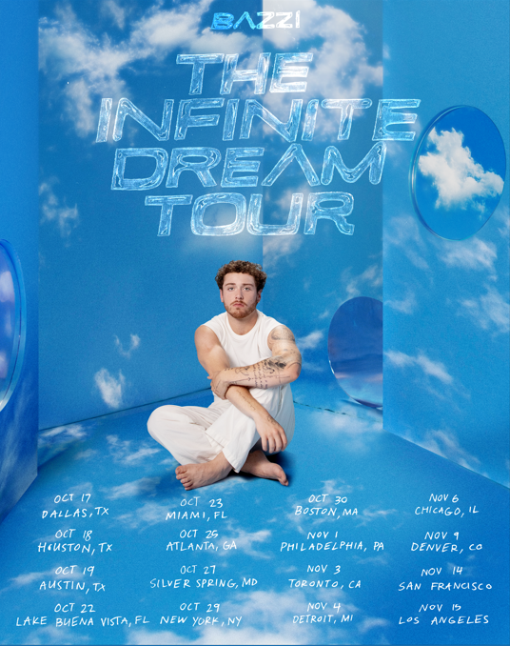

OCTOBER
17 - Dallas, TX - House of Blues
18 - Houston, TX - House of Blues
19 - Austin, TX - Emo’s
22 - Lake Buena Vista, FL - House of Blues
23 - Ft. Lauderdale, FL - Revolution
25 - Atlanta, GA - Tabernacle
27 - Silver Spring, MD - The Fillmore
29 - New York, NY - Hammerstein Ballroom
30 - Boston, MA - House of Blues

NOVEMBER
1 – Philadelphia, PA - The Fillmore
3 - Toronto, ON - Rebel
4 - Detroit, MI - The Fillmore
6 - Chicago, IL - Riviera Theatre
9 - Denver, CO - Summit
14 - San Francisco, CA - The Fillmore
15 - Los Angeles, CA - The Wiltern

# # #

ABOUT BAZZI:
Born to a Lebanese immigrant father and American mother in Canton, MI, Bazzi and his dad moved to California during his senior year where he single-handedly wrote and produced a series of viral smashes like “Alone” and “Beautiful,” earning millions of worldwide streams and top 10 placement on a variety of influential playlists. Now with over 1.9 billion streams to date, 2018’s 5x RIAA platinum certified “Mine“ proved Bazzi’s true breakthrough, ascending to #1 at CHR/Top 40 and making the top 20 on Billboard’s “Hot 100” after reaching #1 on virtually all streaming platforms. As if all that weren’t enough, the “Mine” companion video boasts nearly 196 million views via YouTube alone. Praised by Playboy for its “genre-bending…warts-and-all approach to songwriting,” Bazzi’s RIAA platinum certified debut album, COSMIC, debuted among the top 15 on the SoundScan/Billboard 200 upon its 2018 release, earning over 6.2 billion global streams with hits like the 4x platinum certified, top 40 hit duet version of “Beautiful (Ft. Camila Cabello),” accompanied by a spectacular companion visual now with over 193 million views. In 2019, Bazzi unveiled his first ever mixtape, SOUL SEARCHING, collecting over 2.1 billion streams on the strength of such RIAA platinum certified singles as “I.F.L.Y.“ and “Paradise.” Hailed by Billboard as “his most personal work to date,” the project made a top 20 debut on the Billboard 200, while “Paradise” proved one of Bazzi’s biggest hits with over 716 million global streams and counting.

Bazzi made the most of his 2020, releasing a string of intimate and deeply confessional tracks – including “Young & Alive,” “Renee’s Song,” “I Got You,” “I Don’t Think I’m Okay,” and “Crazy” – all of which drew millions of streams around the world. Bazzi followed the impressive singles run with his 2021 hit “I Like That,” which was joined by a colorful official music video directed by Christian Breslauer (Roddy Ricch, Doja Cat, Yungblud) and co-starring such close personal friends as high profile influencers Luca Sabbat, Scarlett Rose Leithold, Charlotte D’Alessio, Valentina Bilbao, Bruna Lirio, Chandler Lovelle, Duke Nicholson, and more. Most recently, Bazzi has released his most personal song yet, “Will It Ever Feel The Same?,” the dazzling pop anthem “Miss America” and the celestial “Heaven.”

Bazzi is gearing up to release his third album Infinite Dream due out September 16th and head out on his biggest tour yet in support of the new album. Currently boasting over 9 billion catalogue streams worldwide, Bazzi is fully focused on the future.

# # #

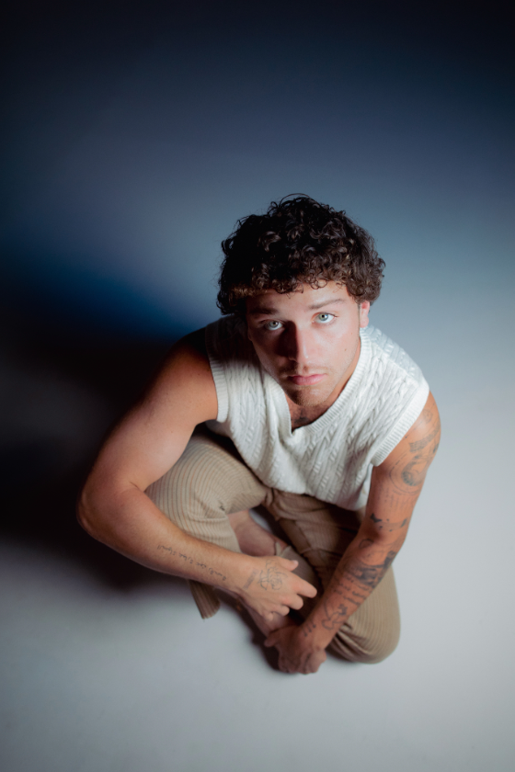
DOWNLOAD HI-RES PRESS PHOTO HERE // CREDIT: HENRY AMMANN

# # #

BAZZI
INFINITE DREAM
(Atlantic Records)

TRACKLIST
Infinite Dream
SYWM
Heaven
Little Miss Sunshine
Uh Oh
One Way Ticket
Lost In The Stimulation
Only Fan (feat. Cordae)
Staying Up Late
dlma </3 (feat. LANY)
Bird
Middle Man
Miss America
Will It Ever Feel The Same?
Human (Cocaine)
I Like That
Young & Alive
Holdin On
Don’t Leave Me Now

# # #

CONNECT WITH BAZZI
BAZZIOFFICIAL.COM | FACEBOOK| INSTAGRAM| TWITTER | YOUTUBE

For press inquiries, please contact:
Kelly McWilliam // Kelly.McWilliam@atlanticrecords.com

