FOR IMMEDIATE RELEASE
JANUARY 14, 2021

CORDAE LIFTS THE CURTAIN ON FROM A BIRDS EYE VIEW

2X GRAMMY® NOMINATED RAPPER UNVEILS EAGERLY AWAITED SOPHOMORE ALBUM

HIGHLIGHTS INCLUDE THE ACCLAIMED “SUPER” & “SINISTER (FEAT. LIL WAYNE)”
AND THE BRAND NEW SINGLES, “CHRONICLES (FEAT. H.E.R & LIL DURK)” & “TODAY (FEAT. GUNNA)”

OFFICIAL “TODAY (FEAT. GUNNA)” MUSIC VIDEO STREAMING HERE

NPR TINY DESK (HOME) CONCERT PREMIERES TODAY

AT&T PRESENTS: CORDAE LIVE: FROM A BIRDS EYE VIEW EVENT SET FOR JANUARY 18

FROM A BIRDS EYE VIEW TOUR BEGINS FEBRUARY 3 IN DALLAS, TX

FROM A BIRDS EYE VIEW AVAILABLE NOW VIA ART@WAR/ATLANTIC HERE

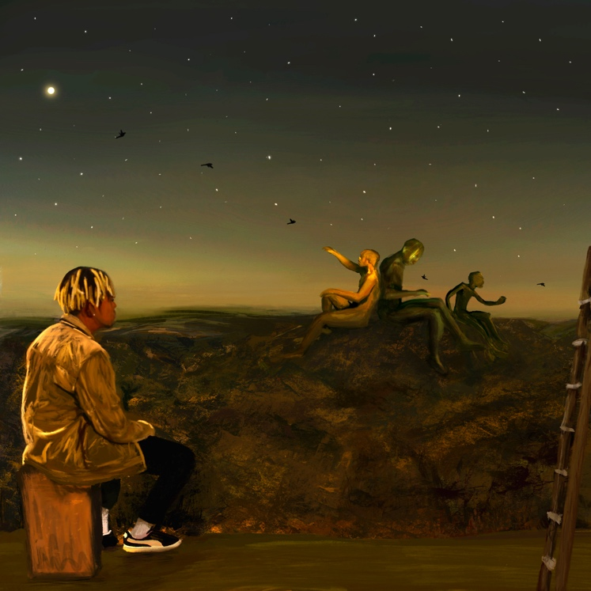

2x GRAMMY® Award-nominated rapper Cordae is proud to announce the release of his hugely anticipated sophomore album. From A Birds Eye View is available now via ART@WAR/Atlantic Records.

The 14-track album release is celebrated by the premiere of the brand new singles, “Chronicles (Feat. H.E.R. & Lil Durk),” and “Today (Feat. Gunna)” available at all DSPs and streaming services; an official music video for “Today (Feat. Gunna)” is streaming now via YouTube HERE.
From A Birds Eye View sees Cordae collaborating with heavyweight names across a variety of genres such as Stevie Wonder, Lil Wayne, Freddie Gibbs, Eminem, H.E.R., Lil Durk, Gunna, Ant Clemons and Roddy Ricch.

In addition to the release of the album, Cordae will perform an intimate live set as part of NPR’s Tiny Desk (Home) Concerts series. On January 18th Cordae is collaborating with AT&T Emerging Voices, a program that pairs artists on-the-rise with AT&T’s platforms and technology, for AT&T Presents: Cordae Live: From A Birds Eye View, an immersive one-of-a-kind audio-visual event and live stream from Brooklyn, NY’s National Sawdust. For complete details, please visit www.emergingvoices.att.com.

Deeply inspired by a life-changing trip to Africa, enduring the loss of a friend gone too soon, and evolving as an artist and a man, From A Birds Eye View sees Cordae telling these stories and more through technicolor imagery, nimble rhymes, and fast evolving wisdom. Among its many highlights, the new collection includes the acclaimed single, “Sinister (Feat. Lil Wayne),” available everywhere for streaming and download HERE; an official music video is streaming via YouTube HERE. In addition, this week saw an electrifying medley performance of “Sinister (Feat. Lil Wayne)” and “Chronicles (Feat. H.E.R. & Lil Durk)” on NBC’s The Tonight Show Starring Jimmy Fallon, streaming HERE.

From A Birds Eye View was first unveiled this fall with the powerhouse single, “Super,” available now at all DSPs and streaming services HERE. Produced by longtime collaborator Kid Culture (Justin Bieber, Ed Sheeran) and co-produced by Jenius, the track is joined by an official music video streaming now at YouTube HERE. The album also includes the bonus track “Gifted (Feat. Roddy Ricch)” a sonic marriage between two of modern hip-hop's greatest players. "Gifted" features a vocal appearance by Ant Clemons and the official music video directed by Cole Bennett is available to watch HERE.

Cordae will mark the album’s arrival with an epic North American headline tour. The From A Birds Eye View Tour begins February 3 at Dallas, TX’s House of Blues and then continues through mid-March. Additional dates and special guests will be announced soon. For complete details and ticket availability, please see www.cordaemusic.com/tour.

CORDAE
FROM A BIRD’S EYE VIEW TOUR 2022

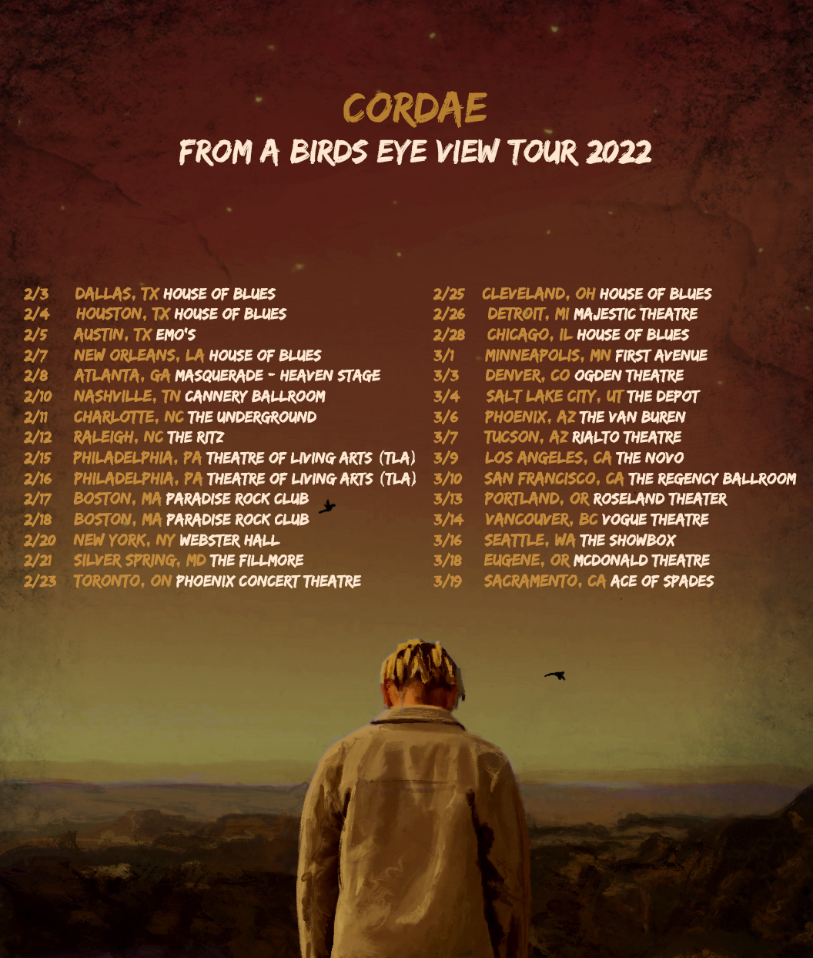

FEBRUARY
3 - Dallas, TX - House of Blues
4 - Houston, TX - House of Blues
5 - Austin, TX - Emo's
7 - New Orleans, LA - House of Blues
8 - Atlanta, GA - The Masquerade - Heaven Stage
10 - Nashville, TN - Cannery Ballroom
11 - Charlotte, NC The Underground
12 - Raleigh, NC - The Ritz
15 - Philadelphia, PA - Theatre of Living Arts (TLA)
16 - Philadelphia, PA - Theatre of Living Arts (TLA)
17 - Boston, MA - Paradise Rock Club
18 - Boston, MA - Paradise Rock Club
20 - New York, NY - Webster Hall
21 - Silver Spring, MD - The Fillmore
23 - Toronto, ON - Phoenix Concert Theatre
25 - Cleveland, OH - House of Blues
26 - Detroit, MI - Majestic Theatre
28 - Chicago, IL - House of Blues

MARCH
1 - Minneapolis, MN - First Avenue
3 - Denver, CO - Ogden Theatre
4 - Salt Lake City, UT - The Depot
6 - Phoenix, AZ - The Van Buren
7 - Tucson, AZ - Rialto Theatre
9 - Los Angeles, CA - The Novo
10 - San Francisco, CA - The Regency Ballroom
13 - Portland, OR - Roseland Theater
14 - Vancouver, BC - Vogue Theatre
16 - Seattle, WA - The Showbox
18 - Eugene, OR - McDonald Theatre
19 - Sacramento, CA - Ace of Spades

ADDITIONAL DATES TO BE ANNOUNCED

# # #

Cordae knows exactly what he wants to say. He chooses his words and phrases carefully. He speaks from a place of truth. That’s why the 2x GRAMMY® Award-nominated gold-selling Maryland-raised rapper has quietly become one of the modern generation’s most trusted narrators. A remarkable life has given him a lot to say. He went from trailer parks and public housing with his mom to stratospheric success. After a series of buzzing singles, he reached critical mass with his milestone 2019 debut album, The Lost Boy, available now at all DSPs and streaming services HERE. Now boasting more than 430M worldwide streams and counting, the full-length project bowed among the top 15 on the Billboard 200 and includes the RIAA gold-certified singles, “Have Mercy,” “RNP (Feat Anderson .Paak),” “Broke As F**k,” and “Kung Fu.”

Beyond unanimous praise from Billboard, Complex, High Snobiety, the New York Times, Pitchfork, and Stereogum, Cordae garnered a pair of GRAMMY® Award nominations in the categories of “Best Rap Album” for The Lost Boy and “Best Rap Song” for the RIAA gold certified lead single, “Bad Idea (Feat. Chance the Rapper).” The rare artist whose presence can be felt on-screen in a Super Bowl commercial alongside legendary Academy® Award-winning director Martin Scorsese and among XXL’s coveted “Freshman Class,” Cordae linked up with Roddy Ricch for “Gifted” as well as joining forces with Eminem for “Killer.”

# # #

CORDAE
FROM A BIRDS EYE VIEW
(ART@WAR/ATLANTIC)
TRACKLIST
1.Shiloh’s Intro
2. Jean-Michel
3. Super
4. Momma’s Hood
5. Want From Me
6. Today ft Gunna
7. Shiloh’s Interlude
8. C Carter
9. Sinister ft. Lil Wayne
10. Chronicles ft. H.E.R. & Lil Durk
11. Champagne Glasses ft. Freddie Gibbs & Stevie Wonder
12. Westlake High
1. Parables (Remix) ft. Eminem
2. Gifted ft. Roddy Ricch & Ant Clemons (Bonus)

CONNECT WITH CORDAE
INSTAGRAM | YOUTUBE | TWITTER | FACEBOOK

FOR PRESS INQUIRIES
SYDNEY.MARGETSON@ATLANTICRECORDS.COM
DVORA.ENGLEFIELD@LEDECOMPANY.COM
COURTNI.ASBURY@LEDECOMPANY.COM

