CHARLIE PUTH DROPS NEW TRACK “SMELLS LIKE ME”
FROM FORTHCOMING ALBUM CHARLIE DUE OCTOBER 7

STREAM OR DOWNLOAD “SMELLS LIKE ME” HERE

PRE-ORDER CHARLIE HERE

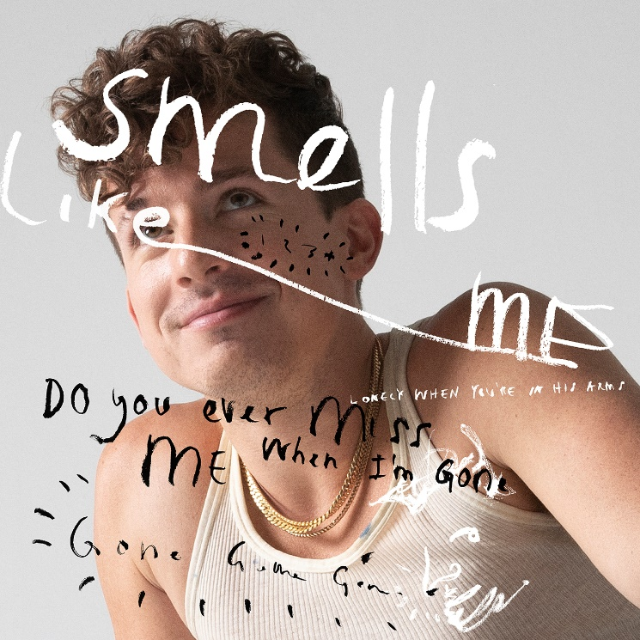
Download Hi-Res Artwork HERE

Los Angeles, CA – September 2, 2022 – Today, GRAMMY-nominated and multi-platinum singer/songwriter/producer Charlie Puth reinvents the breakup record with his new track “Smells Like Me,” out now via Atlantic Records. Puth leans into the biting lyrics with a bright melody, subtle guitar and shimmery neon keys as he wishes, “I hope your jacket smells like me.” Click HERE to stream/download.

“Smells Like Me” is the fourth release from his forthcoming highly anticipated third studio album, CHARLIE, due October 7. Puth made a splash by introducing the album with “Light Switch,” going gold in less than six months and generating half-a-billion streams. Following it up with an emotional and moving song “That’s Hilarious,” which has amassed over 190 million streams to date. On its heels, he kept up the pace with “Left and Right [feat. Jung Kook of BTS]” as his highest charting debut, reeling in over 320 million streams and 186 million video views. Rolling Stone applauded the track as a “breezy, sentimental collaboration.”

Charlie Puth has proven to be one of the industry’s most consistent hitmakers and sought-after collaborators. Puth has amassed eight multi-platinum singles, four GRAMMY nominations, three Billboard Music Awards, a Critic’s Choice Award, and a Golden Globe nomination. His 2018 GRAMMY-nominated LP, Voicenotes, was RIAA Certified Gold only four days after its release and has logged over 5.6 billion streams worldwide. Puth’s 2020 collaboration with Gabby Barrett on their “I Hope” Remix earned him his fourth top 10 track on the Billboard Hot 100, hit number one on the Billboard “Adult Pop Songs” chart, and won a 2021 Billboard Music Award for “Top Collaboration.” Puth also co-wrote and produced The Kid Laroi and Justin Bieber’s record-breaking single, “Stay,” which quickly become one of the biggest songs of 2021 and holds the title for the longest-reigning No. 1 on the Billboard Global 200 chart and the first to lead it for double-digits - spending a total of eleven weeks at the top of the chart.

Connect with Charlie Puth:
Website | Instagram | Facebook | Twitter | TikTok | YouTube | Spotify | Apple Music

# # #

Press Contacts for Charlie Puth:
ID PR, Kelly Bush Novak, Macy Rivet, Courtenay Barrett, Amy Morse, Elif Mamak and Nora Carlblom
(TeamPuth@id-pr.com)
Atlantic Records, Sheila Richman (sheila.richman@atlanticrecords.com) and Ted Sullivan (ted.sullivan@atlanticrecords.com)

