COLDPLAY ANNOUNCE SPECIAL LIVE
BROADCAST FROM BUENOS AIRES
WORLDWIDE CINEMA EVENT ON OCT 28/29

TICKETS ON SALE FOR “THE GREATEST SHOW ON EARTH”
ON SEPT 15 FROM COLDPLAYCINEMA.LIVE

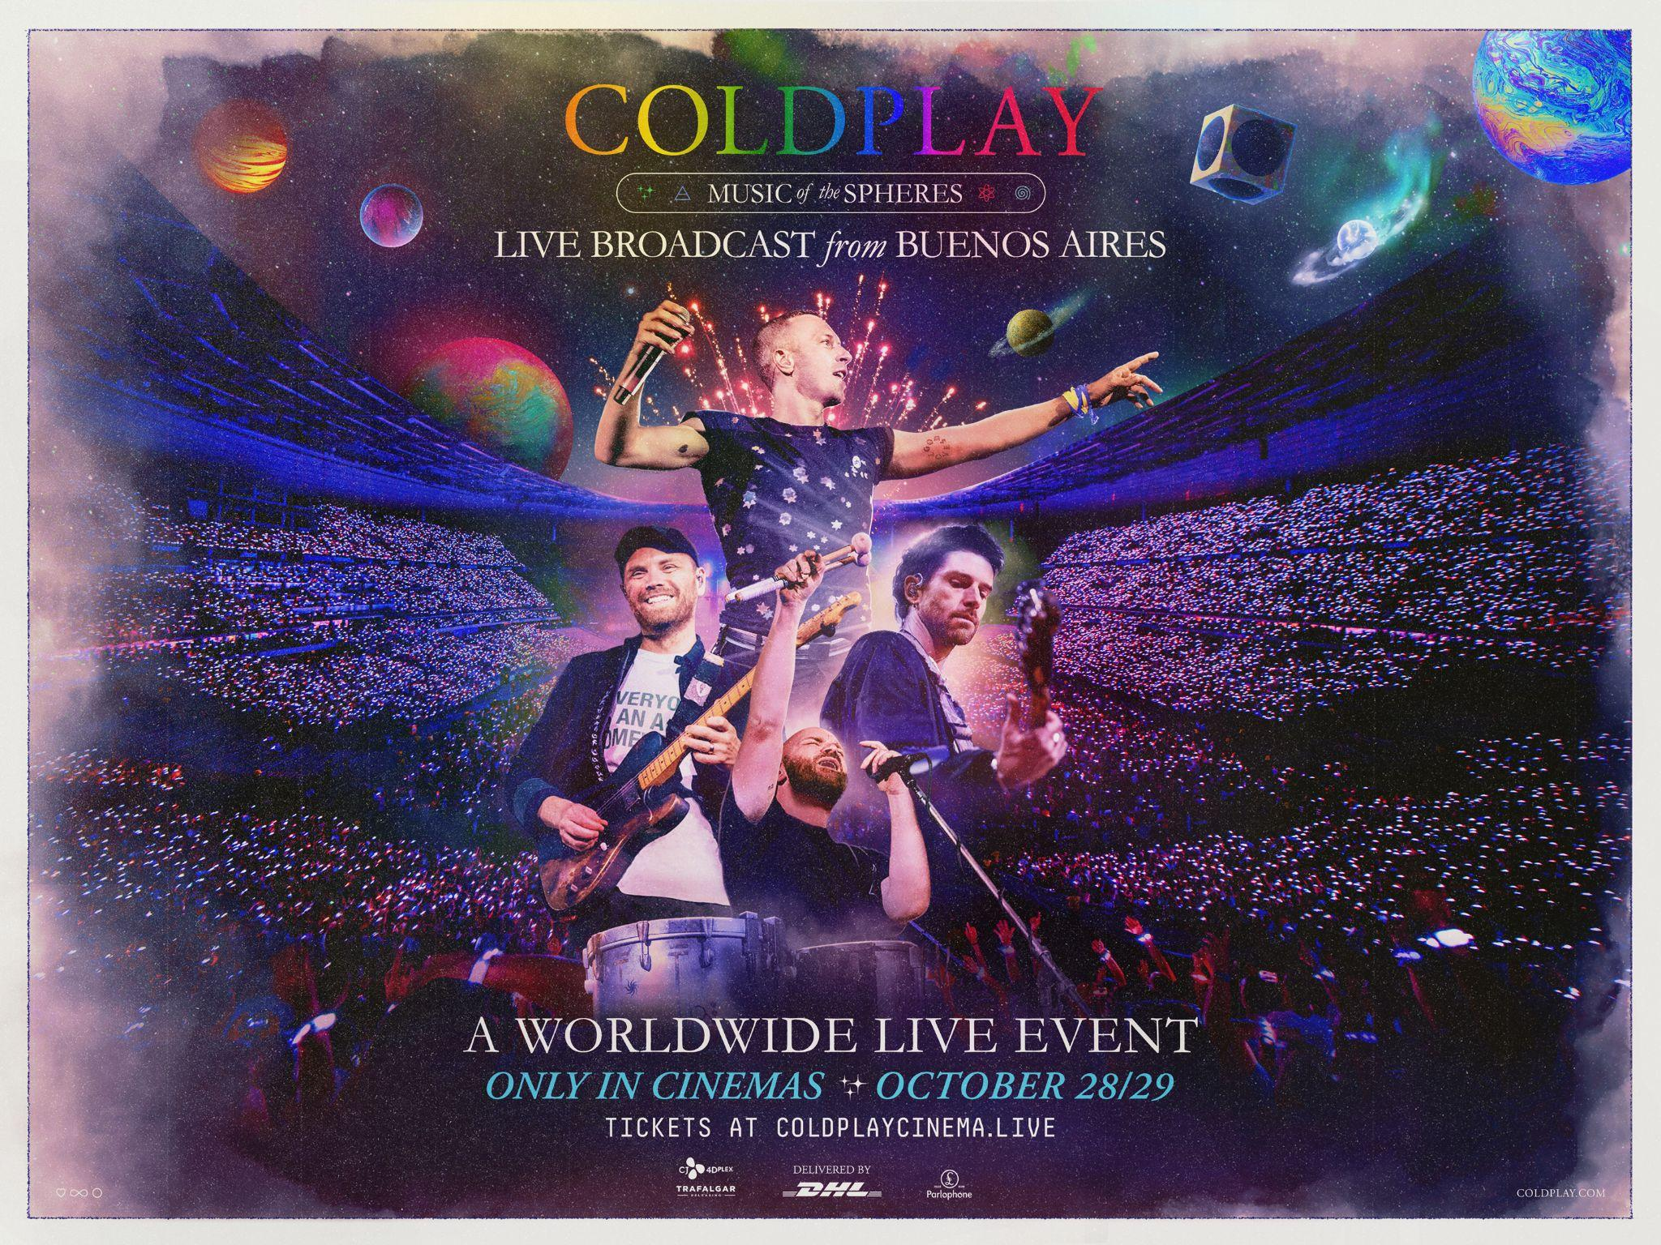
Download hi-res + Coldplay band shots

THUR, SEPT 8th, 2022 – Coldplay have today announced a special live broadcast of the band’s spectacular Music Of The Spheres World Tour from Buenos Aires’ River Plate Stadium. The worldwide live event will be shown in thousands of cinemas across more than 70 countries on October 28 / 29* in partnership with Trafalgar Releasing, who also executive produce alongside CJ 4DPlex. Watch the trailer at youtu.be/vitp2fLRHT0.

The event will give the band’s global fanbase the chance to experience Coldplay’s acclaimed Music Of The Spheres live show, which has sold more than 5.4m tickets and attracted rave reviews from fans and critics alike: with The Guardian calling it “genuinely stunning”, the New York Post describing it as “a night for the history books” and the Glasgow Evening Times heralding it as “the greatest show on Earth”.

The show will see the band perform classic hits from across their career including Yellow, The Scientist, Fix You, Viva La Vida, A Sky Full Of Stars and My Universe in a stadium bursting with lights, lasers, fireworks and LED wristbands - all of which combine to make Coldplay’s concerts such a joyful and life-affirming experience. This beautifully-filmed feature presentation will be directed by acclaimed BAFTA-winning and Grammy-nominated director Paul Dugdale.

Tickets for the event - the first ever live worldwide cinema broadcast of a concert from Latin America - will be available on September 15 at 3pm BST / 4pm CET / 10am ET / 7am PT from coldplaycinema.live (where fans can also sign up now to get updates and information).

Marc Allenby, CEO, Trafalgar Releasing said: “We are delighted to be partnering again with the Coldplay team on this major live broadcast, having established a successful partnership with the 2018 documentary release A Head Full Of Dreams. We are also extending our partnership with CJ 4DPlex on this live event featuring one of the world's biggest artists, giving fans the opportunity to experience the phenomenal Music Of The Spheres tour on the big screen across the globe in unison.”

The live event is supported by DHL with whom the band have partnered to reduce carbon emissions from their world tour.

* The Event is broadcast live to North America and Latin America on Friday, October 28, with the rest of the world joining the broadcast on Saturday, October 29 due to local time zones. Repeat screenings will also be available worldwide. The full list of local screenings will be listed at coldplaycinema.live from Thursday, September 15.

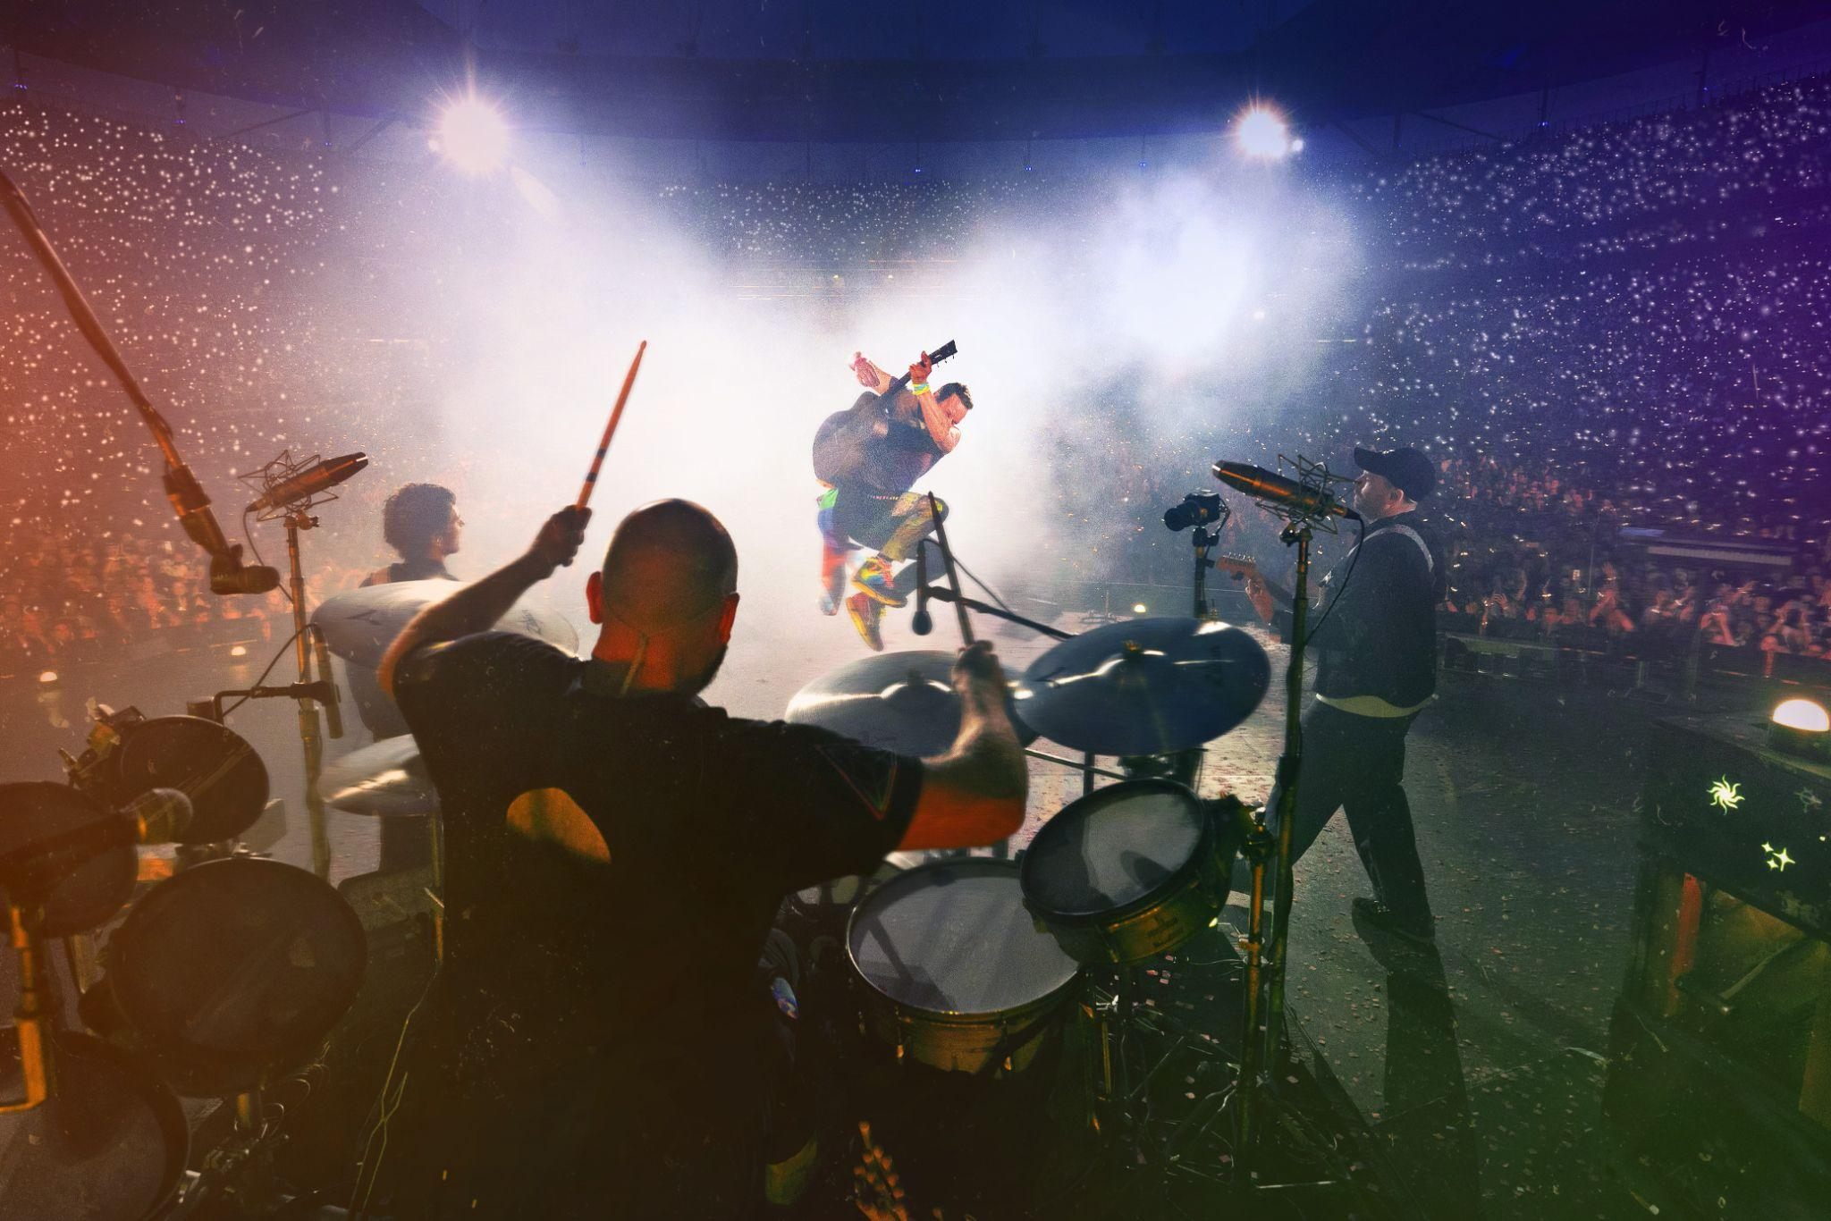
Download hi-res

_________

About Trafalgar Releasing
Trafalgar Releasing, the global leader in event cinema distribution, harnesses the power of cinema to bring fans together in more than 13,000 locations in 132 countries worldwide. A subsidiary of Trafalgar Entertainment, Trafalgar Releasing’s worldwide operations include production, acquisition, marketing, and distribution of live or pre-recorded content to cinemas led by an international team of specialists. Featuring live concerts, music documentaries, world-class opera, award-winning theatre, and more from the leading names in entertainment such as BTS, Metallica, Oasis, Coldplay, Billy Joel, George Michael, Twenty One Pilots, the Royal Opera House and more, Trafalgar Releasing has shattered event cinema box office records, most recently with the BTS Permission to Dance on Stage - Seoul: Live Viewing concert which grossed more than $32.6M at the global box office.

More information about Trafalgar Releasing can be found at www.trafalgar-releasing.com.

About CJ 4DPlex
CJ 4DPlex is a leading, next-generation cinema technology and content production company, headquartered in Seoul with international offices in Los Angeles and Beijing. The company has created immersive film technologies for theaters worldwide that include ‘4DX’, ‘ScreenX’, and ‘4DX Screen’, allowing consumers to experience films in ways that were never before possible.

