ENISA RETURNS WITH IN-STUDIO PERFORMANCE OF HER LATEST SINGLE “ZOOM”
“ZOOM” OFFICIAL VISUAL APPROACHING 1.5 MILLION VIEWS
WATCH/SHARE IN-STUDIO PERFORMANCE
WATCH/SHARE “ZOOM” VISUAL
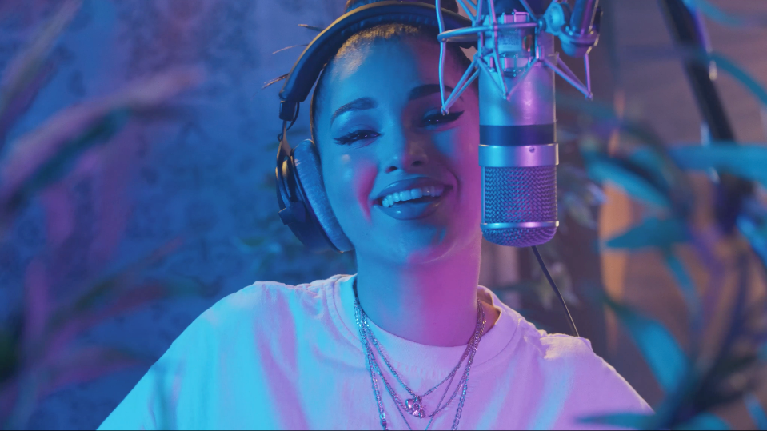

Brooklyn-based songstress Enisa has shared an in-studio performance of her latest single “Zoom.” The in-studio performance comes just on the heels of the release of the fun, upbeat visual that accompanied the single.

“The song is about the beginning stages of falling in love with someone, when everything feels wild, fast & exciting. I’m telling this person to give me the feeling of excitement so my heart could feel something that keeps me moving with him. I say, “make my heartbeat go make that sound like zoom, zoom, zoom.”

# # #

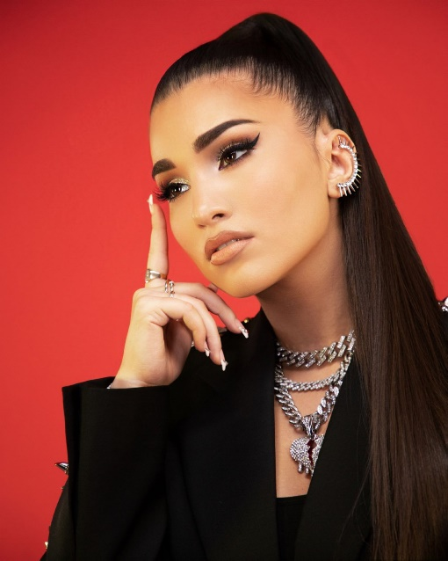

With over 41M worldwide streams and more than 1560M total video views, Enisa has proven a truly global favorite, earning chart-topping success in Nigeria, Gambia, Portugal, Algeria, Tunisia, Morocco, Sri Lanka, and India, to name a few. “Get That Money” marked the latest in a continuing series of increasingly popular releases from the First Lady of Highbridge The Label, following “Tears Hit The Ground” (2.7M views), “Love Cycle” (16M views), “Dumb Boy” (15M views), and the smash hit, “Count My Blessings” (51M views). Earlier this year, Enisa made her TV debut with her performance of her song “Green Light” on NBC’s American Song Contest.

Early 2022 saw the release of Enisa’s Fake Love EP, a body of work that Enisa describes as “empowering” and “authentic” which features the standout tracks “Tears Hit The Ground” and “One Thing,”. The new year also brought with it, Enisa’s television debut as a contestant on the NBC musical reality competition “American Song Contest” in which she represented her home state of New York. With so much in the works it’s clear that 2022 will be another blockbuster year for the Brooklyn-based songstress.

CONNECT WITH ENISA
OFFICIAL | INSTAGRAM | FACEBOOK | TWITTER | TIKTOK | YOUTUBE
PRESS CONTACT
SELAM BELAY | SELAM.BELAY@ATLANTICRECORDS.COM

