FOR IMMEDIATE RELEASE
SEPTEMBER 16, 2022

POP RENEGADE NOGA EREZ TEAMS UP WITH CULTURAL ICON MISSY ELLIOTT
FOR FIERY NEW VERSION OF “NAILS”

LISTEN TO “NAILS (FEAT. MISSY ELLIOTT)” HERE | WATCH OFFICIAL LYRIC VIDEO

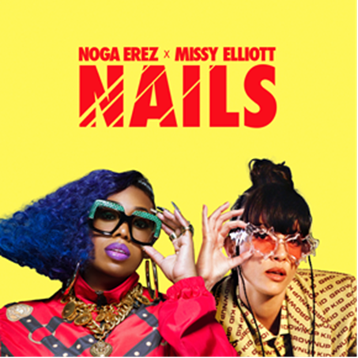
DOWNLOAD ARTWORK HERE

Pop renegade Noga Erez and partner ROUSSO have teamed up with one of the most significant artists in contemporary music history, Missy Elliott, who is featured on the newest version of Noga’s hit single “NAILS (feat. Missy Elliott)” – available now HERE. The official lyric video premieres today at YouTube HERE.

The track stays true to Noga’s trademark swagger, gritty lyrics, and slick production, with Missy bringing her avant-garde stardom and her innovative and inventive songwriting. As one of Noga’s key musical influences, the two blend their voices and unique sounds to create a fiery track.

“Missy Elliott was one of the first artists to pull me into the world of hip hop as a young teen,” shares Noga. “She’s since been a go-to inspiration for me and always symbolizes an artist who is true to herself, who goes far with her visions. I am shocked and humbled by this beautiful perspective that she added on NAILS, and it’s still beyond my ability to comprehend.”

“Julie Greenwald at Atlantic is the one who put me on to Noga Erez. I remember when Julie reached out to me about this new signing, who was a fan of mine, and hearing how hyped and excited she was about her. She shared Noga’s ‘End of the Road’ video with me and I was like ‘oh, I like this!’” Missy shares. ”Noga owns her own lane and has a quirky style like me, so when they sent me ‘Nails’ I hopped on it. I remember listening back to it and reflecting on how both of our styles meshed perfectly! I am always happy to work with talented new artists who aren’t afraid to be uniquely themselves. Noga Erez is definitely one to keep an eye on!”

An acclaimed live performer, Erez has sold out shows at legendary venues including LA’s El Rey and NY’s Bowery Ballroom. Erez is slated to play Madison Square Garden in New York City in support of Florence + The Machine on September 16 and September 17 as well as her headline show at Music Hall of Williamsburg on September 19. See all upcoming North American tour dates below. For all touring updates and details please visit: https://www.nogaerez.com/.

NOGA EREZ
NORTH AMERICA TOUR

SEPTEMBER
16 – New York, NY – Madison Square Garden
17 – New York, NY – Madison Square Garden
19 – Brooklyn, NY – Music Hall of Williamsburg
28 – Morrison, CO – Red Rocks Amphitheatre
29 – Morrison, CO – Red Rocks Amphitheatre

OCTOBER
1 – Dana Point, CA – Ohana Festival

DOWNLOAD PRESS PHOTO HERE // CREDIT: TIMO KERBER

ABOUT NOGA EREZ
Since the release of her debut album Off The Radar in 2017 via City Slang, the world has changed significantly for Noga Erez and her musical & life partner Ori Rousso. The Tel-Aviv based musician and producer gained critical acclaim for her first LP, so the hype around her second album was understandably high. Together, Erez and Rousso took their time to finalize the tracklist for what would become their second album, KIDS.

Whilst Off The Radar felt more politically charged, 2021’s KIDS was a natural evolution into more personal spheres. Through clever lyrics, slick production and commanding beats, Erez blazed an exhilarating musical trail through grief, inner violence, relationships and growth, acknowledging the internal and external factors that affect these elements. The record propelled her into the global spotlight, earning her a ‘Best Pop Album’ nomination from A2IM, nearly 20 million YouTube views and garnering a legion of famous fans in the process, including Billie Eilish, Finneas, Gal Gadot, Britney Spears, Marion Cotillard, Katy Perry & Hayley Williams.

From performing to a packed hometown crowd at the legendary Menora Arena in Tel Aviv, to selling out shows in Europe and the United States, as well as playing stages at festivals like Primavera, Austin City Limits, Outside Lands, Lollapalooza, Bonnaroo & Shaky Knees, Erez’s sound pulses with ambitious, authentic energy. Now, with two full length releases under her belt and newly signed to Neon Gold/Atlantic Records, she has cemented her status as a formidable voice in the world of alternative pop, one which stands head and shoulders above the rest.

ABOUT MISSY ELLIOTT
One of the most significant female artists in contemporary music history, Missy Elliott is an avant-garde solo superstar, pioneering songwriter-producer, and across-the-board cultural icon. The four-time GRAMMY® Award winner has attained unprecedented success, including 22 GRAMMY® nominations spanning three decades, eight MTV Video Music Awards, and sales now exceeding 30 million in the U.S. alone.

Elliott’s most recent work, 2019’s acclaimed EP, ICONOLOGY, drew instant applause upon its surprise release, with USA Today declaring it “a master class at the school of Missy Misdemeanor Elliott…The project brings back the Missy fans know and love, with booming bass beats that are the perfect backdrop to showcase her lyrical prowess.” The EP includes the hit singles “Throw It Back,” “DripDemeanor (Feat. Sum1),” and the aforementioned “Why I Still Love You,” all of which are joined by spectacular companion visuals streaming now via YouTube.

That same year saw the iconic Elliott making history as the first female rapper ever to receive the MTV Video Music Awards’ prestigious Michael Jackson Video Vanguard Award. 2019 also saw her break new ground as the first female hip-hop artist and third-ever rapper to be inducted into the Songwriters Hall of Fame. In addition, Elliott became the first female rapper to receive an honorary Doctor of Music degree from Berklee College of Music, celebrating her lasting contributions to music and popular culture. Further accolades followed in 2021, with Elliott named among the twelve inaugural inductees for the new Atlanta landmark, The Black Music & Entertainment Walk of Fame, and later honored with her own star on the world famous Hollywood Walk of Fame.

CONNECT WITH NOGA EREZ
OFFICIAL SITE | INSTAGRAM | TIKTOK | TWITTER | YOUTUBE

For press inquiries, please contact:
Kelly McWilliam / Kelly.McWilliam@atlanticrecords.com

