FOR IMMEDIATE RELEASE
AUGUST 31, 2022

INGRID ANDRESS PREMIERES “FEEL LIKE THIS” MUSIC VIDEO TODAY
(WATCH HERE)

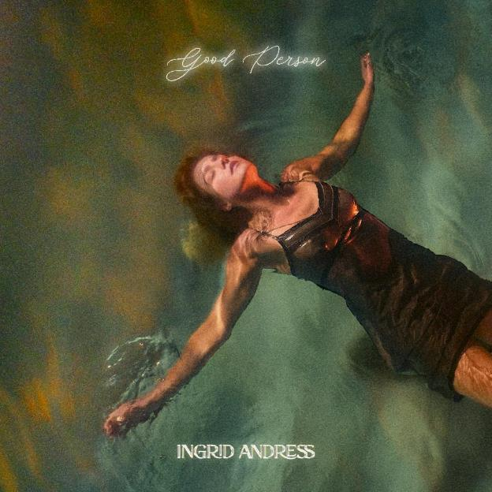
Download Images Here

CRITICAL PRAISE POURS IN FOR NEW ALBUM GOOD PERSON

“The immersive arrangements on [Good Person] are meant to set moods, and its narrative arc is meticulous‌.” - THE NEW YORK TIMES

“Good Person finds Andress turning her earthy-meets-ethereal voice to songs reckoning with life as it is and pondering how it could be.” - BILLBOARD

"Andress’ stunning new second album … journeys through her dark days and, gloriously, into the light.”
- PEOPLE

“A singer-songwriter who explodes commonplace emotions by using words simply and directly … [Good Person is] twelve songs worth of brave, honest material.” - TENNESSEAN

“Ingrid Andress, the Nashville-based singer songwriter who has a knack for balancing country music hallmarks with a sense of modernity and urgency, is back with her sophomore album, good person.”
- CONSEQUENCE OF SOUND

“Good Person makes for a rich and life-affirming listen.” - THE LINE OF BEST FIT

Celebrated singer/songwriter Ingrid Andress has released the cinematic music video for her optimistic “Feel Like This” (WATCH HERE), premiering across all MTV & CMT platforms this morning. Directed by Olivia Bee, the clip portrays the dichotomy between a toxic former flame and healthy new love. Highlighted as a New Release Spotlight on Facebook, V Magazine is also sharing an exclusive behind the scenes look from the video shoot, including multiple never before seen photos.

With its “knockout of an opening line” (Consequence of Sound), “Feel Like This” was co-written by Julia Michaels and made its TV debut recently on ABC’s Jimmy Kimmel Live! (WATCH HERE). “Getting to work with Julia Michaels for the first time and realizing that we are literally the same person was awesome,” she explained in a recent Variety interview profile (READ HERE). “It was actually a beautiful, magical day. We were both falling in love with people at the same time, and I feel like we really captured that.”

“Feel Like This” is one of thirteen brand new songs featured on the 3x GRAMMY-nominee’s latest release, Good Person, where Andress returns to the reflection and confession at the core of her acclaimed debut, Lady Like, and plumbs even deeper (LISTEN HERE). In the co-producer’s chair once again (alongside Sam Ellis, who played the same role on Lady Like), Andress pushed for bold, experimental sounds that blended banjos with vocoders; swung from sweeping orchestration to spare, acoustic-based arrangements; and showcased previously unexplored parts of her vocal range.

Hailed by The New York Times as “a Nashville outsider who paved her own way in” (READ HERE), Andress also co-wrote every track, including her current Gold-certified single, “Wishful Drinking (with Sam Hunt),” as well as the album’s title-track that she performed on The Tonight Show Starring Jimmy Fallon earlier this summer (WATCH HERE). Additional album standouts include the “stunning piano ballad” (Billboard) “Blue,” the genre-pushing power ballad, “Seeing Someone Else,” which explores the complexities and consequences that arise with self-growth and evolution and the explosive “Pain,” as seen on Late Night with Seth Meyers (WATCH HERE).

Good Person sees Andress entering the next chapter of her career following her record-breaking debut, Lady Like, named “one of the year’s strongest albums” by Associated Press and one of Billboard’s Top 10 Best Country Albums of 2020. The celebrated LP scored Andress three GRAMMY nominations including Best New Artist, Best Country Album and Best Country Song for the multi-platinum No. 1 radio single “More Hearts Than Mine.” She is also a 4x ACM Award, 3x CMA Award and 2x CMT Music Award nominee.

With nearly one billion global streams and fans spanning the globe, Andress is currently on the road now with Keith Urban for his 52-date North American “The Speed of Now World Tour.”

Good Person Track List:
1. Good Person
Written by: Ingrid Andress, Steph Jones, Sam Ellis
Produced by: Ingrid Andress & Sam Ellis

2. Yearbook
Written by: Ingrid Andress, Pete Good, Shane McAnally, Derrick Southerland
Produced by: Ingrid Andress & Sam Ellis

3. Seeing Someone Else
Written by: Ingrid Andress, Derrick Southerland, Jesse Frasure
Produced by: Ingrid Andress & Sam Ellis

4. Talk
Written by: Ingrid Andress, Alex Stacey, Tommy Gee, David Fremberg, Mich Hansen
Produced by: Ingrid Andress & Sam Ellis

5. How Honest Do You Want Me to Be?
Written by: Ingrid Andress, Sam Ellis, Derrick Southerland
Produced by: Ingrid Andress & Sam Ellis

6. No Choice
Written by: Ingrid Andress, AJ Pruis, Derrick Southerland
Produced by: Ingrid Andress & AJ Pruis

7. Pain
Written by: Ingrid Andress, Laura Veltz, Sam Ellis
Produced by: Ingrid Andress & Sam Ellis

8. Feel Like This
Written by: Ingrid Andress, Julia Michaels, Sam Ellis
Produced by: Ingrid Andress & Sam Ellis

9. Blue
Written by: Ingrid Andress, Sam Ellis, Derrick Southerland, Shane McAnally
Produced by: Ingrid Andress & Sam Ellis

10. Falling For You
Written by: Ingrid Andress, Derrick Southerland, Sam Ellis
Produced by: Ingrid Andress & Sam Ellis

11. All the Love
Written by: Ingrid Andress, Derrick Southerland, Sam Ellis
Produced by: Ingrid Andress & Sam Ellis

12. Things That Haven't Happened Yet
Written by: Ingrid Andress, Derrick Southerland, Sam Ellis
Produced by: Ingrid Andress & Sam Ellis

13. Wishful Drinking
Written by: Ingrid Andress, Jonny Price, JP Saxe, Lucky Daye, Rykeyz
Produced by: Ingrid Andress & Jordan M. Schmidt

###

CONNECT WITH INGRID ANDRESS:
FACEBOOK | TWITTER | INSTAGRAM | YOUTUBE

PRESS CONTACTS
Andrew George | Atlantic Records
Andrew.George@atlanticrecords.com

Mary Catherine Rebrovick | Warner Music Nashville
MaryCatherine@wmg.com

