FOR IMMEDIATE RELEASE
SEPTEMBER 15, 2022

corook shares playful music video for “it’s ok!”

comedic alt-pop artist set to join Jukebox the Ghost on tour this fall

watch the video for “it’s ok!” | listen to “it’s ok!”

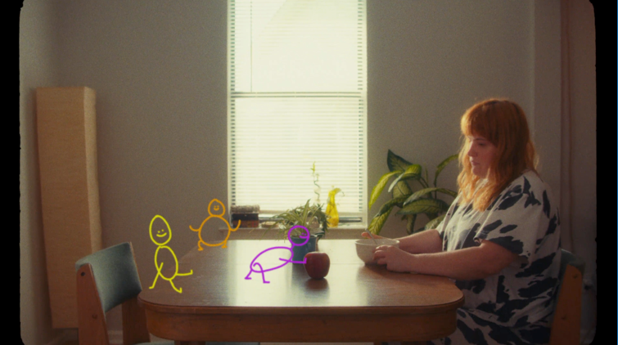

“corook is the next thing to bless your music downloads.” – PEOPLE

“If specificity is the soul of narrative, then corook is one of the most naturally gifted storytellers in the game.” – BILLBOARD

Self-described “singer, songwriter, producer, multi-instrumentalist, and huge f*ckin dork,” corook [pronounced ‘co-rook’], has shared the playful, animated music video for “it’s ok!,” her adult lullaby for when life is just too much – watch HERE. Prior to release, the track which now boasts 6.2M global streams, had already garnered an incredible response on TikTok, earning nearly 4K+ video creates in under a week including a duet with Alyssa Milano. Recently named one of The Advocate’s “7 Queer Artists For Your Fall Playlist,” corook has also shared a stripped back “bedroom demo” version of the song – listen HERE.

Later this month, corook will team up with NYC-based piano pop/rock trio Jukebox the Ghost for a fall tour, beginning September 28 at Philadelphia, PA’s Union Transfer, traveling through mid-October and including a stop at LA’s Echoplex on October 14. Earlier this year, the energetic live performer made her festival debut at Bonnaroo, where she was featured in Rolling Stone’s portrait gallery, hit the road for her first-ever North American live run alongside K.Flay, and opened for X Ambassadors at “A Night Benefitting Reproductive Rights” at The Troubadour. For all tour details and ticket information, please visit www.corook.com.

Tackling deeply personal themes in her music and visuals through a unique, quirky and humorous lens, the genre-busting,Nashville-based artist blessed the world this past spring with her debut achoo! EP. Comprised of surprising and insightful tracks including “idk god,” “degree,” “bad friend,” and “sims,” achoo! also includes the fan favorite, “snakes,” which was added to the EP following a series of well-received teases across social media and live performances on tour. Since the arrival of her EP, corook has shared her unrestrained single “BDSM” and the super-hot “hell yeah.”

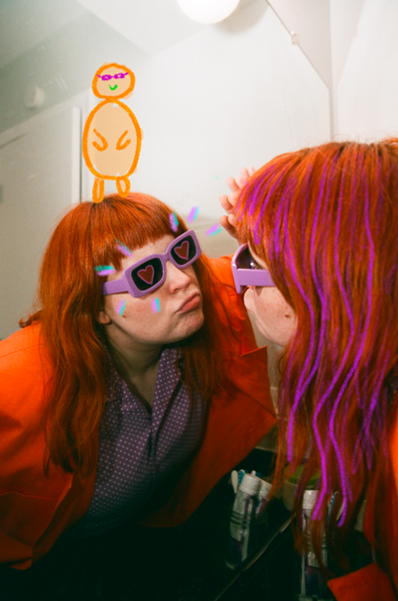
download hi-res press photo // photo credit: christina coleman

corook by corook
corook aka Corinne Savage (yes that’s her real last name) is a singer, songwriter, producer, multi-instrumentalist and a huge fuckin dork. No but seriously. She can solve a Rubix cube in under a minute (depending on how she’s feeling that day.) This ~freckled chubby babe~ was born and raised just outside of downtown Pittsburgh, Pennsylvania, where she grew up listening to Drake, Gwen Stefani and Mac Miller (RIP). She went to a performing arts high school (yes, just like Victorious) where she came out as QUEERAF her senior year. She then went to Berklee College of Music (wow – Owen Wilson voice) and graduated with TWO degrees (barely.) corook currently resides in Nashville, Tennessee (howdy.) She spends most of her time writing and producing music for her artist project “corook” (boop!) locked away in her room, alone (she blames it on Coronavirus but she’s actually just anti-social.) She’s 27 and VERY cute.

corook on tour

SEPTEMBER
28 – Philadelphia, PA – Union Transfer*
29 – Virginia Beach, VA – Elevation 27*
30 – Charlottesville, VA – Jefferson Theater*

OCTOBER
1 – Carrboro, NC – Cat’s Cradle*
2 – Atlanta, GA – The Loft*
3 – Nashville, TN – The Basement East*
5 – St Louis, MO – Off Broadway*
6 – Lawrence, KS – The Bottleneck*
7 – Oklahoma City, OK – Beer City Music Hall*
8 – Dallas, TX – Trees*
10 – Phoenix, AZ – Crescent Ballroom*
11 – San Diego, CA - Voodoo Room @ House of Blues San Diego*
13 – Pioneertown, CA – Pappy & Harriet’s Pioneertown Palace*
14 - Los Angeles, CA – Echoplex*
15 - San Francisco, CA – August Hall*
17 – Portland, OR – Wonder Ballroom*
18 – Seattle, WA – Neptune Theatre*

NOVEMBER
18 – Mexico City, Mexico – Corona Capital

*All Dates w/Jukebox the Ghost

connect with corook:
corook.com | instagram | tiktok | press assets

press contact:
andrew.george@atlanticrecords.com

