FOR IMMEDIATE RELEASE
SEPTEMBER 21, 2022

BLACK PUNK STAR RICO NASTY IS BACK WITH HER LATEST VISUAL FOR
“GOTSTA GET PAID”

SINGLE IS INCLUDED ON HER RECENTLY RELEASED MIXTAPE LAS RUINAS AVAILABLE NOW

CURRENTLY SUPPORTING KEHLANI ON NORTH AMERICAN LEG OF “BLUE ROAD TRIP” TOUR

STREAM/DOWNLOAD “GOTSTA GET PAID”

LAS RUINAS AVAILABLE NOW TO STREAM

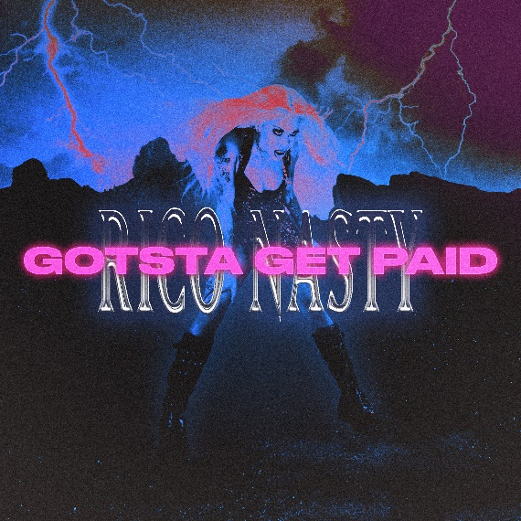
DOWNLOAD HI-RES ART

Today, certified rockstar, Rico Nasty, released her latest visual for “Gotsta Get Paid” available for streaming now. The beautifully chaotic visual, directed by Moshpxt, is consistent with the lively and theatrical releases the artist has been releasing all year. “Gotsta Get Paid” is also included on Rico’s recently released mixtape, Las Ruinas, and is a direct follow up to the project. Las Ruinas is available for streaming now on all DSPs.

Las Ruinas was ushered in by the single “Watch Your Man (Feat. Marshmello)” available for streaming now, along with several other boisterous singles including “Blow Me,” “Skullflower,” “Black Punk,” “Intrusive,” and “Vaderz (feat. Bktherula)” all available to stream now via YouTube. On this body of work, we see Rico taking full creative control creating a work of art that reflects her vulnerability and authenticity. She lets you know that when you release the noise around you, magic is made.

“Black Punk,” released earlier this year, is a masterclass in confidence and how to perfectly marry two opposing music genres while including a catchy hook that fans are sure to mosh to. “Intrusive,” the second single from the project, is an interesting take on and response to how life, social media, people’s opinions, or even your own thoughts can be a lot sometimes – very intrusive even. “Vaderz (Feat. Bktherula)” marked Rico’s first new song of 2022 and follows last year’s “Money (Feat. Flo Milli),” available now at all DSPs and streaming services. Produced by legendary German electronic dance music DJ/producer Boys Noize (Frank Ocean, Skrillex, Snoop Dogg), the track is joined by an official music video streaming now via YouTube HERE. “Money” – which sees Rico teaming with feisty Mobile, AL rapper Flo Milli – was met by ecstatic critical applause, with VIBE declaring, “Both ladies bring their bold attitudes to their verses declaring their desire for cash on their own terms.” “It’s got a big, bouncy beat with Miami bass 808s and chopped-up guitar riffs,” raved Stereogum. “On the hook, Rico adapts 2 Live Crew’s self-explanatory 1986 chant ‘We Want Some Pussy.’ On the verses, Rico and Flo Milli snarl hard and demand whatever’s in your pockets.”

The DMV’s Queen of all genres – who recently appeared alongside Avril Lavigne on the cover of Alternative Press’ “Modern Icons” issue – joined forces with Doja Cat at this this year’s Coachella Valley Music & Arts Festival for an instantly iconic live performance of their classic 2019 collaboration, "Tia Tamera.” A busy live schedule will continue in the coming weeks and months as continues performing dates on the North American leg of Kehlani’s “Blue Water Road” tour. For complete information, please visit www.riconastymusic.com.

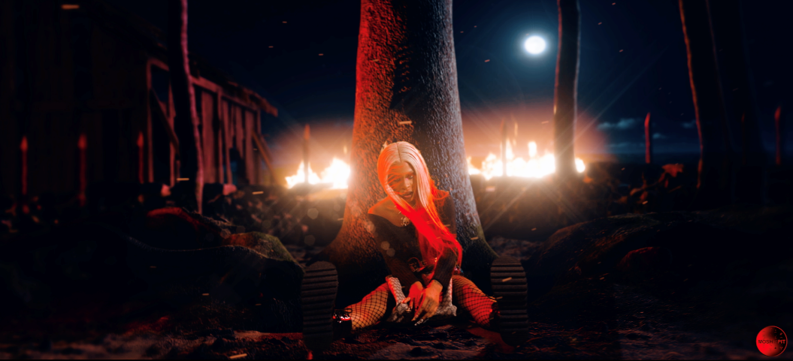

# # #

CONNECT WITH RICO NASTY:
WEBSITE | INSTAGRAM | TWITTER | FACEBOOK | YOUTUBE

FOR PRESS INQUIRIES, PLEASE CONTACT:
Ariana White | Ariana.White@atlanticrecords.com

