FOR IMMEDIATE RELEASE
SEPTEMBER 8, 2022

MUSTARD & SOUTHSIDE COLLAB FOR THE FIRST TIME FOR RODDY RICCH’S
NEW SINGLE “GHETTO SUPERSTAR (FEAT. G HERBO & DOE BOY)”

UPCOMING LIVE SCHEDULE INCLUDES TOP-BILLED APPEARANCE AT ROLLING LOUD TORONTO
AND SPECIAL GUEST RUN ON POST MALONE’S “TWELVE CARAT TOUR,”
BEGINNING SEPTEMBER 11 IN ST. PAUL, MN

LISTEN TO “GHETTO SUPERSTAR (FEAT. G HERBO & DOE BOY)” HERE

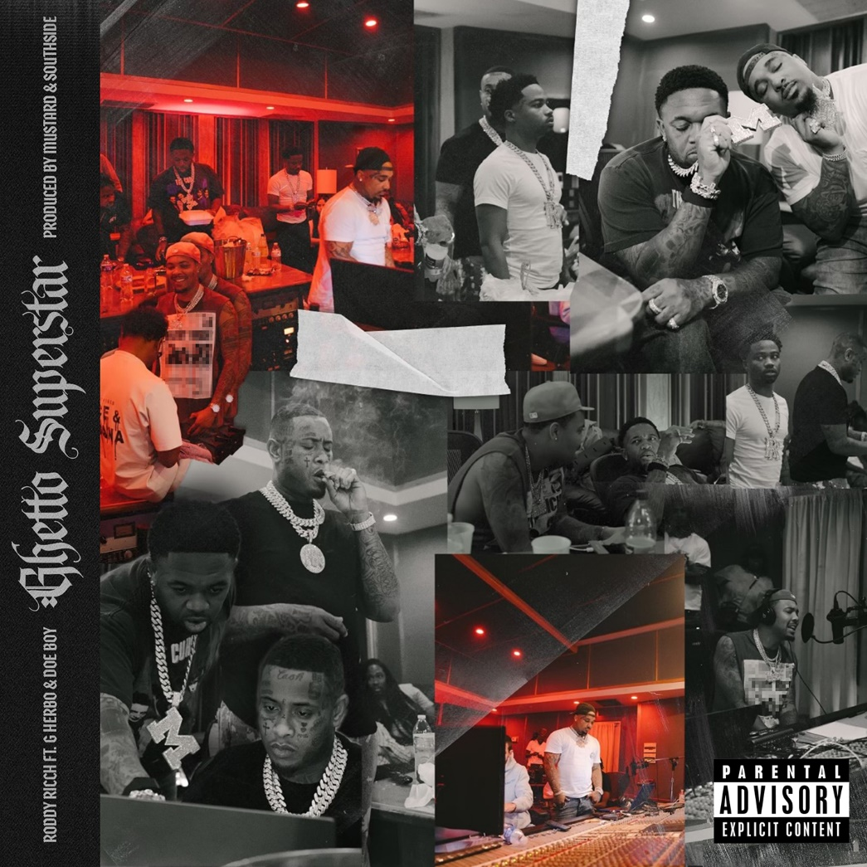
DOWNLOAD ARTWORK HERE |PHOTO CREDIT: OSCAR LOPEZ

Diamond certified, GRAMMY® Award-winning rap superstar Roddy Ricch has shared his brand new single, “Ghetto Superstar (Feat. G Herbo & Doe Boy),” available today via Bird Vision/Atlantic Records at all DSPs and streaming services HERE. The new single marks the first time Mustard and Southside have tag-teamed to produce a record.

“Ghetto Superstar” follows the release earlier this summer of Ricch’s acclaimed new EP, THE BIG 3, available now via Bird Vision/Atlantic Records at all DSPs and streaming services HERE. The three-song collection is highlighted by the smash summer single, “Real Talk,” available now for streaming and download HERE. The Mustard-produced track – which marked the GRAMMY® Award-winning (and 9x GRAMMY® Award-nominated) artist’s first new solo single since last year’s sophomore album, LIVE LIFE FAST – arrived alongside an official music video, directed by Colin Tilley and streaming now via YouTube HERE.

“Real Talk” was met by wide-ranging critical applause upon its arrival, with HotNewHipHop declaring Ricch to be “one of the best young songwriters in hip-hop right now.” “Hard-hitting,” raved REVOLT. “‘Real Talk’ is a celebratory affair that’s full of melodic rhymes about money, women, and the street life that the Compton star has ascended from post-fame.”

Ricch – who has spent much of his summer lighting up such events as Washington, DC’s Something In The Water, Manchester, TN’s Bonnaroo Music & Arts Festival, Concord, CA’s KMEL Summer Jam, and the annual HOT 97 Summer Jam at East Rutherford, NJ’s MetLife Stadium – will return to the road with a top-billed performance at the upcoming Rolling Loud Toronto, set for Saturday, September 10 at Toronto, ON’s Ontario Place. From there Ricch will join Post Malone as special guest on his eagerly awaited “Twelve Carat Tour,” kicking off September 11 at St. Paul, MN’s Xcel Energy Center and then making stops across North America more before wrapping up with a two-night stand at Los Angeles, CA’s Crypto.com Arena on November 15 and 16. The tour follows Ricch’s recent performance alongside Post Malone for their joint track, “Cooped Up,” on NBC’s Saturday Night Live (streaming HERE). The original version of “Cooped Up” – featured on Post Malone’s blockbuster new album, TWELVE CARAT HEARTACHE – is joined by an official music video, now boasting over 32M views via YouTube HERE.

In addition, Ricch recently teamed up with Ella Mai for “How (Feat. Roddy Ricch),” featured on her new album, HEART ON MY SLEEVE. The two artists celebrated their collaboration by uniting on the 2022 BET Awards for a very special live performance of “How,” streaming HERE.

LIVE LIFE FAST – which follows 2019’s 2x RIAA platinum, chart-topping debut album, PLEASE EXCUSE ME FOR BEING ANTISOCIAL, highlighted of course by the historic, 3x GRAMMY® Award-nominated, RIAA diamond certified #1 classic, “The Box” – arrived in December 2021 and made an explosive #1 debut on Billboard’s “Top R&B/Hip-Hop Albums” chart as well as at #4 on the overall Billboard 200. The album includes such smash singles as “Late At Night” and “25 million,” both joined by official music videos streaming now at YouTube.

RODDY RICCH
TOUR 2022

ALL DATES w/POST MALONE’s TWELVE CARAT TOUR EXCEPT *

SEPTEMBER
10 – Toronto, ON – Rolling Loud Toronto *
11 – St. Paul, MN – Xcel Energy Center
14 – Chicago, IL – United Center
15 – Milwaukee, WI – Fiserv Forum
17 – St. Louis, MO – Enterprise Center
18 – Columbus, OH – Nationwide Arena
30 – Auckland, NZ – Listen In *

OCTOBER
4 – Washington, DC – Capital One Arena
6 – Philadelphia, PA – Wells Fargo Center
7 – Newark, NJ – Prudential Center
9 – Belmont Park, NY – UBS Arena
12 – New York, NY – Madison Square Garden
13 – New York, NY – Madison Square Garden
15 – Columbia, SC – Colonial Life Arena
16 – Nashville, TN – Bridgestone Arena
18 – Atlanta, GA – State Farm Arena
21 – Dallas, TX – American Airlines Center
22 – Austin, TX – Moody Center
25 – Houston, TX – Toyota Center
26 – Ft. Worth, TX – Dickies Arena
28 – Tulsa, OK – BOK Center
30 – Denver, CO – Ball Arena

NOVEMBER
1 – Salt Lake City, UT – Vivint Arena
3 – Portland, OR – Moda Center
5 – Seattle, WA – Climate Pledge Arena
6 – Vancouver, BC – Rogers Arena
10 – Inglewood, CA – Kia Forum
11 – Las Vegas, NV – T-Mobile Arena
13 – Inglewood, CA – Kia Forum
15 – Los Angeles, CA – Crypto.com Arena
16 – Los Angeles, CA – Crypto.com Arena

# # #

CONNECT WITH RODDY RICCH
OFFICIAL | FACEBOOK | INSTAGRAM | TWITTER | YOUTUBE

PRESS CONTACT
Brittany Bell | Brittany.Bell@atlanticrecords.com

