FOR IMMEDIATE RELEASE
SEPTEMBER 29, 2022

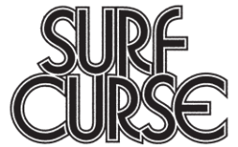

SURF CURSE UNVEIL NEW SINGLE “ARROW”

LATEST SINGLE OFF INDIE ROCK BAND’S HIGHLY ANTICIPATED ATLANTIC RECORDS DEBUT ALBUM MAGIC HOUR

WORLD TOUR KICKS OFF FOLLOWING ELECTRIC SET AT PRIMAVERA SOUND 2022 LOS ANGELES

NORTH AMERICAN HEADLINE RUN BEGINS OCTOBER 30 AT SOLD OUT LAS VEGAS SHOW
WITH HOMECOMING TOUR FINALE AT ICONIC HOLLYWOOD PALLADIUM IN LA ON DECEMBER 17

MAGIC HOUR DUE OUT OCTOBER 7 – PRE-SAVE/PRE-ORDER HERE

LISTEN TO “ARROW” HERE

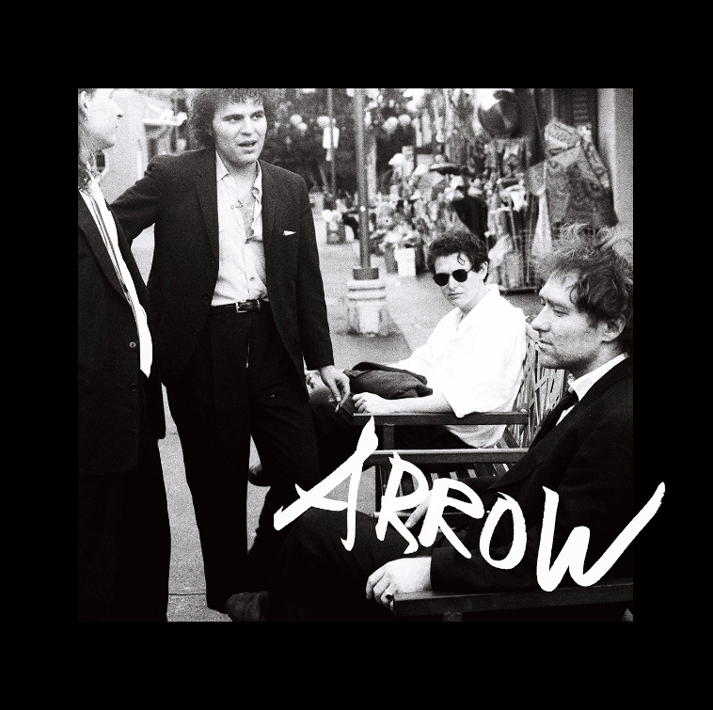
DOWNLOAD ARTWORK HERE

Los Angeles, CA-based, RIAA platinum certified rock band Surf Curse have shared the latest single off their forthcoming album MAGIC HOUR, “Arrow” available now via Atlantic Records at all DSPs and streaming services – LISTEN HERE.

Surf Curse’s fourth LP and Atlantic Records debut, MAGIC HOUR, is due out October 7 and includes most recent single “Self Portrait,” which released alongside an official music video directed by Nathan Castiel and Nick Rattigan – WATCH HERE. The highly anticipated album also includes electrifying singles “Self Portrait,” “Lost Honor,” “TVI,” and the power pop anthem, “Sugar,” all available now for streaming and download. Pre-saves/pre-orders – including digital download, CD, and deluxe CD packages - available now HERE.

Founded in Reno, NV by Nick Rattigan (lead vocals, drums) and Jacob Rubeck (guitar), Surf Curse have been crafting a multifaceted sound informed by indie, punk, pop, psych rock, and more for nearly a decade. 2020 saw the band’s breakthrough with the surprise TikTok success of “Freaks,” which earned over 500M worldwide streams and RIAA platinum certification more than eight years after its original release. Recorded at New York City’s iconic Electric Lady Studios, MAGIC HOUR now sees the band testing the boundaries of their seasoned indie rock approach, exploring a wide range of sonic styles and colors with founders Rattigan and Rubeck now joined by new members Noah Kohll (guitars) and Henry Dillon (bass). The newly expanded lineup allows Surf Curse to push their already ambitious songcraft even further than ever before, spanning the blistering album-opener, “Arrow,” to the somber rock of “No Tomorrows.”

“MAGIC HOUR is our excitement about rock music and being in a band,” says Jacob Rubeck. “This album is the excitement of starting something that we all can feel good about with each other, but also progressing as creative people and throwing in that magic. We’re feeling that magic, what’s brewing in the air and what’s existing in what we’re doing together.”

Surf Curse will celebrate MAGIC HOUR with an epic world headline tour, kicked off by a high energy performance at Primavera Sound 2022 Los Angeles. The band is now headed across the Atlantic for a major EU/UK tour, followed by a North American headline kicking off with a pair of special Halloween shows at Las Vegas, NV’s sold out AREA15 (October 30) and San Diego, CA’s SOMA (October 31) and then traveling through Reno, NV for a sold out show at The Holland Project and a hometown finale at Hollywood, CA’s famed Hollywood Palladium on December 17. Special guests throughout the North American tour include Toner, Grumpy, and others to be announced. For complete details and ticket information, please visit www.surfcurse.com/tour.

SURF CURSE TOUR 2022

SEPTEMBER
28 - London, UK - Electric Ballroom

OCTOBER
1 - Manchester, UK - New Century Hall
2 - Glasgow, UK - Warehouse SWG3 – SOLD OUT
4 - Dublin, Ireland - The Academy
6 - Birmingham, UK - The Castle and Falcon
7 - Brighton, UK - Chalk
8 - Bristol, UK - SWX
10 - Amsterdam, Netherlands - Paradiso
12 - Paris, France - Le Trabendo
13 - Bordeaux, France - Rock School Barbey
14 - Barcelona, Spain - Razzmatazz 2
15 - Madrid, Spain - Independance
17 - Zürich, Switzerland - Mascotte
19 - Berlin, Germany - Kesselhaus in der Kulturbrauerei
20 - Cologne, Germany - Gebäude9
30 - Las Vegas, NV – AREA15 – SOLD OUT
31 - San Diego, CA - SOMA

NOVEMBER
1 - Phoenix, AZ - The Van Buren
3 - Austin, TX - The Mohawk
4 - Austin, TX - The Mohawk
5 - Houston, TX - Warehouse Live
6 - Dallas, TX - The Studio at the Factory
8 - Denver, CO - Ogden Theatre
9 - Salt Lake City, UT - The Complex
11 - Spokane, WA - Knitting Factory Concert House
12 - Portland, OR - Crystal Ballroom
13 - Seattle, WA - Neptune Theatre
15 - Reno, NV - The Holland Project – SOLD OUT
16 - San Francisco, CA - The Warfield
18 - Mexico City, Mexico - Festival Corona Capital *
29 - Philadelphia, PA - Union Transfer
30 - New York, NY - Webster Hall

DECEMBER
3 - Montreal, QC - Club Soda
4 - Toronto, ON - Phoenix Concert Theatre
6 - Chicago, IL - The Vic Theatre
8 - Nashville, TN - The Basement East
9 - Nashville, TN - The Basement East
10 - Asheville, NC - The Orange Peel
12 - Washington, DC - Black Cat
13 - Washington, DC - Black Cat
17 - Hollywood, CA - Hollywood Palladium

* FESTIVAL PERFORMANCE

# # #

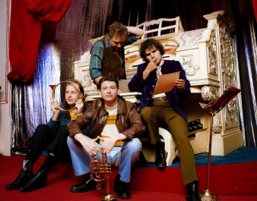
DOWNLOAD HI-RES IMAGE // PHOTO CREDIT: JULIEN SAGE

CONNECT WITH SURF CURSE
WEBSITE | FACEBOOK | INSTAGRAM | YOUTUBE | PRESS ASSETS

For press inquiries, please contact:
Jessica Nall // Jessica.Nall@atlanticrecords.com

