FOR IMMEDIATE RELEASE
SEPTEMBER 27, 2022

TEAMARRR SHARES OFFICIAL “WASTED” VISUAL
WATCH HERE

“WASTED” AVAILABLE VIA RAEDIO/ATLANTIC HERE

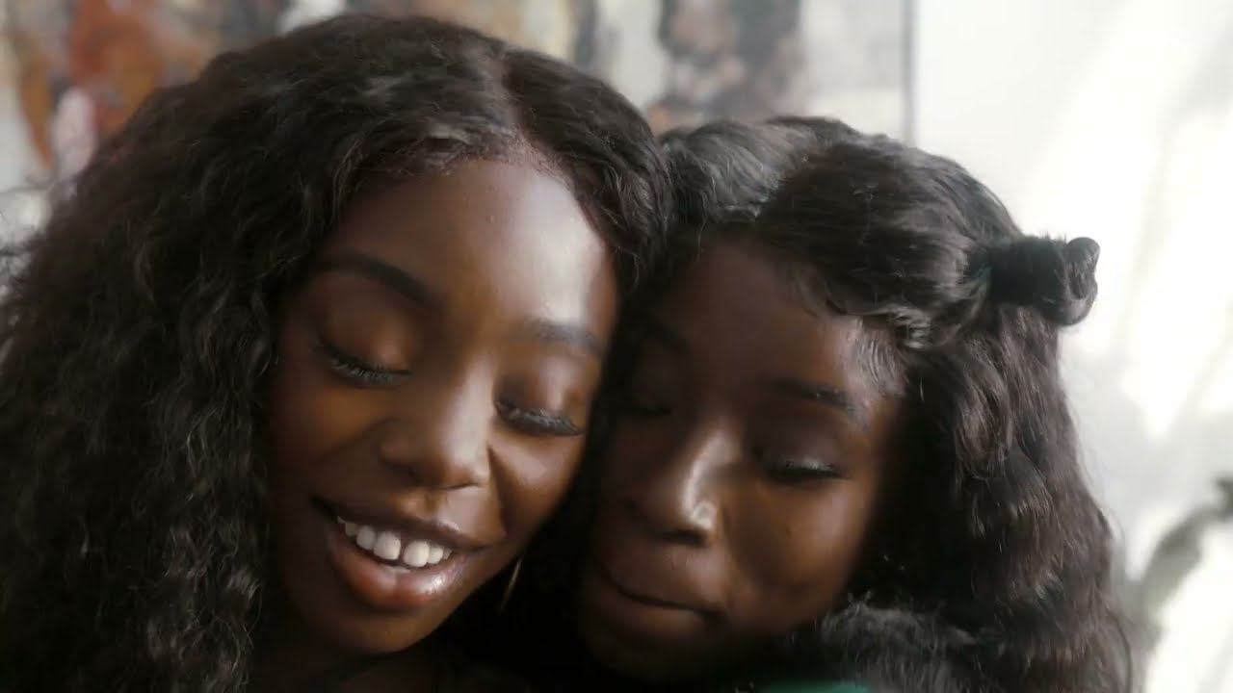

DOWNLOAD THUMBNAIL HERE | DOWNLOAD HIGH-RES PRESS PHOTOS HERE

RAEDIO/Atlantic R&B songstress TeaMarrr has shared an official video for her latest single, “Wasted.” TeaMarrr teams up with Jean Shepherd on the visual that takes us through her battle of want and needs as she fantasizes about the idealistic ways of her life. Watch HERE.

Earlier this month the singer teamed up with fellow labelmate NCognita for their single “F U Money” to be featured on the official soundtrack for Issa Rae’s new HBO comedy series, “Rap Sh!t”. Previously she sat down with Complex, declaring herself as “a musical pharmacist”. “Wasted” marked TeaMarrr’s first single since “Show Me Love (Feat. Meer Colon),” released last year joined by a cinematic and sensual visual directed by Isiah Butler and streaming now via YouTube HERE. Last summer TeaMarrr shared the sweeping and sexy “Specific (Feat. DUCKWORTH),” joined by an official lyric video streaming HERE.

In 2020, TeaMarrr unveiled the Before I Spill Myself EP, generating tens of millions of cumulative streams with tracks like “One Job,” and “Chasing Amy.” In addition, “Cool Enough,” a standout track from Before I Spill Myself, was first heard on the 4th season premiere of the award-winning HBO® series, INSECURE. TeaMarrr was also among the rising new stars showcased on RAEDIO/Atlantic’s INSECURE: Music From the HBO Original Series, Season 4 soundtrack, with her euphoric “Temperature” featured on the season’s fourth episode and joined by an official video, streaming HERE.

Back in 2016, TeaMarrr slipped through a crack in the culture of her own design and asserted herself as an outlier with no regard for the lines between pop, hip-hop, and R&B, quickly earning more than 4 million worldwide streams and high-profile media attention spanning Flaunt and NPR to Ones To Watch and Consequence of Sound. Following her 2017 independent debut, Thanks For The Chapstick, the Boston-born and Los Angeles-based Haitian-American songstress landed on the radar of Issa Rae who signed her to RAEDIO.

TeaMarrr – who has collaborated with a range of artists spanning Wale to DCKWRTH – has earned critical applause from the likes of Interview, which raved, “TeaMarrr is quickly becoming one of the most delightfully surprising voices in music.” Now, with a series of 2022 singles and more to come, TeaMarrr –the “musical pharmacist”, is ready to heal herself and the world, one song at a time.

CONNECT WITH TEAMARRR
INSTAGRAM | FACEBOOK | TWITTER | YOUTUBE

PRESS CONTACT
BRITTANY BELL | BRITTANY.BELL@ATLANTICRECORDS.COM

