BRISTON MARONEY RELEASES TWO-SIDED SINGLE – “OREGON” + “HARVARD” – OUT NOW
BUY/STREAM HERE

MARONEY’s CURATED 2-DAY ‘PARADISE FEST’ SET FOR
NOVEMBER 3 + 4 AT BROOKLYN BOWL NASHVILLE

LINEUP INCLUDES MARONEY, INDIGO DE SOUZA, MICHELLE, SUNFLOWER BEAN, THE GREETING COMMITTEE & MORE

TICKETS ON SALE HERE

“What’s better than a new single from Nashville singer, songwriter, and guitarist Briston Maroney? Well, a new single, music video, and music festival for starters…” – ONES TO WATCH

“…confessional, feel-good music that gets to the heart of being human…” – THE LINE OF BEST FIT

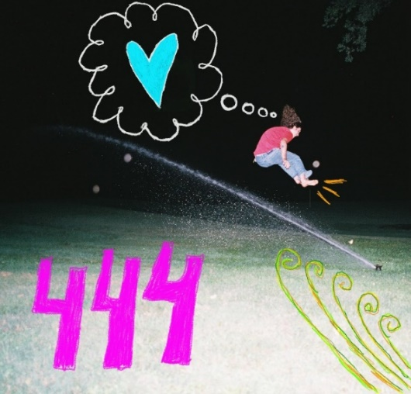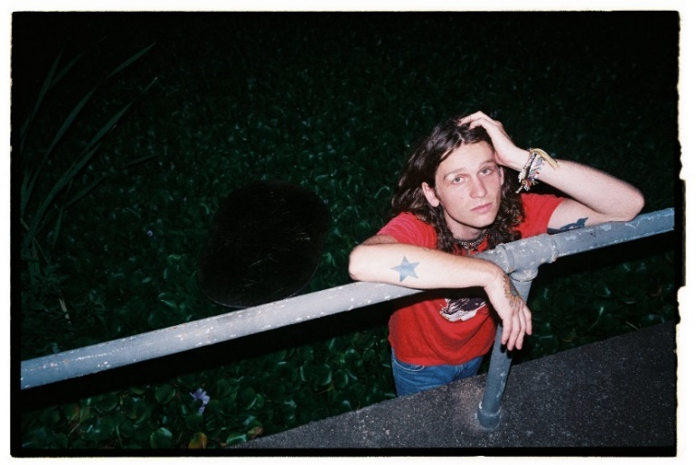
(download hi-res artwork + hi-res press photo; photo credit: Drew Bauml)

Today, Briston Maroney releases two singles – “Oregon” + “Harvard” – out now via Canvasback Music/Atlantic Records (buy/stream here).

Produced by Caleb Wright and Jake Luppen (of Hippo Campus), these A-sides find Maroney reaching back to songs he originally wrote nearly five years ago.

Of “Oregon,” Maroney shares:

“This is honestly an old song that I never thought would see the light of day, but I’m so stoked that it is in its fullest form! It was always in the back of my mind to record, and I’m so glad I waited to find someone like Jake Luppen to produce it. It’s overly earnest – the way that anything that’s written at 20 years old is – but having some perspective on the story and the general attitude of the song helped get it to a place that feels really special! ‘Oregon,’ more than anything, is about being young, and I love that it feels fresh and the opposite of jaded.”

Of “Harvard,” Maroney shares:

“I like to think of ‘Harvard’ as a letter to the feminine side of my identity, something I totally didn’t realize I was doing at the time that I wrote it. This is also an older track, one that I wrote on tour that literally came out without explanation in, like, 20 minutes before a show in Texas! We were sitting on Willie Nelson’s old tour bus, which was being used as the green room for the show we were playing. Sometimes, these lightning bolt songs don’t have an apparent meaning until far after they are written, and this song is no exception to that theory!”

Today’s release follows Maroney’s most recent single, “Paradise,” quickly hailed by Consequence of Sound as a “rousing pop-rock track [that] envisions a life free of mundanities… Maroney hollers on the shiny chorus,” and has been streamed over 2.5 million times since its mid-July release.

Last month, Maroney released a live acoustic video of “Paradise” (watch here), directed by frequent visual collaborator Joey Brodnax.

That video was filmed at Brooklyn Bowl Nashville – the site of Maroney’s upcoming Paradise Fest, set for November 3rd + 4th. The 2-day music festival was conceived and curated by Maroney, and will be presented in collaboration with local organizations, including radio station Lightning 100 and record store Grimey’s (tickets on sale here).

Maroney will headline both nights, sharing the stage with his hand-selected lineup of peers, including Indigo DeSouza, The Greeting Committee, Sunflower Bean, Annie DiRusso, Cece Coakley, and Canvasback labelmates MICHELLE. (Fans who purchase select VIP packages will have the opportunity to share a bowling lane with Maroney himself - learn more here).

First announced in July, the news was met with immediate anticipation from press and fans alike:

“’Paradise,’ the song, is a fitting sample of the type of fun fans can expect at the fest… the rousing pop-rock track envisions a life free of mundanities… Maroney hollers on the shiny chorus.” – CONSEQUENCE OF SOUND

“What’s better than a new single from Nashville singer, songwriter, and guitarist Briston Maroney? Well, a new single, music video, and music festival for starters… The new track arrives just in time for summer, racing forward with an unbridled sense of optimism, evoking the very essence of carpe diem… ‘Paradise’ feels like an apt reminder to live life to its fullest…” – ONES TO WATCH

“…one of the most exciting voices in alternative folk-rock… the festival looks to provide thoughtfully curated tunes and feel-good indie fun… it’s one to mark on the calendar for sure!” – NUANCE

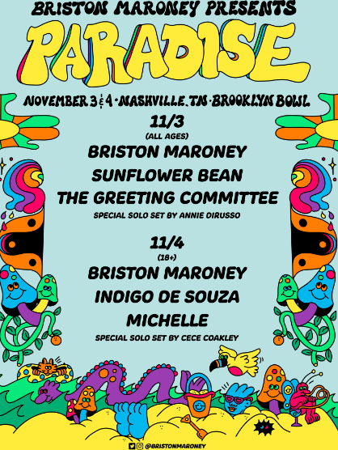
(download hi-res poster)

Maroney just wrapped his headline ‘All Aboard’ North American fall tour, which included stops in cities including Toronto, Atlanta, and Charleston, as well as appearances at Delaware’s Firefly Festival and Southern California’s Ohana Music Festival. Over the summer, he played standout sets to crowds at Bonnaroo and Outside Lands, shortly after serving as support on select dates of 2022 tours for both Jack White and Rainbow Kitten Surprise.

Earlier this year, Maroney released Sunflower: Deluxe, an extended version of his 2021 full-length debut Sunflower. That project included new tracks such as “The Kitchen” – heralded by V Magazine as “infectious” – and reworks of original album tracks including “Bottle Rocket,” featuring Manchester Orchestra, and “Cinnamon,” featuring alt-pop singer-songwriter Genevieve Stokes.

***

ABOUT BRISTON MARONEY:
After a childhood spent between Tennessee and Florida, 24-year-old recording artist Briston Maroney landed in Nashville and developed a style steeped in the sweat and scrappy sounds of the city's DIY house parties, winning over fans one living room at a time.

Maroney’s 2018 EP Carnival –his take on the modern coming-of-age story and debut for Canvasback Music/Atlantic Records – amassed millions of streams, is highlighted by RIAA-Gold certified track “Freakin' Out On The Interstate,” and opened the door to tours with Wallows and Liz Cooper. The following year saw the release of Indiana, lauded by such tracks as “Fool’s Gold” (later featured on fellow Nashvillian Taylor Swift’s hugely popular Apple Music “Playlist by ME!”). Indiana was met with wide-ranging critical acclaim, with PAPER praising the EP for its “mixture of absolute tension and mounting significance” and NPR applauding his “buoyant guitar-pop” and “taut, hooky romanticism.” Indiana was ultimately cited on a number of 2019 “Best Of” lists, including Consequence of Sound, Vulture, and PAPER. At the top of 2020, Maroney released his third EP Miracle, heralded by “Chattanooga” and “The Garden” which Consequence of Sound declared “refreshingly raw.”

Briston released his full-length debut Sunflower in 2021, which earned critical acclaim from Billboard, NME and more, had a sold out accompanying tour, and has amassed 40+ million streams. Earlier this year, Maroney released Sunflower: Deluxe, which includes “Bottle Rocket” featuring Manchester Orchestra, as well as a rework of album track “Cinnamon” featuring alt-pop singer-songwriter Genevieve Stokes.

An energetic live performer with a craft honed in basements, living rooms, and jam-packed clubs, Maroney’s live touring includes sold out headline shows around the world, dates alongside Cold War Kids, Jack White and Rainbow Kitten Surprise, and international festival performances spanning Austin City Limits Music Festival to Pitchfork Paris.

CONNECT WITH BRISTON MARONEY:
OFFICIAL I INSTAGRAM I YOUTUBE I FACEBOOK I TWITTER

FOR ALL PRESS INQUIRIES, PLEASE CONTACT:
Libby Kober (National) | Libby.Kober@AtlanticRecords.com
Gabby Reese (Tour/Online) | Gabrielle.Reese@AtlanticRecords.com

