BRISTON MARONEY RELEASES OFFICIAL MUSIC VIDEO FOR “OREGON” – WATCH HERE
NEW VISUAL ARRIVES FOLLOWING RELEASE OF TWO-SIDED SINGLE

LISTEN TO “OREGON” + “HARVARD” HERE

MARONEY’s CURATED 2-DAY ‘PARADISE FEST’ SET FOR NEXT MONTH
BUY TICKETS HERE: NOVEMBER 3 (LIMITED TICKETS) + 4 (SOLD OUT)

LINEUP INCLUDES MARONEY, INDIGO DE SOUZA, MICHELLE, SUNFLOWER BEAN, THE GREETING COMMITTEE & MORE

“What’s better than a new single from Nashville singer, songwriter, and guitarist Briston Maroney? Well, a new single, music video, and music festival for starters…” – ONES TO WATCH

“…confessional, feel-good music that gets to the heart of being human…” – THE LINE OF BEST FIT

“A storyteller at heart, Maroney makes his music personal. Each song paints a vivid image of a singular moment, either real or imagined. Poignant lyrics are wrapped up in unique alt musicianship.” – THE HARVARD CRIMSON

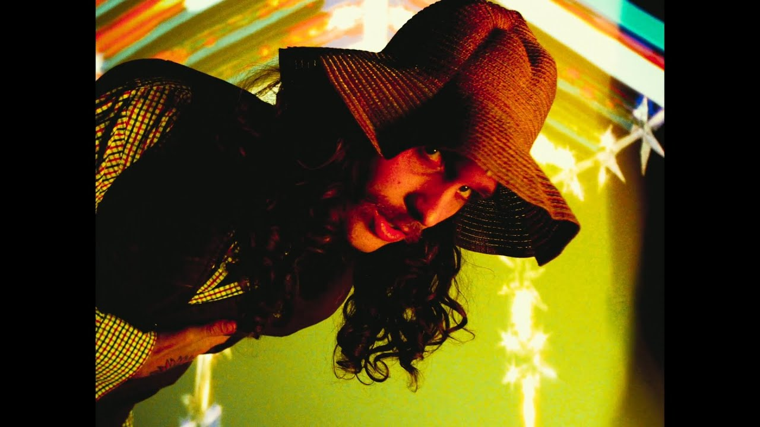

Today, Briston Maroney releases the official music video for his current single “Oregon” (watch here). Directed by longtime visual collaborator Joey Brodnax, the video perfectly complements the standout track, which was released as half of a two-sided single on October 14. Both tracks are out now via Canvasback Music/Atlantic Records (buy/stream here).

“Oregon,” as well as accompanying track “Harvard,” received praise upon release, including from Staged Haze, who hailed it as, “a love song straight out of a coming-of-age movie. Boastful and full of energy, but forlorn at the same time… a type of tempo that will give you strength and determination to live and love boldly while maybe bringing a few others along for the ride.”

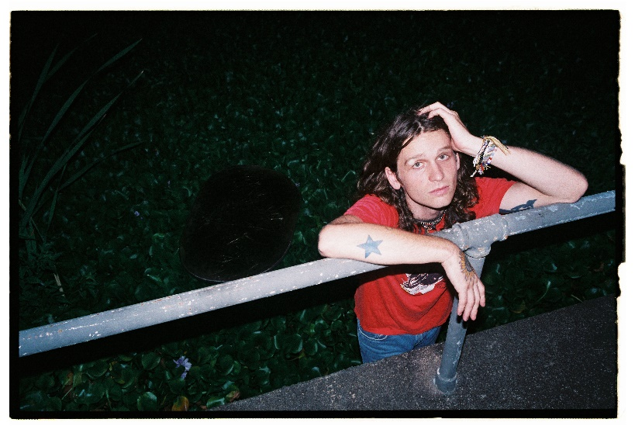
(download hi-res press photo; photo credit: Drew Bauml)

Last month, Maroney shared a live acoustic video of his previous single “Paradise” (watch here), a song that was quickly hailed by Consequence of Sound as a “rousing pop-rock track [that] envisions a life free of mundanities… Maroney hollers on the shiny chorus,” and has been streamed over 2.5 million times since its mid-July release.

Also directed by Joey Brodnax, that video was filmed at Brooklyn Bowl Nashville – the site of Maroney’s upcoming Paradise Fest, set for November 3rd + 4th. The 2-day music festival was conceived and curated by Maroney, and will be presented in collaboration with Nashville radio station Lightning 100 and record store Grimey’s, along with a portion of proceeds benefiting local nonprofits The Nashville Food Project and Oasis Center.

Friday night, November 4th has officially sold out, but remaining tickets for night one can be found on sale here.

Maroney will headline both nights, sharing the stage with his hand-selected lineup of peers, including Indigo DeSouza, The Greeting Committee, Sunflower Bean, Annie DiRusso, Cece Coakley, and Canvasback labelmates MICHELLE. (Fans who purchase select VIP packages will have the opportunity to share a bowling lane with Maroney himself - learn more here).

First announced in July, the news was met with immediate anticipation from press and fans alike:

“’Paradise,’ the song, is a fitting sample of the type of fun fans can expect at the fest… the rousing pop-rock track envisions a life free of mundanities… Maroney hollers on the shiny chorus.” – CONSEQUENCE OF SOUND

“What’s better than a new single from Nashville singer, songwriter, and guitarist Briston Maroney? Well, a new single, music video, and music festival for starters… The new track arrives just in time for summer, racing forward with an unbridled sense of optimism, evoking the very essence of carpe diem… ‘Paradise’ feels like an apt reminder to live life to its fullest…” – ONES TO WATCH

“…one of the most exciting voices in alternative folk-rock… the festival looks to provide thoughtfully curated tunes and feel-good indie fun… it’s one to mark on the calendar for sure!” – NUANCE

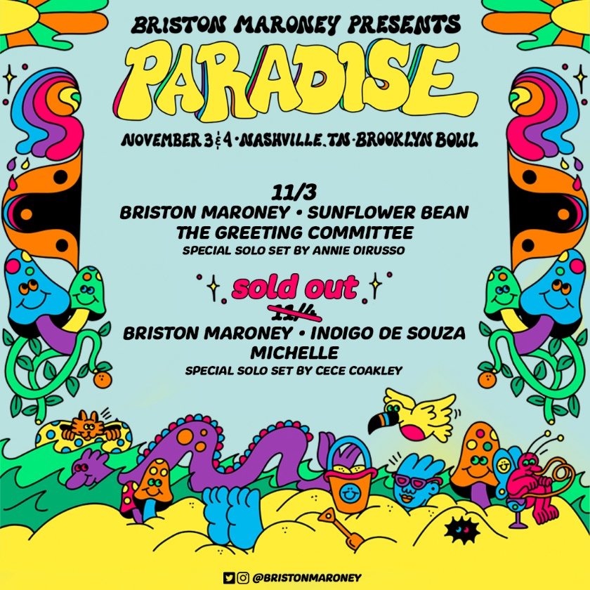
(download hi-res poster)

Maroney recently wrapped his headline ‘All Aboard’ North American fall tour, which included stops in cities including Toronto, Atlanta, and Charleston, as well as appearances at Delaware’s Firefly Festival and Southern California’s Ohana Music Festival. Over the summer, he played standout sets to crowds at Bonnaroo and Outside Lands, shortly after serving as support on select dates of 2022 tours for both Jack White and Rainbow Kitten Surprise.

Earlier this year, Maroney released Sunflower: Deluxe, an extended version of his 2021 full-length debut Sunflower. That project included new tracks such as “The Kitchen” – heralded by V Magazine as “infectious” – and reworks of original album tracks including “Bottle Rocket,” featuring Manchester Orchestra, and “Cinnamon,” featuring alt-pop singer-songwriter Genevieve Stokes.

***

ABOUT BRISTON MARONEY:
After a childhood spent between Tennessee and Florida, 24-year-old recording artist Briston Maroney landed in Nashville and developed a style steeped in the sweat and scrappy sounds of the city's DIY house parties, winning over fans one living room at a time.

Maroney’s 2018 EP Carnival –his take on the modern coming-of-age story and debut for Canvasback Music/Atlantic Records – amassed millions of streams, is highlighted by RIAA-Gold certified track “Freakin' Out On The Interstate,” and opened the door to tours with Wallows and Liz Cooper. The following year saw the release of Indiana, lauded by such tracks as “Fool’s Gold” (later featured on fellow Nashvillian Taylor Swift’s hugely popular Apple Music “Playlist by ME!”). Indiana was met with wide-ranging critical acclaim, with PAPER praising the EP for its “mixture of absolute tension and mounting significance” and NPR applauding his “buoyant guitar-pop” and “taut, hooky romanticism.” Indiana was ultimately cited on a number of 2019 “Best Of” lists, including Consequence of Sound, Vulture, and PAPER. At the top of 2020, Maroney released his third EP Miracle, heralded by “Chattanooga” and “The Garden” which Consequence of Sound declared “refreshingly raw.”

Briston released his full-length debut Sunflower in 2021, which earned critical acclaim from Billboard, NME and more, had a sold out accompanying tour, and has amassed 40+ million streams. Earlier this year, Maroney released Sunflower: Deluxe, which includes “Bottle Rocket” featuring Manchester Orchestra, as well as a rework of album track “Cinnamon” featuring alt-pop singer-songwriter Genevieve Stokes.

An energetic live performer with a craft honed in basements, living rooms, and jam-packed clubs, Maroney’s live touring includes sold out headline shows around the world, dates alongside Cold War Kids, Jack White and Rainbow Kitten Surprise, and international festival performances spanning Austin City Limits Music Festival to Pitchfork Paris.

CONNECT WITH BRISTON MARONEY:
OFFICIAL I INSTAGRAM I YOUTUBE I FACEBOOK I TWITTER

FOR ALL PRESS INQUIRIES, PLEASE CONTACT:
Libby Kober (National) | Libby.Kober@AtlanticRecords.com
Gabby Reese (Tour/Online) | Gabrielle.Reese@AtlanticRecords.com

