BRISTON MARONEY RELEASES LIVE ACOUSTIC VIDEO FOR CURRENT SINGLE “PARADISE”
WATCH HERE

PERFORMANCE VISUAL FILMED AT BROOKLYN BOWL NASHVILLE – SITE OF MARONEY’S UPCOMING, SELF-CONCEIVED & CURATED 2-DAY MUSIC FESTIVAL SET FOR NOVEMBER 3 + 4
TICKETS ON SALE HERE

LINEUP INCLUDES MARONEY, INDIGO DE SOUZA, MICHELLE, SUNFLOWER BEAN, THE GREETING COMMITTEE & MORE

MARONEY CURRENTLY IN THE MIDST OF U.S. HEADLINE ‘ALL ABOARD’ TOUR

BUY/STREAM “PARADISE” HERE
TICKETS FOR ‘ALL ABOARD’ TOUR HERE

“…infectious…” – V MAGAZINE

“…confessional, feel-good music that gets to the heart of being human…” – THE LINE OF BEST FIT

“’Paradise,’ the song, is a fitting sample of the type of fun fans can expect at the fest… the rousing pop-rock track envisions a life free of mundanities… Maroney hollers on the shiny chorus.” – CONSEQUENCE OF SOUND

“What’s better than a new single from Nashville singer, songwriter, and guitarist Briston Maroney? Well, a new single, music video, and music festival for starters… The new track arrives just in time for summer, racing forward with an unbridled sense of optimism, evoking the very essence of carpe diem… ‘Paradise’ feels like an apt reminder to live life to its fullest…” – ONES TO WATCH

“…one of the most exciting voices in alternative folk-rock… the festival looks to provide thoughtfully curated tunes and feel-good indie fun… it’s one to mark on the calendar for sure!” – NUANCE

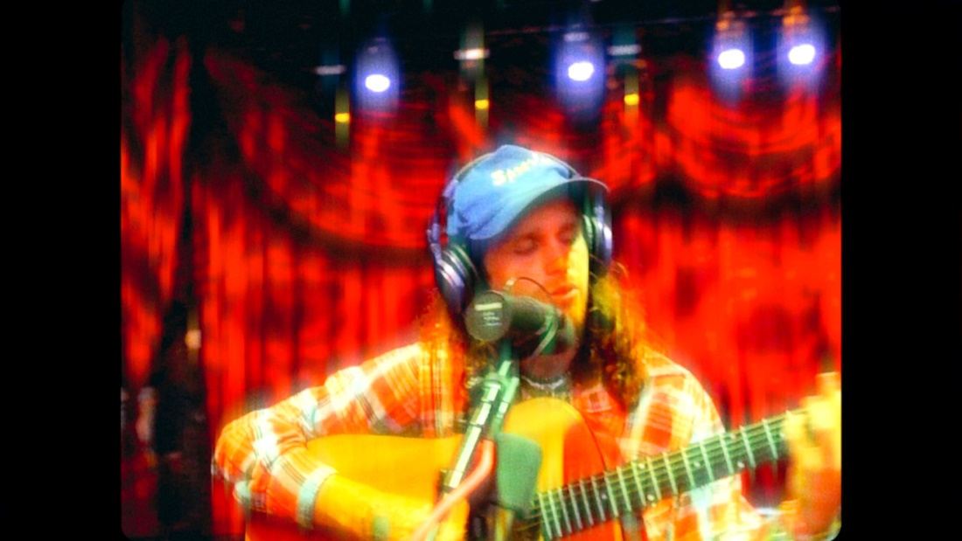

Today, rising indie rock singer-songwriter Briston Maroney has released a live acoustic video of current single “Paradise” (watch here). Directed by frequent collaborator Joey Brodnax, the video was filmed at Brooklyn Bowl Nashville – the site of Maroney’s upcoming 2-night Paradise Festival, set for November 3rd + 4th. First announced in July, the festival was conceived and curated by Maroney himself, and will be presented in collaboration with local organizations; he will also headline both nights of the weekend (tickets on sale here).

Raised between Knoxville and Florida, and now currently based in Nashville, TN, Maroney has helped to cultivate the city’s young and vibrant alternative/indie music scene. Fans and friends who began singing along to his early songs at house shows can look forward to the unique and celebratory homecoming his headline sets at Paradise Festival will be.

Maroney will share the stage with his hand-selected lineup of peers, including Indigo DeSouza, The Greeting Committee, Sunflower Bean, Annie DiRusso, Cece Coakley, and Canvasback labelmates MICHELLE. As previewed in today’s “Paradise” video, both nights will feature a photo booth, carnival games, and specialty drinks, while VIP tickets will even grant fans the opportunity to bowl with the band.

“Paradise”– out now via Canvasback Music/Atlantic Records (buy/stream the single here) – arrived to significant critical acclaim in July, with V Magazine declaring, “The song starts with a bang, a joyful explosion of drums and guitars, and never slows down” and Consequence of Sound proclaiming, “the rousing pop-rock track envisions a life free of mundanities… Maroney hollers on the shiny chorus.”

Written by Maroney and produced by Andrew Sarlo (Big Thief, Bon Iver, Dijon), with additional production by Julian Cruz (Dominic Fike, Kenny Mason, Ambar Lucid), the song has been streamed over 1.8 million times so far.

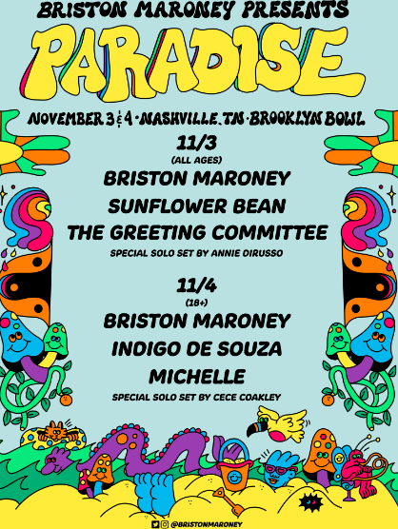
(download hi-res poster here)

Maroney is currently in the midst of his headline ‘All Aboard’ US fall tour, which includes upcoming stops in Pittsburgh and Toronto and appearances at Delaware’s Firefly Festival on September 22nd and Southern California’s Ohana Music Festival on October 2nd.

Earlier this summer, he played standout sets to crowds at Bonnaroo and Outside Lands, shortly after serving as support on select dates of 2022 tours for both Jack White and Rainbow Kitten Surprise.

“Paradise” follows Sunflower: Deluxe, an extended version of Maroney’s 2021 full-length debut Sunflower. That project included new tracks such as “The Kitchen” – heralded by V Magazine as “infectious” – and reworks of original album tracks including “Bottle Rocket,” featuring Manchester Orchestra, and “Cinnamon,” featuring alt-pop singer-songwriter Genevieve Stokes.

UPCOMING LIVE DATES
9/14/22 – Charlottesville, VA – Jefferson Theater #
9/16/22 – Columbus, OH – Newport Music Hall #
9/17/22 – Pittsburgh, PA – Roxian Theatre #
9/19/22 – Grand Rapids, MI – Elevation at The Intersection #
9/20/22 – Toronto, ON – Phoenix Concert Theatre #
9/22/22 – Dover, DE – Firefly Festival
9/23/22 – Morgantown, WV – Metropolitan Theatre #
9/24/22 – Louisville, KY – Headliners Music Hall #
10/2/22 – Dana Point, CA – Ohana Music Festival 2022
11/3/22 – Nashville, TN – Paradise Festival @ Brooklyn Bowl Nashville
11/4/22 – Nashville, TN – Paradise Festival @ Brooklyn Bowl Nashville

# with Special Guest Medium Build

***

ABOUT BRISTON MARONEY:
After a childhood spent between Tennessee and Florida, 24-year-old recording artist Briston Maroney landed in Nashville and developed a style steeped in the sweat and scrappy sounds of the city's DIY house parties, winning over fans one living room at a time.

Maroney’s 2018 EP Carnival –his take on the modern coming-of-age story and debut for Canvasback Music/Atlantic Records – amassed millions of streams, is highlighted by RIAA-Gold certified track “Freakin' Out On The Interstate,” and opened the door to tours with Wallows and Liz Cooper. The following year saw the release of Indiana, lauded by such tracks as “Fool’s Gold” (later featured on fellow Nashvillian Taylor Swift’s hugely popular Apple Music “Playlist by ME!”). Indiana was met with wide-ranging critical acclaim, with PAPER praising the EP for its “mixture of absolute tension and mounting significance” and NPR applauding his “buoyant guitar-pop” and “taut, hooky romanticism.” Indiana was ultimately cited on a number of 2019 “Best Of” lists, including Consequence of Sound, Vulture, and PAPER. At the top of 2020, Maroney released his third EP Miracle, heralded by “Chattanooga” and “The Garden” which Consequence of Sound declared “refreshingly raw.”

Briston released his full-length debut Sunflower in 2021, which earned critical acclaim from Billboard, NME and more, had a sold out accompanying tour, and has amassed 40+ million streams. Earlier this year, Maroney released Sunflower: Deluxe, which includes “Bottle Rocket” featuring Manchester Orchestra, as well as a rework of album track “Cinnamon” featuring alt-pop singer-songwriter Genevieve Stokes.

An energetic live performer with a craft honed in basements, living rooms, and jam-packed clubs, Maroney’s live touring includes sold out headline shows around the world, dates alongside Cold War Kids, Jack White and Rainbow Kitten Surprise, and international festival performances spanning Austin City Limits Music Festival to Pitchfork Paris.

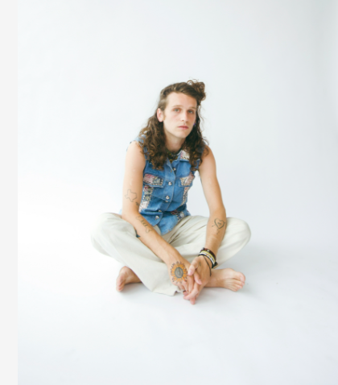
(download hi-res press photo here; credit: Danica Robinson)

CONNECT WITH BRISTON MARONEY:
OFFICIAL I INSTAGRAM I YOUTUBE I FACEBOOK I TWITTER

FOR ALL PRESS INQUIRIES, PLEASE CONTACT:
Libby Kober (National) | Libby.Kober@AtlanticRecords.com
Gabby Reese (Tour/Online) | gabrielle.reese@AtlanticRecords.com

