FOR IMMEDIATE RELEASE
OCTOBER 5, 2022

Galantis celebrate 8th anniversary of “Runaway (U & I)” with Subtronics Remix

2x-Platinum & Grammy-nominated single boasts over 1.5 billion global streams

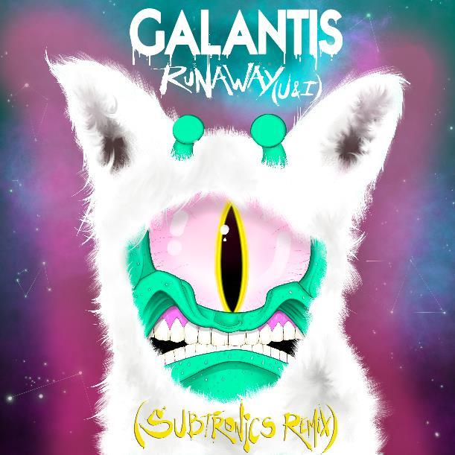
Artwork credit: Aaron Brooks
DOWNLOAD HIGH-RES IMAGES/ARTWORK

Internationally-acclaimed collaborative project Galantis celebrate the 8th anniversary of single “Runaway (U & I)” today with an explosive remix by Subtronics – available now via Big Beat Records. The 2x-Platinum and GRAMMY-nominated track has proven a worldwide smash since release in 2014 as the second single from Galantis’ debut album Pharmacy, boasting over 1.5 billion global streams to date.

Subtronics began incorporating the epic, energetic remix of “Runaway (U & I)” into their set in late 2021 and it quickly became a fan favorite to vast crowds across the globe. Alongside the epic drop, is a vibrant single artwork designed by Aaron Brooks, head of Subtronics’ illustrations.

The past year has seen a series of massive genre-bending releases for Galantis, most recently including “1x1,” “DNA” with Craig David, “What It Feels Like” with Navos & You, “Good Luck” with Mabel & Jax Jones, “Run” with Becky Hill, “Sweet Talker” with Years & Years and a remix of Coldplay & BTS’ #1 single “My Universe.”
***

ABOUT GALANTIS:
Setting a new standard for songwriting in dance music, Galantis is a collaborative project led by Christian Karlsson (aka Bloodshy, one-third of Miike Snow). Galantis' debut album Pharmacy reached No. 1 on the Billboard Dance album chart on the strength of RIAA gold certified single “Peanut Butter Jelly” and 2x platinum certified smash “Runaway (U & I)” – the latter of which earned GRAMMY nominations for “Best Dance Recording” and “Best Remixed Recording” – while 2017’s sophomore album The Aviary (featuring platinum certified single “No Money”) saw a top 10 debut in 23 countries. The third Galantis album, 2020’s Church, featured the chart-topping single “Faith” with country music icon Dolly Parton featuring Mr. Probz, which saw a #1 debut on Billboard’s Dance/Electronic Chart before quickly reaching #1 on the Dance/Mix Show Airplay Chart where it remained for 5 weeks. Meanwhile, 2021’s collaborative single “Heartbreak Anthem” with David Guetta & Little Mix proved a global sensation, spending 10 weeks on the Billboard Global 200 chart and reaching #1 on the overall UK Radio chart. Galantis has received over 4 billion cumulative worldwide streams, and over 1.7 billion video views to date.

The story of Galantis started back in 2009. Working as Bloodshy, Karlsson’s songwriting collaborations have included Madonna, Kylie Minogue, Katy Perry and Britney Spears (whose “Toxic” earned a GRAMMY for “Best Dance Recording”). This collaborative nature led to the birth of the Galantis project which had its live debut at 2014’s Coachella Valley Music and Arts Festival and has continued on years later as one of dance music's most dynamic and in-demand live performers.

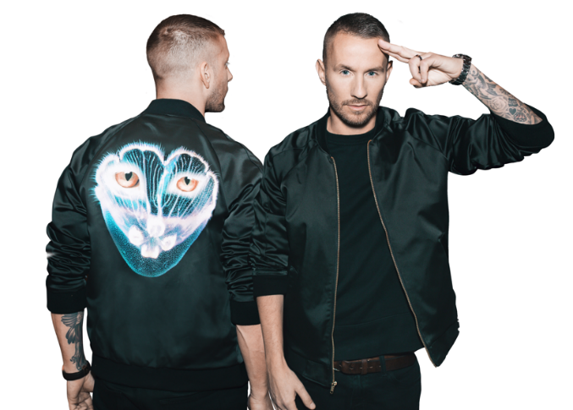
DOWNLOAD HIGH-RES IMAGES/ARTWORK

CONNECT WITH GALANTIS:
WeAreGalantis.com | Twitter | Facebook | YouTube | Instagram

CONTACT:
Ted Sullivan (Atlantic Records) | Ted.Sullivan@atlanticrecords.com

