FOR IMMEDIATE RELEASE

OCTOBER 6, 2022

**JAYSON CASH ROCKS BET HIP HOP AWARDS CYPHER**

**WITH SHOW-STEALING FREESTYLE PERFORMANCE**

**CARSON, CA RAPPER SHOWCASES SKILLS ON SERIES OF FREESTYLE FRIDAYS**

**FREESTYLE FRIDAY CONTENT STREAMING NOW –** [**WATCH**](https://www.youtube.com/channel/UCEWnd3btemXhmp_EwEOdcYA/videos)

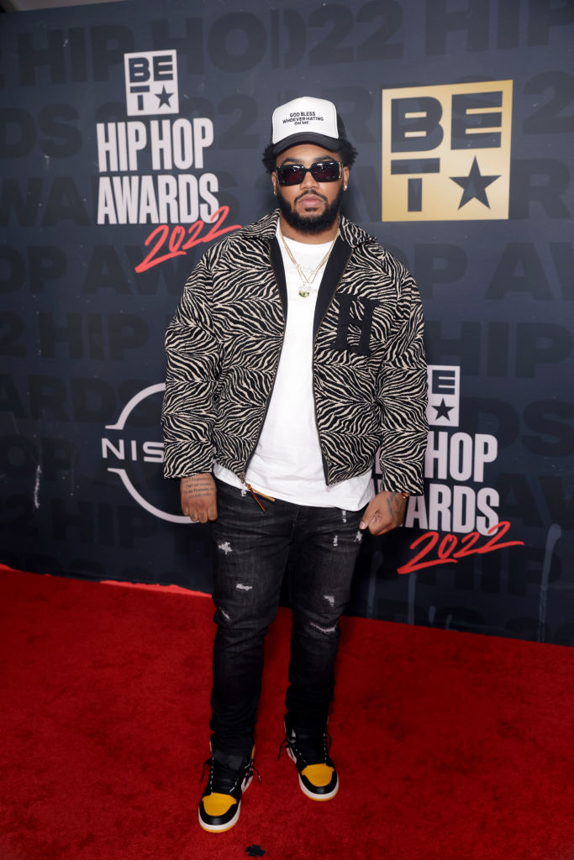

*Photo Credit: Getty Images | Terence Rushin*

**Los Angeles, CA** - Carson, CA-based rapper **Jayson Cash** lit up last night’s BET Hip Hop Awards in Atlanta, GA with show-stealing freestyle during the award ceremonies’ annual cypher. Highlights from the cypher – featuring Reuben Vincent, Sa-Roc, Guapdad 4000, Big Boss Vette and fellow Carson, CA native, DJ HED spinning for all the cypher moments throughout the show – are streaming now [HERE](https://www.youtube.com/watch?v=u7L_gITGmzA).

Cash took to his socials shortly after the release of his label debut mixtape, [***Read The Room***](https://jaysoncash.lnk.to/ReadTheRoom), to kick off his own version of *Freestyle Fridays*, dropping 14 freestyles on Instagram backed by a wide range of classic beats – all streaming now on YouTube [HERE](https://www.youtube.com/channel/UCEWnd3btemXhmp_EwEOdcYA/videos). Check out each freestyle below.

[**Week 1**](https://youtu.be/yyw1I9Me-b0)**:** Kendrick Lamar – “Savior”

[**Week 2**](https://youtu.be/Rd_1eiMd9pI)**:** The Notorious BIG – “Mo Money Problems”

[**Week 3**](https://youtu.be/fvR7WjKrbpo)**:** EST GEE – “5500 Degrees”

[**Week 4**](https://youtu.be/QSDA-ZpKiAE)**:** YG – “Run”

[**Week 5**](https://youtu.be/_t55ticT7IU)**:** Mobb Deep – “Shook Ones”

[**Week 6**](https://youtu.be/7xnmzDX0uls)**:** Baby Face Ray – “Sincerely Face”

[**Week 7**](https://youtu.be/jdJkGpAUM-A)**:** Drego & Beno / Sada Baby – “Bloxk Party”

[**Week 8**](https://youtu.be/B8OnhTAjc_k)**:** Bobby Valentino – “Tell Me”

[**Week 9**](https://youtu.be/7mwlUsYalOY)**:** The Game – “Violence”

[**Week 10**](https://youtu.be/l86aZ7ZYstQ)**:** Peezy – “2 Million Up”

[**Week 11**](https://youtu.be/tkgMO0ZShoI)**:** King Combs – “Can’t Stop Won’t Stop”

[**Week 12**](https://youtu.be/9BmNLyfBOsk)**:** YG – “Toxic”

[**Week 13**](https://youtu.be/WZmiVINEsA8)**:** Real Boston Richey – “Certified Dripper”

[**Week 14**](https://youtu.be/yhMjsUn2rEQ)**:** Puff Daddy – “It’s All About The Benjamins”

With his label signing announced with an exclusive feature in [Billboard](https://nam04.safelinks.protection.outlook.com/?url=https%3A%2F%2Fwww.billboard.com%2Fbusiness%2Frecord-labels%2Fjayson-cash-signs-atlantic-records-read-the-room-mixtape-1235061751%2F&data=05%7C01%7CBrittany.Bell%40atlanticrecords.com%7C5bfcb194fd404e6069db08da2ddf7a88%7C8367939002ec4ba1ad3d69da3fdd637e%7C0%7C0%7C637872735516120075%7CUnknown%7CTWFpbGZsb3d8eyJWIjoiMC4wLjAwMDAiLCJQIjoiV2luMzIiLCJBTiI6Ik1haWwiLCJXVCI6Mn0%3D%7C3000%7C%7C%7C&sdata=TwaXhHyQQC9O4hPItBXF3PbYjklAvBEvx8ynip9rh4E%3D&reserved=0), Cash released his label debut mixtape, [***Read The Room***](https://jaysoncash.lnk.to/ReadTheRoom), earlier this year available now via Atlantic Records at all DSPs and streaming services. The project includes such singles such as the Mustard-produced “[Top Down](https://jaysoncash.lnk.to/TopDown),” “[Him (Feat. Dom Kennedy)](https://jaysoncash.lnk.to/Him),” “[Priority (Feat. BLXST)](https://www.youtube.com/watch?v=IlzBqVPMFXc)” and “[Selfish (Feat. Major Myjah)](https://youtu.be/eWZrlt40VMU),” joined by an official music video; inspired by classic scenes from director John Singleton’s 2001 film, *Baby Boy*, streaming via YouTube [HERE](https://www.youtube.com/watch?v=eWZrlt40VMU).

Cash has made an appearance on *Sway’s Universe Cypher* (streaming [HERE](https://www.youtube.com/watch?v=ELFM-gmYzwQ)), as well as delivered electrifying freestyles across platforms such as *A Trip To The Corner Store* (streaming [HERE](https://www.youtube.com/watch?v=wKielfJU8wY)), Real 92.3 LA’s Bootleg Kev & DJ Hed (streaming [HERE](https://www.youtube.com/watch?v=CMtKpioa1QQ)), and Power 106 Los Angeles’ *LA Leakers* (streaming [HERE](https://www.youtube.com/watch?v=8wVNeCUeGYA)), the latter of which has earned more than 32K views via YouTube and sees Cash rapping over Jermaine Dupri’s “Money Ain’t A Thang” and Snoop Dogg’s “Still A G Thang.” In addition, he’s dropped freestyles direct from his car including verses over Jack Harlow’s “First Class” (watch [HERE](https://www.instagram.com/reel/Cc3kYfGMfc1/)), Buddy’s “Wait Too Long (Feat. BLXST)” (watch [HERE](https://www.instagram.com/reel/CdGn-u0JUwt/)), and Suga Free’s “I’d Rather Give You My Bitch” (watch [HERE](https://www.instagram.com/reel/Cdei5E5JfK0/)). What’s more, after local LA magazine, *A Day In LA*, dropped their “LA Rap Report Card” and gave Jayson a “D+,” instead of being salty about the grade, he jumped in the booth (streaming [HERE](https://nam04.safelinks.protection.outlook.com/?url=https%3A%2F%2Fsoundcloud.com%2Fcrowdedcash%2Fsets%2Fread-the-room%2Fs-uFBVh7JUDjq%3Futm_source%3Dclipboard%26utm_medium%3Dtext%26utm_campaign%3Dsocial_sharing&data=04%7C01%7CNaiera.Robinson%40atlanticrecords.com%7C06da3a57f00e4aa5159208da1d7af2ac%7C8367939002ec4ba1ad3d69da3fdd637e%7C0%7C0%7C637854711141653647%7CUnknown%7CTWFpbGZsb3d8eyJWIjoiMC4wLjAwMDAiLCJQIjoiV2luMzIiLCJBTiI6Ik1haWwiLCJXVCI6Mn0%3D%7C3000&sdata=yk5%2BUhhKW%2FN3mgTS96CkAsGcshWtIYa1MLJndJCQpHA%3D&reserved=0)) forcing the Editor-In-Chief of the magazine to [respond](https://nam04.safelinks.protection.outlook.com/?url=https%3A%2F%2Ftwitter.com%2FUknowcash%2Fstatus%2F1481873506983833600%3Fs%3D20&data=04%7C01%7CNaiera.Robinson%40atlanticrecords.com%7C06da3a57f00e4aa5159208da1d7af2ac%7C8367939002ec4ba1ad3d69da3fdd637e%7C0%7C0%7C637854711141653647%7CUnknown%7CTWFpbGZsb3d8eyJWIjoiMC4wLjAwMDAiLCJQIjoiV2luMzIiLCJBTiI6Ik1haWwiLCJXVCI6Mn0%3D%7C3000&sdata=Gl97g%2FPUTZLHu5qy5tTLtk6WIJfnepTvrTYBiGjFm1k%3D&reserved=0) in fun. [DJ Mustard](https://nam04.safelinks.protection.outlook.com/?url=https%3A%2F%2Ftwitter.com%2Fmustard%2Fstatus%2F1482023912510668801%3Fs%3D20&data=04%7C01%7CNaiera.Robinson%40atlanticrecords.com%7C06da3a57f00e4aa5159208da1d7af2ac%7C8367939002ec4ba1ad3d69da3fdd637e%7C0%7C0%7C637854711141653647%7CUnknown%7CTWFpbGZsb3d8eyJWIjoiMC4wLjAwMDAiLCJQIjoiV2luMzIiLCJBTiI6Ik1haWwiLCJXVCI6Mn0%3D%7C3000&sdata=GhUlNkhgSIx%2FjvA9VhtrVREeCZ4BzbxJFIV4aAbeH9I%3D&reserved=0) soon stepped up to stan the freestyle as a new fan and “[Top Down](https://jaysoncash.lnk.to/TopDown)” was created. Cash later sat down with the EIC for A Day In LA podcast to discuss the grade (streaming [HERE](https://www.youtube.com/watch?v=0Dah7vgB-T8)).

# # #

**CONNECT WITH JAYSON CASH**

[INSTAGRAM](https://www.instagram.com/uknowcash) | [TWITTER](https://twitter.com/uknowcash) | [FACEBOOK](https://www.facebook.com/CrowdedCash) | [SNAPCHAT](ttps://www.snapchat.com/add/uknowcash) | [YOUTUBE](https://www.youtube.com/channel/UCEWnd3btemXhmp_EwEOdcYA)

**PRESS CONTACT**

[BRITTANY.BELL@ATLANTICRECORDS.COM](mailto:brittany.bell@atlanticrecords.com)

###