FOR IMMEDIATE RELEASE
OCTOBER 20, 2022

JOSH LEVI STEALS THE SHOW WITH SERIES OF LIVE PERFORMANCE VIDEOS

VEVO DEBUTS EXCLUSIVE LIVE TAKES ON
HIT SINGLES, “VICES” AND “ALL OVER AGAIN”

LIVE PERFORMANCE OF “IF THE WORLD” ON GENIUS OPEN MIC SESSION
PRESENTED BY M&M’S HERE

BEHIND-THE-SCENES FOOTAGE OF “ALL OVER AGAIN” OFFICIAL MUSIC VIDEO STREAMING HERE

LEVI FEATURED IN GRAMMY.COM’S
“R&B IS ALIVE AND WELL” LIST + “VICES” INCLUDED ON PLAYLIST

ACCLAIMED SOPHOMORE EP, DISC TWO, AVAILABLE NOW
VIA RAEDIO/ATLANTIC RECORDS HERE

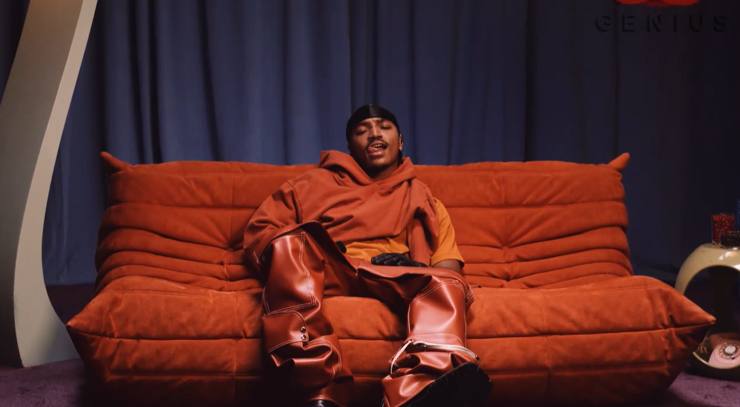

Claiming his lane as one of the rising R&B acts pushing the genre forward, Josh Levi is continuing to light up 2022 with a series of spectacular live performances. This week sees the premiere of show-stopping renditions of Levi’s recent hit singles, “VICES” and “ALL OVER AGAIN,” both filmed exclusively for Vevo and streaming now via YouTube. In addition, Levi recently stopped by the Genius studio to drop a live version of “IF THE WORLD” for the hugely popular Open Mic series, presented by M&M’s. Watch HERE.

As if all that weren’t enough, Levi invited fans behind the scenes of his recently unveiled official music video for “ALL OVER AGAIN,” revealing never-before-seen details of the visual’s intense therapy session and cinematic production. Both “ALL OVER AGAIN” and “ALL OVER AGAIN (BEHIND THE SCENES)” are streaming now at the official Josh Levi YouTube channel HERE.
“ALL OVER AGAIN” is among the highlights featured on Levi’s acclaimed sophomore EP, DISC TWO, available everywhere now HERE. The eight-track collection also includes such powerhouse singles as
“NASA,” “DON’T THEY REMIX (FEAT. NORMANI)” (which exclusively premiered on Apple Music’s The Zane Lowe Show), and “SHE KEEPS COMIN,” the latter joined by an astonishing self-shot live performance video streaming via YouTube HERE.

DISC TWO also includes Levi’s luxurious hit single, “VICES,” a personal favorite of Justin Bieber, who shared the song on his Instagram feed and story. The track is currently featured on GRAMMY.com’s “R&B Is Alive And Well” playlist, accompanied by an exclusive feature which named Levi among the next-gen R&B “Artists Who Are Pushing The Genre Forward,” hailing the gifted new artist for his “soulful and electric sounds.”

Levi marked DISC TWO with his first ever headline tour run to date, “The VICES Tour,” kicking off with a sold-out show at Los Angeles, CA’s Peppermint Club and followed by full houses in San Francisco, Chicago, Houston, New York, Atlanta, and other major markets across the country. Additional dates will be announced soon.

Levi further celebrated the release of DISC TWO with a stunning live rendition of “VICES” on The Terrell Show, as well as an exclusive interview with Rated R&B. What’s more, the rising star displayed his intimate approach to modern R&B with an exhilarating live performance video of “NASA,” streaming HERE.

Josh Levi immediately captivates with each inhale of experience and exhale of emotion. The Houston, TX-raised and Los Angeles-based singer, songwriter, and actor developed a fervent fan base through roles on such hit series as Friday Night Lights as well as a series of viral YouTube covers and consistent touring. Hailed by Earmilk as “an all-encompassing showcase of how much of an anomaly he is,” Levi’s 2020 debut EP, DISC ONE – highlighted by such tracks as “IF THE WORLD,”– earned high profile media attention from the likes of Billboard, Wonderland, and V, which declared him “your classic triple threat.” As a result, Levi caught the attention of Issa Rae's label imprint, Raedio, featuring his 2021 single, “What’s The Use,” on the soundtrack to her critically acclaimed HBO Series, Insecure: Season 5. The track proved an instant smash for Levi, named by Billboard at #6 on their “Tunefind Top TV/Movie Syncs of 2021.”

Named by PEOPLE as one of last year’s “25 Emerging Musical Artists You Should Add to Your Playlist This Fall,” Levi was featured in Disney/Pixar’s blockbuster, Turning Red, starring as the voice of Aaron Z., a member of the teenage heartthrob boyband 4*Town. The soundtrack’s feel-good first single, “Nobody Like U,” written by GRAMMY® Award-winning singer-songwriters Billie Eilish and Finneas O’Connell, proved an immediate “Hot 100” smash, earning a MTV Movie & TV Awards “Best Musical Moment” nomination while sending Levi’s monthly Spotify listeners to more than 4.5M.

CONNECT WITH JOSH LEVI
OFFICIAL | FACEBOOK | INSTAGRAM | TIKTOK | TWITTER | YOUTUBE

PRESS CONTACT:
Brittany Bell | Brittany.Bell@atlanticrecords.com

