KSI RELEASES SURPRISE NEW SINGLE
“SUMMER IS OVER”

LISTEN & WATCH THE MUSIC VIDEO HERE

DL art here

Today, 3x BRIT nominated musician KSI drops surprise new single “Summer Is Over”, marking a significant chapter in KSI’s burgeoning pop career. Tender lyrics paired with a calmer melodic version of KSI allow listeners to reminisce on those summer evenings as the leaves change and the nights draw in. Opening a vulnerable side of KSI, “Summer is Over” hints at what listeners can expect from his upcoming third studio album via Atlantic Records. Listen to “Summer Is Over” HERE.

KSI made history this summer with a record-breaking double knockout win during one of the biggest boxing events of all time and claimed a Big Top 40 #1 single with “Not Over Yet” featuring Ivor Novello-nominated star Tom Grennan (amassing over 40 million streams and counting); the same track that featured a remix with king of drill Headie One and rapper Nines.

On the surprise release of the new single, KSI says: “this is a song I made during a tough time in my life, at a time when I was completely lost. This is a song that is very personal to me, and I think the song says everything. I hope you enjoy.”

The official video – directed by Troy Roscoe (Ed Sheeran, Burna Boy, Lil Wayne, Rick Ross, Polo G) – gives us a glimpse of the good life as we are invited to KSI’s closing summer pool party with champagne aplenty before KSI is seen around a firepit with friends, signaling the end of summer.

“Summer Is Over” is produced by Dan Priddy (Ashnikko, Rag’n’Bone Man, P!nk) and written alongside James ‘YAMI’ Bell (Cat Burns, Tom Grennan, James Arthur), Nick Gale (Dua Lipa, Mimi Webb, Charli XCX), and Andrew Bullimore (Little Mix, Wilkinson, Jonas Blue).

KSI was recently announced as an ambassador for National Album Day, taking place on Saturday 15th October. National Album Day shines a light on the art form of the album, celebrating the creativity and artistry that goes into making an album, with this year’s theme focusing on Debut Albums.

“With an album, it’s essentially you are living in the mind of an artist. What they’re thinking, what they’re feeling and how it makes me feel listening to it. Do I relate? Do I agree or disagree, what emotions do I feel? Even the instrumental can make you feel a certain way. Albums at different stages in our lives can be so pivotal and help inspire different ways of thinking or feeling and why I feel it is so important in our lives. Listening to certain albums is like looking back at history of how I was feeling in the moment in time. And the nostalgia is truly amazing.”

ABOUT KSI:
A pioneering, YouTuber (fourth most followed channel for a British artist behind Ed Sheeran, One Direction and Adele) approaching 20 billion cumulative views, his 40.8 million subscribers know him as a creator, an artist, a mate who brings the passion (and the jokes) to whatever he does. He’s a businessman with a portfolio of interests, from owning his own music label, The Online Takeover and his own boxing promotions company, Misfits Boxing to one of the fastest growing beverages, his Prime Hydration drink (recently partnered with Arsenal FC) is set to surpass $140 million in revenue in its first year. As a performer and all-round entertainer, he can light up stages (Reading, TRNSMT, a Wembley headline) and screen: an upcoming documentary for Prime Video, produced by Louis Theroux, promises to lift the lid on the extraordinary life of the 29-year-old from Watford. And as a boxer, the amateur-turned-professional fighter is undefeated, defeating Logan Paul at Los Angeles Staples Centre in 2019, a global pay-per-view knockout and double knockout with at London’s O2 against rapper Swarmz and professional boxer, Luis Alcarez Pineda. As a musician with over 12 million monthly Spotify listeners, he’s also well-versed in coming out on top. His second album, summer 2021’s All Over the Place entered the charts at #1, an emphatic follow-up to the previous year’s debut, Dissimulation, a #2 hit which was the biggest selling debut album of 2020. In rapid succession there’s been a flurry of hits, on his own merits (making him the British Breakthrough Artist of 2020) and with others (Don’t Play with Anne-Marie, Lighter with Nathan Dawe), making for eight Top Ten singles in total. As prolific as he is innovative, KSI was the only artist to be nominated twice in the Song of the Year category at the 2022 Brit Awards. That’s KSI in 2022: in the ring and in the charts, he’s punching well above his weight. Get ready for his next knockout.

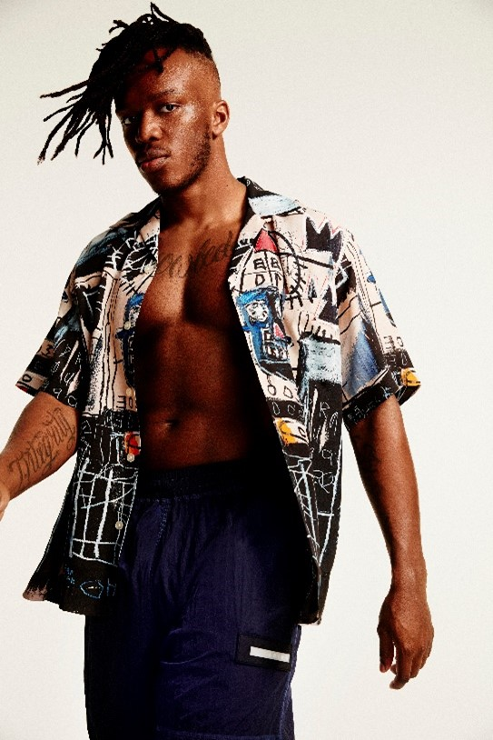
DOWNLOAD PRESS PHOTO HERE

CONNECT WITH KSI
Instagram | Twitter | Spotify | YouTube | Website

FOR MORE INFORMATION:
Paige.Rosoff@atlanticrecords.com
Atlantic Records | Big Beat Records

