GRAMMY NOMINATED ARTIST LIL UZI VERT RELEASES LATEST SINGLE
“JUST WANNA ROCK”
SERVES AS THE FOLLOW UP TO RED & WHITE EP RELEASE
COMES ON THE HEELS OF A SUMMER FULL OF FESTIVAL PERFORMANCES
STREAM “JUST WANNA ROCK”
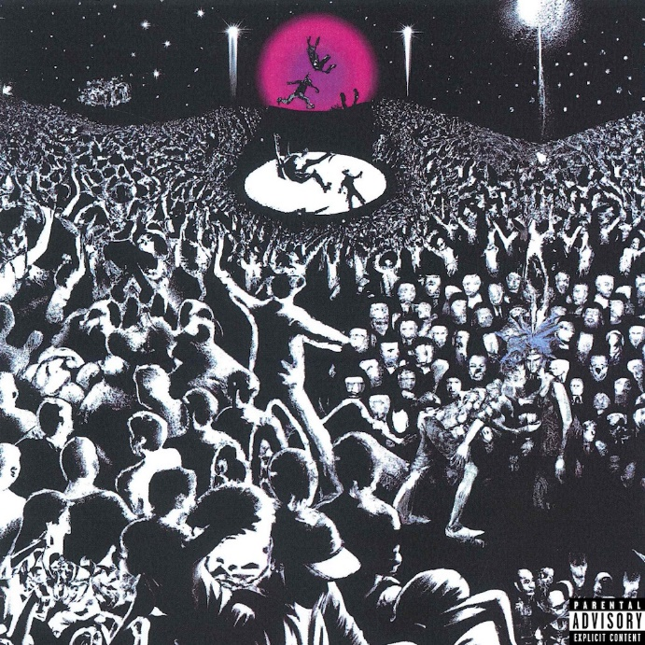
DOWNLOAD HI-RES ARTWORK

Today, Grammy nominated artist Lil Uzi Vert released his latest single “Just Wanna Rock” available for streaming and download now. The single serves as the official follow up to his Red & White EP released this past summer which now has over 149M global streams. The original sound was previously teased on TikTok and has over 150k creates and over 500M views in just three short weeks. “Just Wanna Rock” also comes on the heels of a flurry of festival performances across the world including Rolling Loud Miami, Toronto, and New York and Made in America.

ABOUT LIL UZI VERT

In addition to Lil Uzi Vert’s 2018 Grammy nomination as “Best New Artist”, the artist also received the “Breakout Artist of the Year Award” and the “Breakthrough Artist” award during Billboard’s 2017 Touring Awards. The rap superstar has also been featured on several record-breaking tracks including Travis Scotts’ RIAA 3X platinum certified “Wasted” featuring Kanye West, the RIAA gold certified single with Future “Drankin and Smokin” and Lil Baby’s RIAA platinum certified “Commercial” single to name a few. In 2020, Uzi dropped the deluxe edition of the long-awaited release, Eternal Atake, which includes part two of the album, titled LUV vs. The World 2, reaching #1 on the Billboard 200. Eternal Atake would go on to gain RIAA Platinum certification and was nominated for favorite rap/hip hop album at the 2020 American Music Awards. Immediately following these projects, Uzi and Future released both Pluto x Baby Pluto and the deluxe version in the same year. The Eternal Atake would go on to peak at #2 on Billboard 200 and features the notable singles “Patek” and “Over Your Head.” Uzi made his 2022 return a strong one with a flood of national festival performances and the release of the EP Red & White.

# # #

CONNECT WITH LIL UZI VERT
INSTAGRAM | FACEBOOK | TWITTER | SOUNDCLOUD | OFFICIAL

FOR ALL INQUIRIES, PLEASE CONTACT
SYDNEY.MARGETSON@ATLANTICRECORDS.COM
JANA FLEISHMAN
JANAF@ROCNATION.COM

