MICHELLE releases new single “PULSE”
buy/stream HERE | watch visual HERE

additional headline dates on THE LAVENDER TOUR kick off on Halloween – includes performances at Pitchfork Music Festivals in London + Paris
tickets available HERE

NYC collective’s sophomore album AFTER DINNER WE TALK DREAMS out now
buy/stream HERE

“…an upbeat, groovy track oozing with sultry undertones… It’s a song that’s meant to be danced to—whether you’re at home or at a club. The single gives us a glimpse of what we might expect from their third album or with future music in general—the same focus on love and passion, infectious beats, and energy…” – FLAUNT

“MICHELLE are like a party that everyone’s invited to… lovable, genre-bending music… infused with inspiration from a plethora of music genres, but they all blend to create a cohesive vision. There’s crooning, dance-worthy tracks, euphoric R&B melodies, and sucker-punching lyrics that evoke an almost guttural shout from Gen Z” – ELLE

“The kind of breezy, timeline-cleansing tunes our overstimulated brains are begging for right now”
Entertainment Weekly – 9 Artists to Watch in 2022

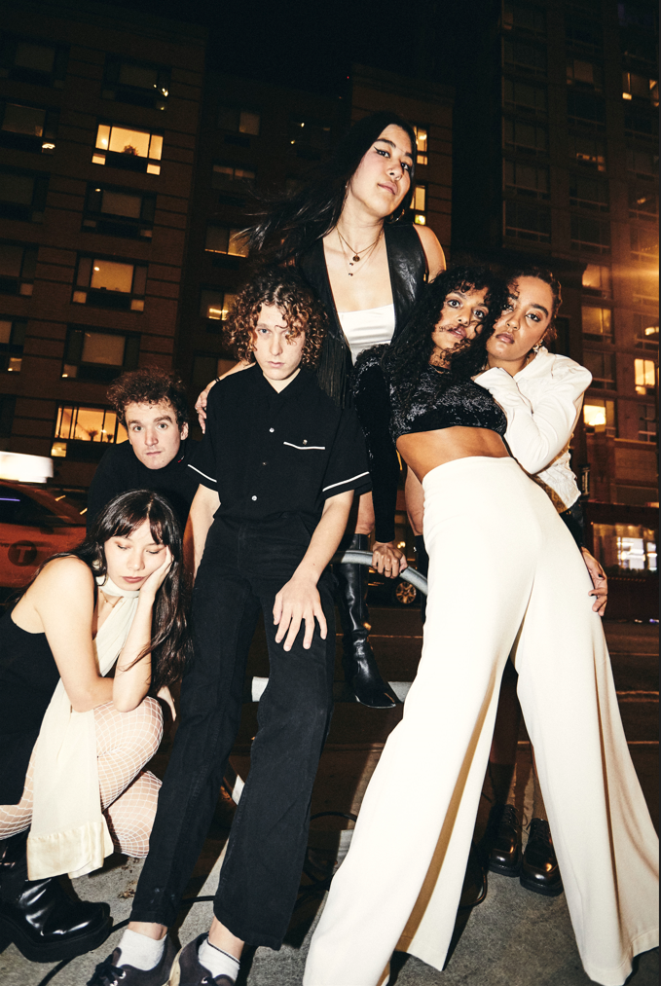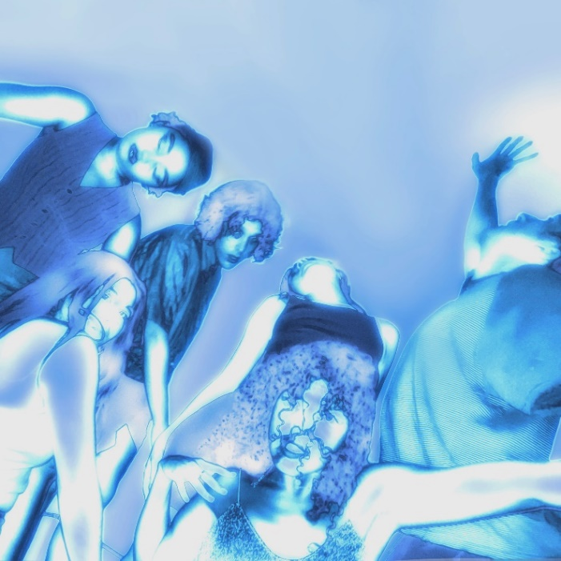
download hi-res press photo | download hi-res artwork

Today, NYC-based collective MICHELLE has released new single “PULSE” (buy/stream here). Premiered via Clara Amfo’s “First Play” on BBC Radio 1 in the UK, the track arrives with a visualizer designed by Juliet Bryant (Justin Vernon, Japanese Breakfast, Death Cab for Cutie) – watch here.

Of “PULSE,” MICHELLE shares:
“‘PULSE’ is for release and for some sharp and glowing feeling when you lock eyes with a lover. ‘PULSE’ is for the dance floor. When the heat is cranked from moving bodies and a shared wanting, ‘PULSE’ is playing.”

“PULSE” follows the recent release of four live videos – for “MY FRIENDS,” “FIRE ESCAPE,” “SPACED OUT, PHASED OUT,” and “NO SIGNAL” – tracks from the band’s acclaimed sophomore album AFTER DINNER WE TALK DREAMS, released via Atlantic Records/Canvasback Music in March of 2022. Directed by filmmaker Greg Corn, the acoustic live takes were filmed on the rooftop and fire escape of band member Jamee Lockard’s NYC apartment.

MICHELLE will soon embark on an additional leg of their headline run The Lavender Tour (tickets here) - kicking off October 31st in Durham, NC and culminating in Brussels, Belgium on November 17th, and including performances at Pitchfork Music Festival London and Paris.

The band will also appear on the bill of Canvasback labelmate Briston Maroney’s Paradise Fest on November 4th at Brooklyn Bowl in Nashville, TN.

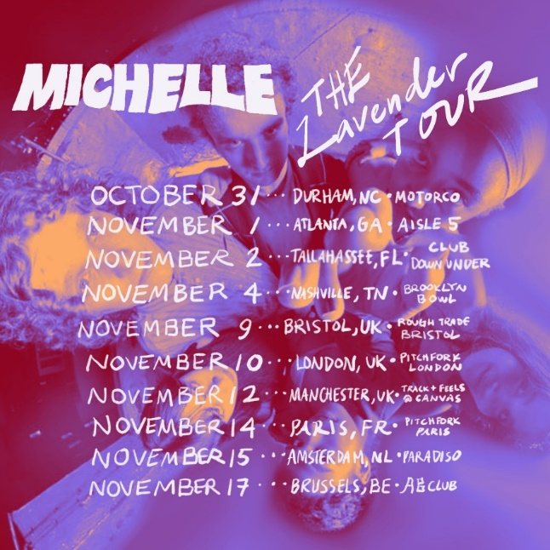
download hi-res admat

Last month, MICHELLE wrapped up the first leg of The Lavender Tour, which began with a festival appearance at This Ain’t No Picnic in Los Angeles and saw the band traverse North America from San Diego to Chicago to Toronto. MICHELLE also performed this summer at Outside Lands in San Francisco and Capitol Hill Block Party in Seattle.

Released in early 2022, AFTER DINNER WE TALK DREAMS marked the band’s full-length debut for Canvasback Music (Transgressive in the UK). Featuring singles “POSE,” “SYNCOPATE,” and “MESS U MADE,” the album bears all the hallmarks of MICHELLE’s music – layered vocal harmonies, analog synthesizers, vibrant percussion, and smoldering hooks.

The record was named to Billboard’s “10 Best Pride Albums of 2022,” joining the critical acclaim the project received upon release from outlets including Pigeons & Planes, NME, Interview, Paste and more. The group was named to Entertainment Weekly’s “9 Artists to Watch in 2022,” with the outlet calling their music “the kind of breezy, timeline-cleansing tunes our overstimulated brains are begging for right now.”

In June, the band followed up their LP release with a special two-track project dubbed THE SIDE DISHES, featuring two new songs, “FOOL 4 U” and “SEA SHANTY” (listen here).

This past spring, MICHELLE played a sold-out show at New York’s Bowery Ballroom, which followed touring earlier in the year opening for Mitski on select dates. They also played a sold-out show at London’s iconic alternative venue Electrowerkz, and a set at UK festival The Great Escape, which received rave reviews from fans and press alike (“an ecstatic, joyful celebration… sharp and ambitious collective musicality” – NME).

Born-and-bred New Yorkers, MICHELLE formed in 2018 and is comprised of Sofia D’Angelo, Julian Kaufman, Charlie Kilgore, Layla Ku, Emma Lee and Jamee Lockard. The predominantly POC and queer collective mix and match the writing and production groups amongst the six of them. Their debut album HEATWAVE was self-released, featuring standout single “THE BOTTOM.”

***

“DREAMS is the collective main-character moment for the alt-pop group, whether clearing out for a solo dancefloor moment on ‘POSE’… or counting down to a sexy apocalypse on ‘END OF THE WORLD.’ Even on the songs that call out for extra company, the outfit sounds totally in control — not easily shocked and dominating the crosswalk.”
Billboard – 10 Best Pride Albums of 2022

“MICHELLE are like a party that everyone’s invited to… lovable, genre-bending music… infused with inspiration from a plethora of music genres, but they all blend to create a cohesive vision. There’s crooning, dance-worthy tracks, euphoric R&B melodies, and sucker-punching lyrics that evoke an almost guttural shout from Gen Z”
ELLE

“the kind of breezy, timeline-cleansing tunes our overstimulated brains are begging for right now”
Entertainment Weekly – 9 Artists to Watch in 2022

“the collective’s contagious charm and versatile creative approach is worth our attention”
Pigeons & Planes

“AFTER DINNER WE TALK DREAMS is going to usher in an entirely new era of MICHELLE, emphasizing their creative maturity and growth as a collective”
V Magazine

“plush R&B pop that feels wholly indebted to the flexuous city that surrounds them”
The FADER

***

MICHELLE – THE LAVENDER TOUR – 2022
October 31 – Durham, NC – Motorco
November 1 – Atlanta, GA – Aisle 5
November 2 – Tallahassee, FL – Club Down Under
November 4 – Nashville, TN – Paradise Fest @ Brooklyn Bowl
November 9 – Bristol, UK – Bristol, UK @ Rough Trade
November 10 – London, UK – Pitchfork Music Festival London
November 12 – Manchester, UK – Track + Feels @ Canvas
November 14 – Paris, FR – Pitchfork Music Festival Paris
November 15 – Amsterdam, NL – Paradiso
November 17 – Brussels, BE – FiftyLab @ AB Club

###

connect with MICHELLE
Website | Instagram | Twitter | Facebook | YouTube

for all press inquiries, please contact
Libby Kober | Libby.Kober@atlanticrecords.com

