PARAMORE ANNOUNCE NEW ALBUM THIS IS WHY FOR FEBRUARY 10TH ON ATLANTIC RECORDS

LISTEN TO THE TITLE TRACK & FIRST SINGLE “THIS IS WHY”

Sold Out Tour Starts October 2nd
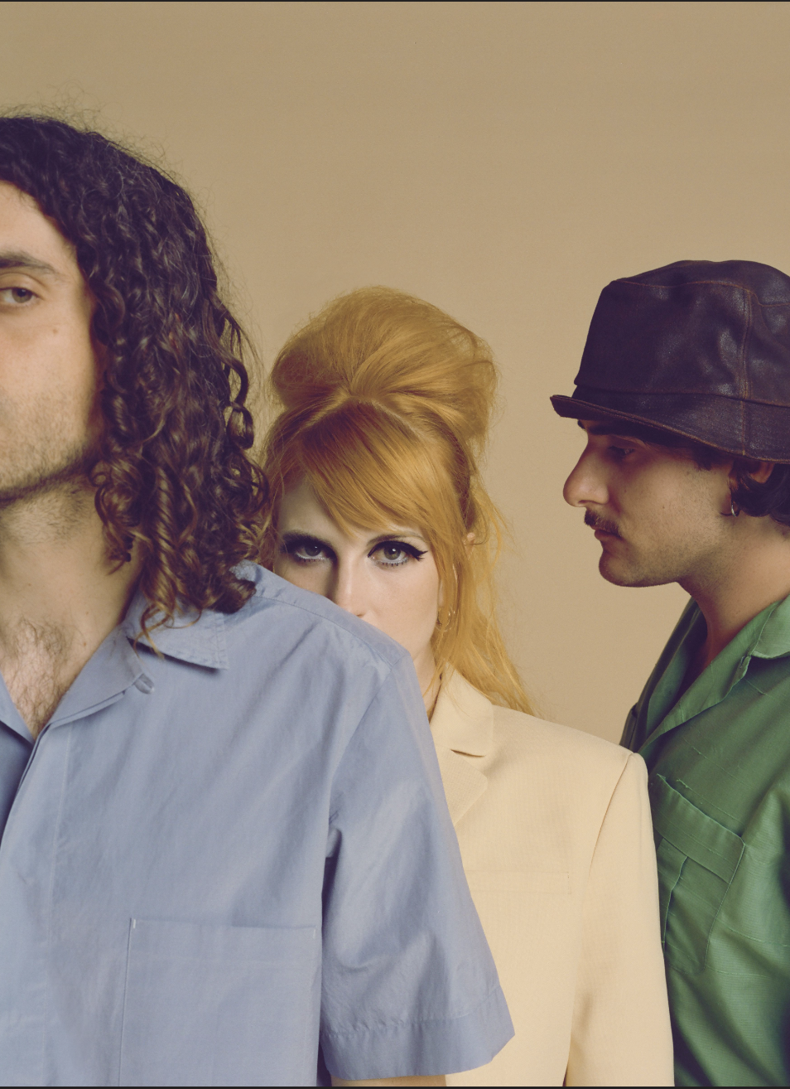
(Paramore - L-R: Taylor York, Hayley Williams, Zac Farro. Photo Credit: Zachary Gray. High Res HERE)

Wednesday, September 28, 2022 - 6.15pm UK/ 1:15pm ET/ 10.15am PT

Paramore are back with their first new music since 2017. The beloved Nashville-based trio of Zac Farro, Hayley Williams & Taylor York have returned from their hiatus - and the global pandemic - with “This Is Why”, one of the best songs of their already impressive repertoire. In what’s widely recognized as one of the most exciting musical returns of the year, the band have also announced the release of their long awaited sixth studio album, This is Why, for February 10th 2023 on Atlantic Records. Recorded in Los Angeles, California with long-time collaborator Carlos de la Garza, the album features 10 new Paramore songs with cover art shot by Zachary Gray.

Entering back into a world - and cultural landscape - very different from the one they last participated in, Paramore have returned with a song about exactly that. “This Is Why” is a deliciously infectious Paramore ear-worm for the post-truth world. Of the song, Williams says, “This Is Why was the very last song we wrote for the album. To be honest, I was so tired of writing lyrics but Taylor convinced Zac and I both that we should work on this last idea. What came out of it was the title track for the whole album. It summarizes the plethora of ridiculous emotions, the rollercoaster of being alive in 2022, having survived even just the last 3 or 4 years. You’d think after a global pandemic of fucking biblical proportions and the impending doom of a dying planet, that humans would have found it deep within themselves to be kinder or more empathetic or something.”

The video was directed by Turnstile’s Brendan Yates and filmed in Malibu, California last month. Speaking on the video and collaboration, Williams says, “It was so rad working with Brendan. I’ve known the Turnstile guys for a little while and was so psyched to have our worlds collide in this way. There’s a cool kinship between the way our bands do things... Hopefully we will get to play shows with them at some point,”

STREAM “THIS IS WHY” HERE

WATCH VIDEO FOR “THIS IS WHY” HERE

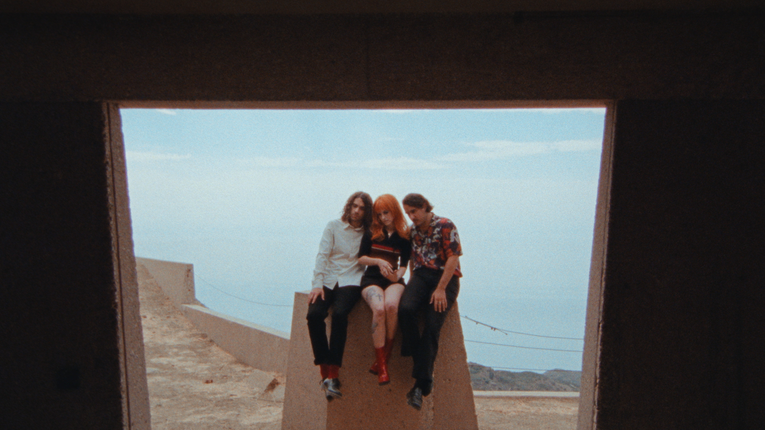
(Still from “This is Why” video)

When Paramore revealed they were recording together in January 2022 the response from music fans around the world was immediate and celebratory. In the time since the Grammy-winning, RIAA-certified multi-Platinum band released their last album, After Laughter - and Hayley Williams unveiled two lauded solo albums - Paramore have become more popular than ever. Over the last few years Paramore’s influence and popularity has snowballed, as the age of streaming organically propelled them into a position as one of the world’s biggest, most culturally compelling rock bands. For the band, who formed as teenagers in Tennessee, their 20 year trajectory has seen them grow from youthful outsiders to bone-fide pop culture icons, permeating the musical landscape by inspiring a new generation of musical talent.

PRE-ORDER THIS IS WHY HERE

Renowned for their arena-filling and festival-headlining performance prowess, the opportunity to see Paramore play their first theater shows in years created headline news. Their upcoming run of intimate live dates sold out in minutes. The band are donating a portion of their ticket sales to organizations working in areas of essential community support, including ARC Southeast, Kansas Abortion Funds, Shelter Safe Canada and Support & Feed. (All dates below)
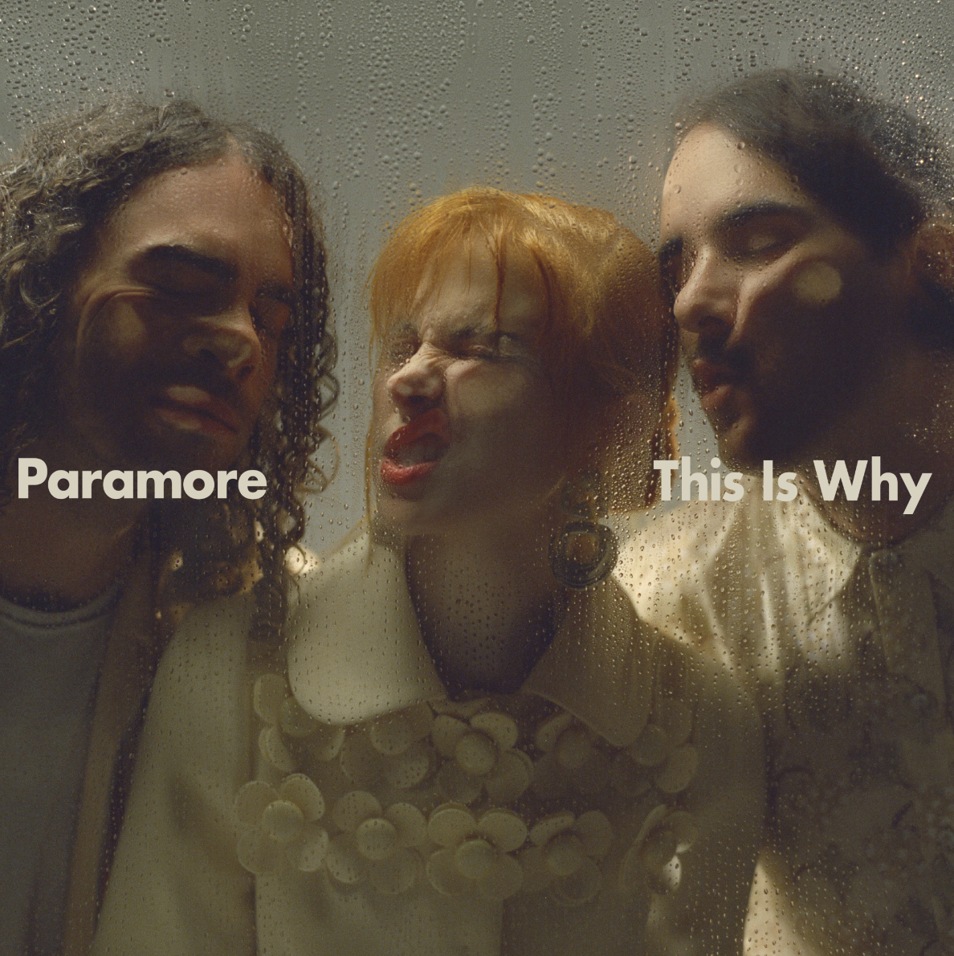
(This Is Why - Album Art - High Res HERE)

PARAMORE SHOW DATES
October 2, 2022 - Bakersfield, CA - Mechanics Bank Theater # SOLD OUT
October 4, 2022 - Magna, UT - The Great SaltAir # SOLD OUT
October 6, 2022 - Omaha, NE - Orpheum Theater Omaha # SOLD OUT
October 8, 2022 - Oklahoma City, OK - The Criterion # SOLD OUT
October 9, 2022 - Austin, TX - Austin City Limits
October 11, 2022 - Chesterfield, MO - The Factory # SOLD OUT
October 14, 2022 - Bonner Springs, KS - Azura Amphitheater* & SOLD OUT
October 16, 2022 - Austin, TX - Austin City Limits^
October 20, 2022 - Los Angeles, CA - The Wiltern ~ SOLD OUT
October 22, 2022 - Las Vegas, NV - When We Were Young Festival^
October 23, 2022 - Las Vegas, NV - When We Were Young Festival^
October 27, 2022 - Los Angeles, CA - The Belasco % SOLD OUT
October 29, 2022 - Las Vegas, NV - When We Were Young Festival^
November 7, 2022 - Toronto, ON - HISTORY = SOLD OUT
November 9, 2022 - Chicago, IL - The Chicago Theatre = SOLD OUT
November 11, 2022 - Cincinnati, OH - The Andrew J Brady Music Center = SOLD OUT
November 13, 2022 - New York City, NY - The Beacon Theatre SOLD OUT
November 15, 2022 - Atlanta, GA - Tabernacle = SOLD OUT
November 16, 2022 - St. Augustine, FL - The St. Augustine Amphitheatre =SOLD OUT
November 19, 2022 - Mexico City, MX - Corona Capital Festival^

# with Claud
= with Ogi
& with Japanese Breakfast + Young the Giant
~ with Faux Real
% with Elke

More information on ARC Southeast, ShelterSafe.CA, Kansas Abortion Fund, Support + Feed

KEEP UP WITH PARAMORE:
Twitter / Instagram / Facebook / Web

