FOR IMMEDIATE RELEASE
OCTOBER 28, 2022

ALEX WARREN UNVEILS “HEADLIGHTS (ACOUSTIC)”

MULTI-TALENTED SINGER-SONGWRITER SHARES STRIPPED RENDITION OF “HEADLIGHTS”

LISTEN TO “HEADLIGHTS (ACOUSTIC)” | WATCH OFFICIAL VIDEO

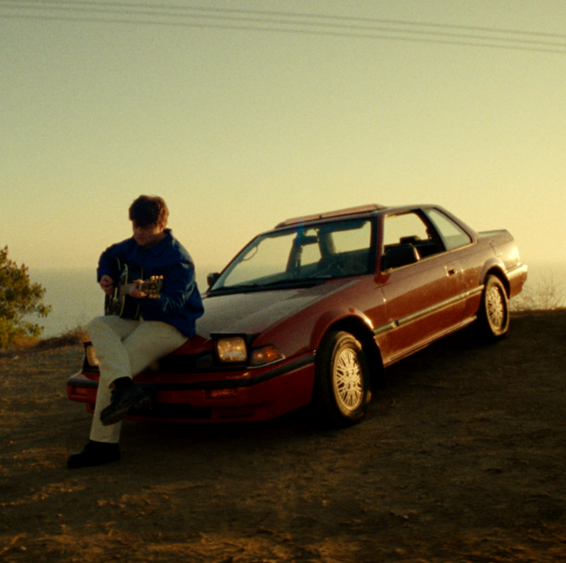
DOWNLOAD ARTWORK HERE

Multi-talented singer-songwriter Alex Warren has shared an acoustic version of his label debut single, “Headlights,” available now at all DSPs and streaming services HERE with an official visual streaming now via YouTube HERE.

"The acoustic version of Headlights is extremely cool because the song originally started as a stripped-down ballad so it’s almost nostalgic because it's like I’m in a time machine looking back at when we first wrote the record,” shared Alex.

The magnetic, deeply moving track first garnered 74M views on TikTok prior to release and has since earned over 4M streams worldwide. Watch the song’s official music video, which is based on Alex’s true life story and premiered exclusively on Rolling Stone, HERE.

Known for his vulnerable pop melodies, passionate vocals, and lyrical candor, Alex shared the news of his signing with Atlantic Records in August via an exclusive Billboard announcement. Shortly after the announcement, Warren shared the first episode of his self-produced docuseries, “I Hope You’re Proud.” The 9-minute episode follows Alex on his journey into music and how he attributes his success to his late father who passed away when he was 9 years old. From being homeless and sleeping in his friends’ cars with nothing but a camera and a laptop to landing a record deal, Alex’s evolution is anything but ordinary, and his late father has always been a driving presence in his life.

At just 22-years-old, the charismatic musician, digital creator and entrepreneur is one of the most followed Gen Z celebrities on YouTube, Instagram and TikTok. Alex has shared his life with the internet for 11+ years, building an online community of 20M+ cumulative followers.

WHAT CRITICS ARE SAYING:

“a deeply moving track” – E! NEWS

“a powerful and emotionally charged ballad” – AMERICAN SONGWRITER

“It has the texture of hope, buoyed by colorful guitar chords and his ambitious vocals” – UPROXX

“a sure-fired hit for anyone willing to hit the play button.” – EUPHORIA

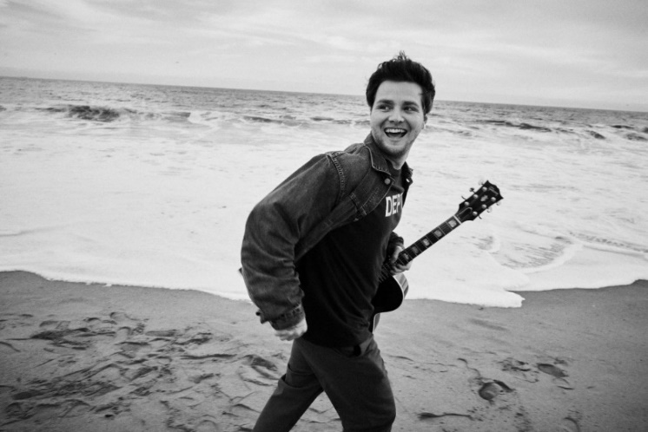
DOWNLOAD HI-RES PHOTO – CREDIT: JIMMY FONTAINE

CONNECT WITH ALEX WARREN:
FACEBOOK | INSTAGRAM | SNAPCHAT | TIKTOK | TWITTER | YOUTUBE | PRESS ASSETS

CONTACT:
ANDREW GEORGE | ANDREW.GEORGE@ATLANTICRECORDS.COM

