FOR IMMEDIATE RELEASE
October 5, 2022

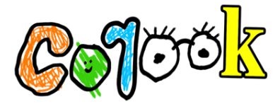

corook keeps secrets from “your mom”

comedic alt-pop artist shares new single and tender music video co-starring real life girlfriend

North American tour alongside Jukebox the Ghost underway

listen to “your mom” | watch official music video

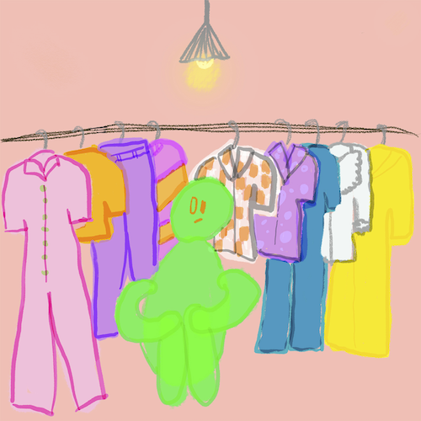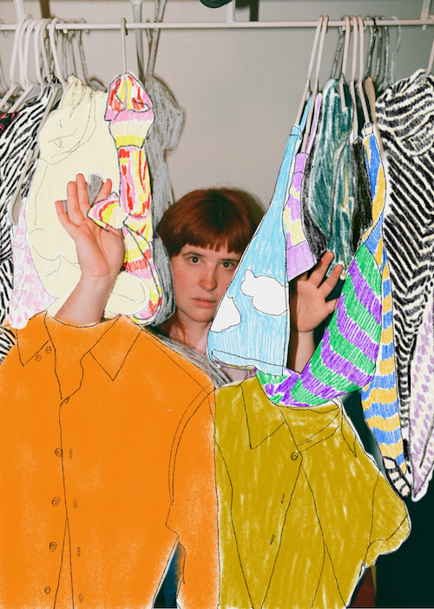
download hi-res artwork + press photo // credit: Christina Coleman

“corook is the next thing to bless your music downloads.” – PEOPLE

“If specificity is the soul of narrative, then corook is one of the most naturally gifted storytellers in the game.” – BILLBOARD

“It's an emotional story that many queer people who have dated/been with others who aren't out of the closet yet can definitely relate to.” - OUT MAGAZINE

Self-described “singer, songwriter, producer, multi-instrumentalist, and huge f*ckin dork” corook [pronounced ‘co-rook’] has shared her sneakily catchy and heartfelt new single, “your mom,” available today at all DSPs and streaming services. A bittersweet yet heartwarming music video, starring corook alongside her actual girlfriend, premiered earlier today on Out Magazine and is now streaming at YouTube HERE.

"I wrote this song when I was dating a girl in the closet,” shared corook. “I was really fortunate to have already come out so I wanted to extend support if she wanted it, as well as the time and space to make her own decisions about it. I think the line ‘You don't have to tell your mom about me’ can relate to so many couples in that giddy beginning, living in their little love bubble not wanting to pop it too soon. I hope this song gives people the patience, love and compassion that they truly deserve during the coming out process."

Recently named one of The Advocate’s “7 Queer Artists For Your Fall Playlist,” the genre-busting, Nashville-based musician tackles deeply personal themes in her music and visuals through a unique, quirky and humorous lens. This past spring, she blessed the world with her debut achoo! EP, which features surprising and insightful tracks including “idk god,” “degree,” “bad friend,” and “sims,” in addition to the fan favorite, “snakes”. Since release, corook has shared her viral adult lullaby, “it’s ok!,” the unrestrained single “BDSM” and super-hot “hell yeah.”

corook – who lit up this summer’s Bonnaroo Music & Arts Festival with her debut festival performance, featuring in Rolling Stone’s Bonnaroo 2022 wrap-up – is currently teaming up with NYC-based piano pop/rock trio Jukebox the Ghost on a US tour, with dates scheduled through mid-October. Next month will see corook travel to Mexico City for Mexico’s Festival Corona Capital, set for Friday, November 18. Earlier this year, she hit the road for her first-ever North American live run alongside K.Flay and opened for X Ambassadors at “A Night Benefitting Reproductive Rights” at The Troubadour. For all tour details and ticket information, please visit www.corook.com.

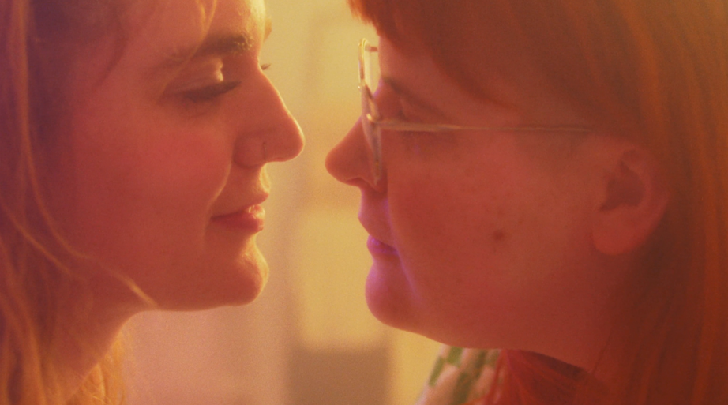

corook by corook
corook aka Corinne Savage (yes that’s her real last name) is a singer, songwriter, producer, multi-instrumentalist and a huge fuckin dork. No but seriously. She can solve a Rubix cube in under a minute (depending on how she’s feeling that day.) This ~freckled chubby babe~ was born and raised just outside of downtown Pittsburgh, Pennsylvania, where she grew up listening to Drake, Gwen Stefani and Mac Miller (RIP). She went to a performing arts high school (yes, just like Victorious) where she came out as QUEERAF her senior year. She then went to Berklee College of Music (wow – Owen Wilson voice) and graduated with TWO degrees (barely.) corook currently resides in Nashville, Tennessee (howdy.) She spends most of her time writing and producing music for her artist project “corook” (boop!) locked away in her room, alone (she blames it on Coronavirus but she’s actually just anti-social.) She’s 27 and VERY cute.

corook on tour

OCTOBER
5 - St Louis, MO - Off Broadway
6 - Lawrence, KS - The Bottleneck
7 - Oklahoma City, OK - Beer City Music Hall
8 - Dallas TX - Trees
10 - Phoenix, AZ - Crescent Ballroom
11 - San Diego, CA - Voodoo Room @ House of Blues San Diego
13 – Pioneertown, CA – Pappy & Harriet’s
14 - Los Angeles, CA - Echoplex
15 - San Francisco, CA - August Hall
17 - Portland, OR - Wonder Ballroom
18 - Seattle, WA - Neptune Theatre
21 – Los Angeles, CA – Baader House *

NOVEMBER
18 - Mexico City, Mexico - Festival Corona Capital *

All Dates w/Jukebox the Ghost Except *

connect with corook:
corook.com | instagram | tiktok | press assets

press contact:
andrew.george@atlanticrecords.com

