FOR IMMEDIATE RELEASE

OCTOBER 11, 2022

RAVYN LENAE SHARES LIVE RENDITION OF "SKIN TIGHT"
LISTEN HERE | WATCH HERE

LAUNCHES TOUR WITH OMAR APOLLO ON OCTOBER 21

HYPNOS OUT NOW VIA ATLANTIC RECORDS

HYPNOS
https://RavynLenae.lnk.to/Hypnos

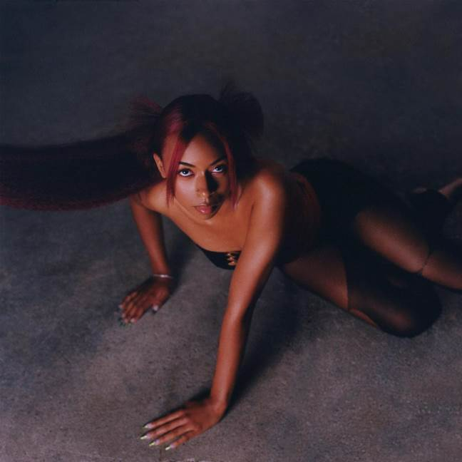
Download High-Res Artwork Here

WHAT THE PRESS IS SAYING ABOUT RAVYN LENAE:
“At 23, the singer-songwriter is deftly creating her own R&B lane.”
Billboard

"Ravyn Lenae is unstoppable"
FLOOD Magazine
“Ravyn Lenae’s take on R&B is heaven sent.”
Harper’s Bazaar

"sky-high vocals with funky bass lines and delicious electro-soul textures."
New York Times

“…shaping up to be one of the best albums of 2022.”
NPR

"Ravyn Lenae is always a step ahead"
OkayPlayer

"Lenae’s transcendental poise establishes her as a resonant voice in R&B"
Pitchfork

“One of the most exciting emerging forces in modern R&B is ready to make a lasting mark.”
Uproxx

(October 11, 2022) - Just ahead of launching her North American tour with Omar Apollo this month, Chicago-born and Los Angeles-based singer and songwriter Ravyn Lenae shares a new live rendition of the lead single "Skin Tight" from her critically-acclaimed debut album HYPNOS, out now via Atlantic Records. The new version of the song comprises an intimate stripped-down performance showcasing Ravyn's vocal range alongside an official visualizer and arrives closely following her recent installment of A COLORS Show where she performed "Inside Out" and her collaboration with Doechii for the remix of her Kaytranada-produced track "Xtasy."

Ravyn's aforementioned debut HYPNOS has proven to be one of the year's most celebrated albums with more than 16 national publications including the project on their Best Albums of 2022 lists. Among the praise for the body of work, Pitchfork described the album as revering "the musical icons before her in ways that show just how ready she is for her own turn" when awarding it Best New Music. Featured artists and producers on the album include Kaytranada, Steve Lacy, Luke Titus, Monte Booker, Smino, Foushee, Phoelix, Mereba, Teo Halm and IAMNOBODI. Following the album's release, Lenae performed for NPR's Tiny Desk Concert as the first artist to tape for the series in the NPR offices since they closed in spring of 2020. Watch HERE

After opening for Erykah Badu in her Chicago hometown last month, Lenae will continue her banner year by joining Omar Apollo on a North American tour this fall, kicking off on October 21. The 23-date run includes stops in Houston, Los Angeles, Salt Lake City, Atlanta, Nashville, and Brooklyn before wrapping up in Toronto on November 29th. Tickets available HERE.

Listen to and watch the live version of "Skin Tight" above, check out full tour routing below and stay tuned for more from Ravyn Lenae coming soon.

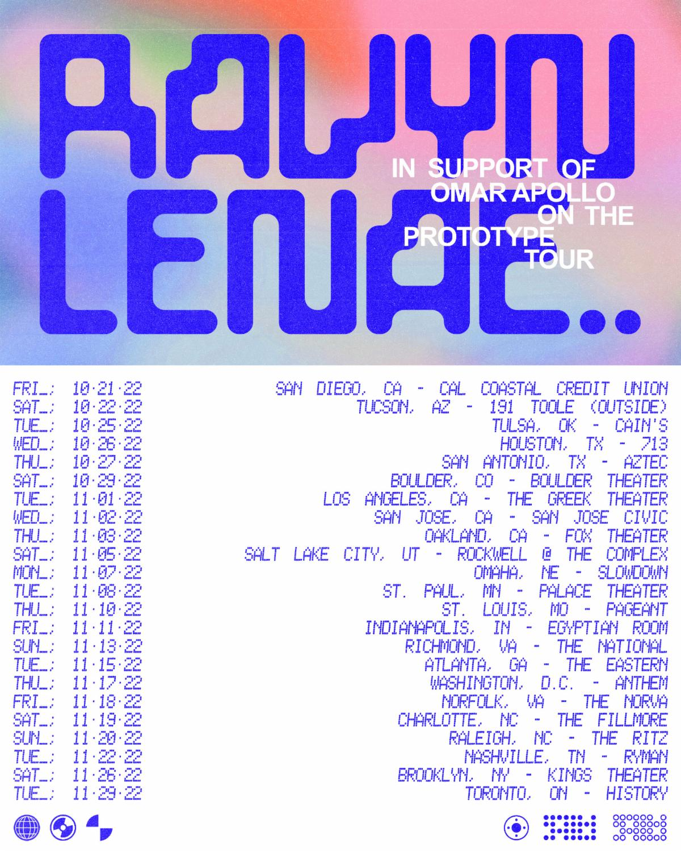

10/21/22 - San Diego, CA @ Cal Coastal Credit Union*
10/22/22 - Tucson, AZ @ 191 Toole*
10/25/22 - Tulsa, OK @ Cain's Ballroom*
10/26/22 - Houston, TX @ 713 Music Hall*
10/27/22 - San Antonio, TX @ Aztec Theatre*
10/29/22 - Boulder, CO @ Boulder Theater*
11/01/22 - Los Angeles, CA @ The Greek Theater*
11/02/22 - San Jose, CA @ San Jose Civic*
11/03/22 - Oakland, CA @ Fox Theater*
11/05/22 - Salt Lake City, UT @ The Complex*
11/07/22 - Omaha, NE @ Slowdown*
11/08/22 - St. Paul, MN @ Palace Theatre*
11/10/22 - St. Louis, MO @ The Pageant*
11/11/22 - Indianapolis, IN @ Egyptian Room at Old National Centre*
11/13/22 - Richmond, VA @ The National*
11/15/22 - Atlanta, GA @ The Eastern*
11/17/22 - Washington, D.C. @ The Anthem*
11/18/22 - Norfolk, VA @ The NorVa*
11/19/22 - Charlotte, NC @ The Fillmore*
11/20/22 - Raleigh, NC @ The Ritz*
11/22/22 - Nashville, TN @ Ryman Auditorium*
11/26/22 - Brooklyn, NY @ Kings Theatre*
11/29/22 - Toronto, ON @ HISTORY*

# # #

CONNECT WITH RAVYN LENAE
WEBSITE | FACEBOOK | INSTAGRAM | TWITTER | YOUTUBE

PRESS CONTACTS
Fairley McCaskill | Fairley.McCaskill@atlanticrecords.com
Nick Dierl |Nick@orienteer.us

