FOR IMMEDIATE RELEASE
OCTOBER 21, 2022

RODDY RICCH PULLS UP WITH NEW SINGLE
“ASTON MARTIN TRUCK”

NEW RECORD ARRIVES ALONGSIDE OFFICIAL LIFESTYLE VISUAL HERE

RIAA DIAMOND RAP SUPERSTAR UNVEILS LATEST SINGLE IN SERIES OF NEW RELEASES
INCLUDING “STOP BREATHING” & “GHETTO SUPERSTAR (FEAT. G HERBO & DOE BOY)”

SPECIAL GUEST RUN ON POST MALONE’S “TWELVE CARAT TOUR”
CONTINUES THROUGH NOVEMBER

LISTEN TO “ASTON MARTIN TRUCK” HERE

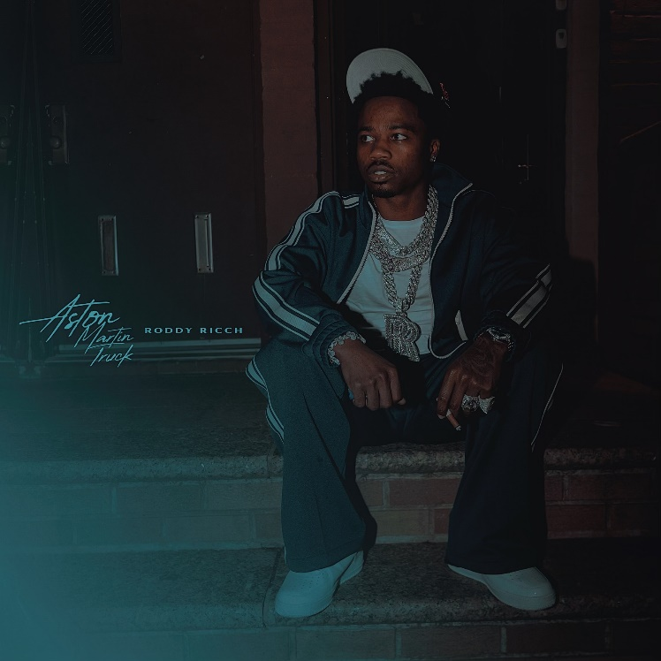
DOWNLOAD HI-RES ARTWORK HERE

GRAMMY® Award-winning, RIAA Diamond-certified rap superstar Roddy Ricch has shared his latest single, “Aston Martin Truck,” available now via Atlantic Records at all DSPs and streaming services HERE. The Teddy Walton (Drake, Kendrick Lamar, Chris Brown, Nipsey Hussle) produced track brought Roddy to the streets of Queens, NY for an official visual directed by 20K. Watch HERE

Setting the tone for more to come, “Aston Martin Truck” continues a sequence of recent releases from Ricch, including last month’s “Stop Breathing.” Produced by Turbo (Travis Scott, Nav, Lil Baby), JetsonMade (DaBaby, Jack Harlow, J. Cole) and Pooh You A Fool (Migos, Symba, NBA YoungBoy), the track arrived alongside an official visual offering fans a glimpse into Ricch’s luxurious life on the road, streaming
now via YouTube HERE. This summer also saw the arrival of “Ghetto Superstar (Feat. G Herbo & Doe Boy),” marking the first ever studio collaboration between superstar producers Mustard and Southside.
Ricch spent much of the summer lighting up such events as Washington, DC’s Something In The Water, Manchester, TN’s Bonnaroo Music & Arts Festival, Concord, CA’s KMEL Summer Jam, East Rutherford, NJ’s annual HOT 97 Summer Jam at MetLife Stadium, and Rolling Loud Toronto.

Continuing his run as special guest on Post Malone’s blockbuster “Twelve Carat Tour,” Ricch and Malone hit New York City’s world-famous Madison Square Garden for two shows last week, with the tour making stops across North America through a two-night stand at Los Angeles, CA’s Crypto.com Arena on November 15 and 16. The tour follows Ricch’s recent performance alongside Post Malone for their joint track, “Cooped Up,” on NBC’s Saturday Night Live (streaming HERE). The original version of “Cooped Up” – featured on Post Malone’s blockbuster new album, TWELVE CARAT HEARTACHE – is joined by an official music video, now boasting over 40M views via YouTube HERE.

Ricch’s latest EP, THE BIG 3, is available at all DSPs and streaming services HERE. The three-song collection is highlighted by the summer single, “Real Talk,” with HotNewHipHop declaring Ricch to be “one of the best young songwriters in hip-hop right now.” The Mustard-produced track – which marked the GRAMMY® Award-winning (and 9x GRAMMY® Award-nominated) artist’s first new solo single since last year’s sophomore album, LIVE LIFE FAST – arrived alongside an official music video, directed by Colin Tilley and streaming now via YouTube HERE.

LIVE LIFE FAST – which follows 2019’s 2x RIAA platinum, chart-topping debut album, PLEASE EXCUSE ME FOR BEING ANTISOCIAL, highlighted by the historic, 3x GRAMMY® Award-nominated, RIAA diamond certified #1 classic, “The Box” – arrived in December 2021 and made an explosive #1 debut on Billboard’s “Top R&B/Hip-Hop Albums” chart as well as at #4 on the overall Billboard 200. The album includes such smash singles as “Late At Night” and “25 million,” both joined by official music videos streaming now at YouTube.

RODDY RICCH
TOUR 2022

ALL DATES w/POST MALONE’s TWELVE CARAT TOUR

OCTOBER
21 – Dallas, TX – American Airlines Center
22 – Austin, TX – Moody Center
25 – Houston, TX – Toyota Center
26 – Ft. Worth, TX – Dickies Arena
28 – Tulsa, OK – BOK Center
30 – Denver, CO – Ball Arena

NOVEMBER
1 – Salt Lake City, UT – Vivint Arena
3 – Portland, OR – Moda Center
5 – Seattle, WA – Climate Pledge Arena
6 – Vancouver, BC – Rogers Arena
10 – Inglewood, CA – Kia Forum
11 – Las Vegas, NV – T-Mobile Arena
13 – Inglewood, CA – Kia Forum
15 – Los Angeles, CA – Crypto.com Arena
16 – Los Angeles, CA – Crypto.com Arena

# # #

CONNECT WITH RODDY RICCH
OFFICIAL | FACEBOOK | INSTAGRAM | TWITTER | YOUTUBE

PRESS CONTACT
Brittany Bell | Brittany.Bell@atlanticrecords.com

