FOR IMMEDIATE RELEASE
OCTOBER 24, 2022

GRAMMY AWARD WINNING SUPERSTAR RODDY RICCH ANNOUNCES
FEED THE STREETS III TO DROP NOVEMBER 18TH

RAP SUPERSTAR UNVEILs MIXTAPE ARTWORK
ON THE HEALS OF NEW HIT TRACK “ASTON MARTIN TRUCK”

NEW TRACK RELEASED ALONGSIDE OFFICIAL LIFESTYLE VISUAL HERE

LATEST SINGLES IN SERIES OF NEW RELEASES INCLUDE
“STOP BREATHING” & “GHETTO SUPERSTAR (FEAT. G HERBO & DOE BOY)”

SPECIAL GUEST RUN ON POST MALONE’S “TWELVE CARAT TOUR”
CONTINUES THROUGH NOVEMBER

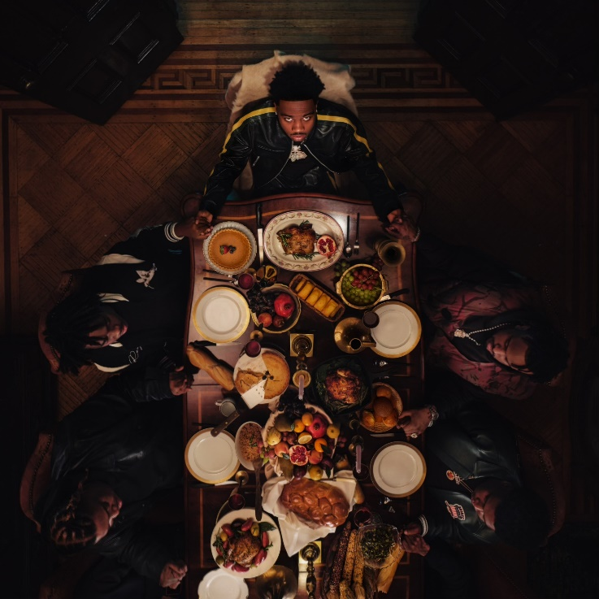
DOWNLOAD HI-RES ARTWORK

RIAA Diamond-certified rap superstar Roddy Ricch celebrated his 24th birthday with the announcement of the official release date of the highly anticipated mixtape, Feed The Street III dropping November 18th. The announcement came a few hours after sharing his latest single “Aston Martin Truck.”

“Aston Martin Truck” produced by Teddy Walton (Drake, Kendrick Lamar, Chris Brown, Nipsey Hussle), added to the sequence of recent releases from Ricch. Last month he dropped “Stop Breathing,” produced by Turbo (Travis Scott, Nav, Lil Baby), JetsonMade (DaBaby, Jack Harlow, J. Cole) and Pooh You A Fool (Migos, Symba, NBA YoungBoy), which arrived alongside an official visual offering fans a glimpse into Ricch’s luxurious life on the road, streaming now via YouTube HERE. This past summer also saw the arrival of “Ghetto Superstar (Feat. G Herbo & Doe Boy),” marking the first ever studio collaboration between superstar producers Mustard and Southside.

Continuing his run as special guest on Post Malone’s blockbuster “Twelve Carat Tour,” Ricch and Malone hit New York City’s world-famous Madison Square Garden for two shows, with the tour making stops across North America through a two-night stand at Los Angeles, CA’s Crypto.com Arena on November 15 and 16. The tour follows Ricch’s recent performance alongside Post Malone for their joint track, “Cooped Up,” on NBC’s Saturday Night Live (streaming HERE). The original version of “Cooped Up” – featured on Post Malone’s blockbuster new album, TWELVE CARAT HEARTACHE – is joined by an official music video, now boasting over 40M views via YouTube HERE.

Ricch’s latest EP, THE BIG 3, is available at all DSPs and streaming services HERE. The three-song collection is highlighted by the summer single, “Real Talk,” with HotNewHipHop declaring Ricch to be “one of the best young songwriters in hip-hop right now.” The Mustard-produced track – which marked the GRAMMY® Award-winning (and 9x GRAMMY® Award-nominated) artist’s first new solo single since last year’s sophomore album, LIVE LIFE FAST – arrived alongside an official music video, directed by Colin Tilley and streaming now via YouTube HERE.

LIVE LIFE FAST – which follows 2019’s 2x RIAA platinum, chart-topping debut album, PLEASE EXCUSE ME FOR BEING ANTISOCIAL, highlighted by the historic, 3x GRAMMY® Award-nominated, RIAA diamond certified #1 classic, “The Box” – arrived in December 2021 and made an explosive #1 debut on Billboard’s “Top R&B/Hip-Hop Albums” chart as well as at #4 on the overall Billboard 200. The album includes such smash singles as “Late At Night” and “25 million,” both joined by official music videos streaming now at YouTube.

RODDY RICCH
TOUR 2022

ALL DATES w/POST MALONE’s TWELVE CARAT TOUR

OCTOBER
21 – Dallas, TX – American Airlines Center
22 – Austin, TX – Moody Center
25 – Houston, TX – Toyota Center
26 – Ft. Worth, TX – Dickies Arena
28 – Tulsa, OK – BOK Center
30 – Denver, CO – Ball Arena

NOVEMBER
1 – Salt Lake City, UT – Vivint Arena
3 – Portland, OR – Moda Center
5 – Seattle, WA – Climate Pledge Arena
6 – Vancouver, BC – Rogers Arena
10 – Inglewood, CA – Kia Forum
11 – Las Vegas, NV – T-Mobile Arena
13 – Inglewood, CA – Kia Forum
15 – Los Angeles, CA – Crypto.com Arena
16 – Los Angeles, CA – Crypto.com Arena

# # #

CONNECT WITH RODDY RICCH
OFFICIAL | FACEBOOK | INSTAGRAM | TWITTER | YOUTUBE

PRESS CONTACT
Brittany Bell | Brittany.Bell@atlanticrecords.com

