FOR IMMEDIATE RELEASE
OCTOBER 4, 2022

GROUNDBREAKING ALTERNATIVE ARTIST SAM AUSTINS UNVEILS “MATADOR”

NORTH AMERICAN TOUR SUPPORTING DORA JAR
BEGINS NOVEMBER 3 IN ATLANTA, GA

LISTEN TO “MATADOR” HERE

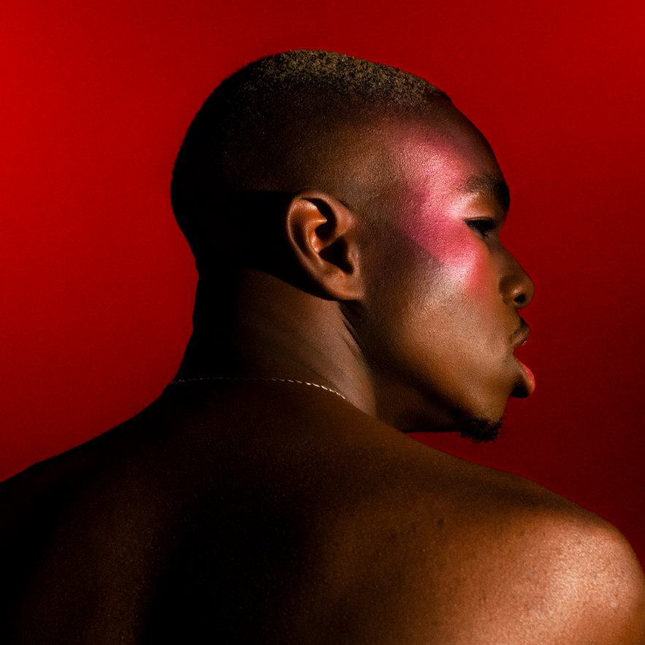
DOWNLOAD HI-RES ARTWORK

“Sam Austins is a boundary-breaker, challenging long-held ideas of what it means to be an alternative artist.”
– BILLBOARD

Alt-pop singer-songwriter/model/artist Sam Austins has shared his triumphant new single, “Matador,” listen HERE. Produced by Rodaidh McDonald (The xx, David Byrne, Hot Chip), “Matador” marks the first single off Austins’ forthcoming new project, dropping next year, and a follow up to his 2021 debut mixtape, HOMELESS STAR. Simultaneously uplifting and melancholy, the track exemplifies the Detroit-born, Los Angeles-based artist’s paradoxical ability to create ethereal indie pop with a razor-sharp edge, a groundbreaking musical approach tattooed by a creative bravado that lures with a red cape but conceals a devastating sword.

“As an artist, I'm drawn to exploring the duality of masculinity and femininity,” says Austins. “I was obsessed with the imagery and metaphor of love as a bullfight. It's a seductive choreography and misdirection. I approached it as someone who has been vulnerable in the arena; deceived and strung along by someone with a fatal purpose.”
Austins – who spent his summer stealing the show at such festivals as Chicago, IL’s Lollapalooza and Gonzalez, TX’s Float Fest – will celebrate “Matador” with a wide ranging North American tour supporting Dora Jar, getting underway November 3 at Atlanta, GA’s Vinyl and then traveling through a November 30 finale at West Hollywood, CA’s historic Troubadour. A number of dates – including shows in Boston and New York City – are already sold out; for complete details and remaining ticket availability, please visit www.samaustins.com.

SAM AUSTINS
ON TOUR 2022

NOVEMBER
3 - Atlanta, GA - Vinyl
5 - Washington, DC - DC9 Nightclub
6 - Philadelphia, PA - PhilaMOCA
8 - New York, NY - Bowery Ballroom (SOLD OUT)
10 - Boston, MA - Red Room, Cafe 939, Berklee College of Music (SOLD OUT)
12 - Toronto, ON - Drake Hotel Underground
14 - Chicago, IL - Schubas Tavern
15 - Minneapolis, MN - 7th St Entry
19 - Seattle, WA - Barboza
20 - Portland, OR - Polaris Hall
22 - San Francisco, CA - Rickshaw Stop
30 - West Hollywood, CA – Troubadour

* ALL DATES w/DORA JAR

ABOUT SAM AUSTINS:
Sam Austins is quickly rising to the forefront of contemporary art pop with his revolutionary fusion of energies, merging 90s alternative and R&B melodies with the aspirational aesthetics of high fashion and authentic tales of his Detroit youth. A series of increasingly acclaimed releases and performances saw the preternaturally gifted musician and in-demand model earning early acclaim and accolades from such outlets as VOGUE, HYPEBEAST, Pigeons & Planes, and many more.

Austins joined Atlantic Records’ legendary roster in 2021 and quickly unveiled his label debut mixtape, HOMELESS STAR, highlighted by such genre-defying singles as “KILOS,” “MIND ON DRUGS,” “DRIFTING AWAY,” and “JOY FOR YOUTH (with Sir Chloe),” all available now for streaming and download. The 10-track collection was greeted by critical acclaim from the likes of Billboard, which raved, “Austins carries his struggles proudly, channeling his experiences as inspiration for the creative direction and lyrical content of HOMELESS STAR…The avant-garde storyteller paints a picture of Detroit in the summer…he hones in on eclectic influences that manage to achieve synchronicity…part Blood Orange, part Tame Impala, yet entirely Austins.”

# # #

CONNECT WITH SAM AUSTINS
WEBSITE | FACEBOOK | INSTAGRAM | TWITTER | YOUTUBE

PRESS CONTACT
Fairley McCaskill | Fairley.McCaskill@atlanticrecords.com

