FOR IMMEDIATE RELEASE
OCTOBER 7, 2022
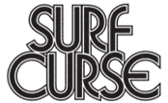

SURF CURSE UNLEASHES MAGIC HOUR

RIAA PLATINUM INDIE ROCK BAND UNVEILS HIGHLY ANTICIPATED ATLANTIC RECORDS DEBUT ALBUM, INCLUDING LATEST SINGLE “ARROW”

NORTH AMERICAN HEADLINE RUN BEGINS OCTOBER 30 AT SOLD OUT LAS VEGAS SHOW
WITH HOMECOMING TOUR FINALE AT ICONIC HOLLYWOOD PALLADIUM IN LA ON DECEMBER 17

MAGIC HOUR IS AVAILABLE EVERYWHERE NOW
LISTEN HERE

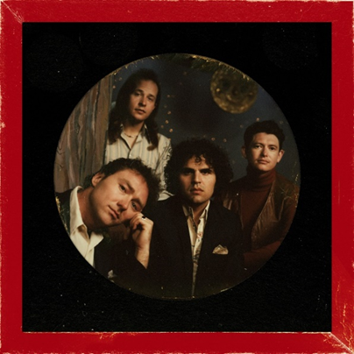
DOWNLOAD ARTWORK HERE

“The unstoppable Surf Curse are entering a new epoch in their already storied career…it’s evident that the pinnacle of their success is still yet to come” – WONDERLAND

“[The new music] marks a brand new era of Surf Curse — one that capitalizes on their frenetic, emotive post-punk while leaning into a more contemplative, psychedelic, and unpredictable sound.” -CONSEQUENCE

“Surf Curse has the pop-guitar bones to sound like a classic coming of age soundtrack fit for a movie with rock 'n' roll screams and a booming drumbeat.” ­-V MAGAZINE

RIAA platinum certified indie rock band Surf Curse have unveiled their fourth LP and eagerly awaited Atlantic Records debut album, MAGIC HOUR – available now at all DSPs and streaming services HERE.

Surf Curse’s MAGIC HOUR includes latest single and standout track, “Arrow,” alongside other recent single, “Self Portrait,” which released alongside an official music video directed by Nathan Castiel and Nick Rattigan – WATCH HERE. The highly anticipated album also includes energetic singles “Self Portrait,” “Lost Honor,” “TVI,” and the power pop anthem, “Sugar,” the latter of which has already garnered over 6.6M streams worldwide. The band is currently on tour following sold out shows this summer in London, Paris and Berlin, as well as stand out performances at Coachella and Primavera’s debut LA incarnation last month. While in London, the band sat down to chat with Abbey Road – Watch full interview HERE.

"Normally when you hear people talk about what went into the making of their albums they say ‘blood sweat and tears’ but for us it was love, sweat and laughs,” shared Jacob Rubeck. “Magic Hour is not only our ode to rock music but our bond together as bandmates and creatives. We’re excited to share these songs that we’re so proud of and are stoked on the response to the songs we’ve already released."

Founded in Reno, NV by Nick Rattigan (lead vocals, drums) and Jacob Rubeck (guitar), Surf Curse have been crafting a multifaceted sound informed by indie, punk, pop, psych rock, and more for nearly a decade. 2020 saw the band’s breakthrough with the surprise TikTok success of “Freaks,” which has earned over 650M worldwide streams and RIAA platinum certification more than eight years after its original release. Recorded at New York City’s iconic Electric Lady Studios, MAGIC HOUR now sees the band testing the boundaries of their seasoned indie rock approach, exploring a wide range of sonic styles and colors with founders Rattigan and Rubeck now joined by new members Noah Kohll (guitars) and Henry Dillon (bass). The newly expanded lineup allows Surf Curse to push their already ambitious songcraft even further than ever before, spanning the blistering album-opener, “Arrow,” to the somber rock of “No Tomorrows.”

Surf Curse is celebrating MAGIC HOUR with an epic world headline tour, starting off across the Atlantic for a major EU/UK tour, followed by a North American headline kicking off with a pair of special Halloween shows at Las Vegas, NV’s sold out AREA15 (October 30) and San Diego, CA’s SOMA (October 31) and then traveling through Reno, NV for a sold out show at The Holland Project and a hometown finale at Hollywood, CA’s famed Hollywood Palladium on December 17. Special guests throughout the North American tour include Toner, Grumpy, and others to be announced. For complete details and ticket information, please visit www.surfcurse.com/tour.

SURF CURSE TOUR 2022

OCTOBER
7 - Brighton, UK - Chalk
8 - Bristol, UK - SWX
10 - Amsterdam, Netherlands - Paradiso
12 - Paris, France - Le Trabendo
13 - Bordeaux, France - Rock School Barbey
14 - Barcelona, Spain - Razzmatazz 2
15 - Madrid, Spain - Independance
17 - Zürich, Switzerland - Mascotte
19 - Berlin, Germany - Kesselhaus in der Kulturbrauerei
20 - Cologne, Germany - Gebäude9
30 - Las Vegas, NV – AREA15 – SOLD OUT
31 - San Diego, CA - SOMA

NOVEMBER
1 - Phoenix, AZ - The Van Buren
3 - Austin, TX - The Mohawk
4 - Austin, TX - The Mohawk
5 - Houston, TX - Warehouse Live
6 - Dallas, TX - The Studio at the Factory
8 - Denver, CO - Ogden Theatre
9 - Salt Lake City, UT - The Complex
11 - Spokane, WA - Knitting Factory Concert House
12 - Portland, OR - Crystal Ballroom
13 - Seattle, WA - Neptune Theatre
15 - Reno, NV - The Holland Project – SOLD OUT
16 - San Francisco, CA - The Warfield
18 - Mexico City, Mexico - Festival Corona Capital *
29 - Philadelphia, PA - Union Transfer
30 - New York, NY - Webster Hall

DECEMBER
3 - Montreal, QC - Club Soda
4 - Toronto, ON - Phoenix Concert Theatre
6 - Chicago, IL - The Vic Theatre
8 - Nashville, TN - The Basement East
9 - Nashville, TN - The Basement East
10 - Asheville, NC - The Orange Peel
12 - Washington, DC - Black Cat
13 - Washington, DC - Black Cat
17 - Hollywood, CA - Hollywood Palladium

* FESTIVAL PERFORMANCE

# # #

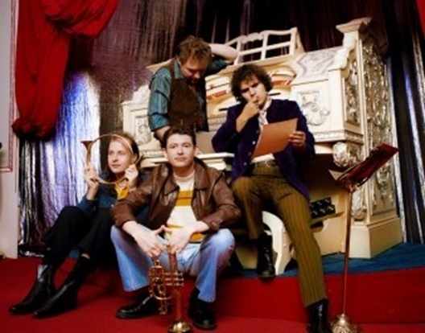
DOWNLOAD HI-RES IMAGE // PHOTO CREDIT: JULIEN SAGE

CONNECT WITH SURF CURSE
WEBSITE | FACEBOOK | INSTAGRAM | YOUTUBE | PRESS ASSETS

For press inquiries, please contact:
Jessica Nall // Jessica.Nall@atlanticrecords.com

