TIËSTO AND TATE MCRAE PARTNER WITH
ATLANTIS THE ROYAL,
FOR NEW SINGLE “10:35”

THE TRACK CELEBRATES THE OPENING OF
DUBAI’S NEWEST AND MOST LUXURIOUS RESORT

OFFICIAL VIDEO PREMIERING LIVE ON MTV & PARAMOUNT TIMES SQUARE BILLBOARDS

ATLANTIS THE ROYAL PARTNERSHIP ANNOUNCED EXCLUSIVELY BY BILLBOARD
READ HERE

TIËSTO’S ALBUM “DRIVE” COMING 2/24/23

LISTEN HERE | WATCH OFFICIAL VIDEO HERE
DOWNLOAD HIGH-RES PRESS PHOTO HERE

GRAMMY® Award-winning, RIAA platinum-certified international icon Tiësto has joined forces with multi-platinum singer/songwriter Tate McRae and Dubai’s new ultra-luxury resort Atlantis The Royal to create the spectacular new single, “10:35,” listen HERE. The track is joined by a strikingly conceptual music video that will make its broadcast premiere on MTV Live, MTVU, MTV Biggest Pop and Paramount Times Square Billboards. The visual is highlighted by a performance from Tiësto and Tate throughout the stunning Atlantis The Royal resort, with the Dubai skyline as the glittering backdrop. Watch HERE. Also announced today is the release of Tiësto’s highly anticipated album, “Drive”, being released on 2/24/23 alongside F1 racing inspired visuals. The album is more than just an “album,” it’s an experience that showcases Tiësto’s unique style. “Drive” will take you on the ride of your life; featuring previously released Don’t Be Shy, The Motto, The Business, and Hot in It, which have all accumulated over 3.5B streams leading into its release. Pre-save HERE.

“10:35” is inspired by and encapsulates the essence, energy and electricity of Atlantis The Royal, the newest icon of the Dubai skyline and the world’s most luxurious resort. When first introduced to the resort’s architectural plans, Tiësto honed in on the duality of the daytime experience of luxury vs the nighttime’s spirit of possibility and excitement. This juxtaposition fueled the idea for the time where day turns to night and that experience shifts – hence, “10:35.” McRae, who spent time growing up in the Middle East, proved a perfect partner, her vocals providing the ideal complement to the aspirational Atlantis The Royal brand.

“I’m very excited to be partnering with this iconic new property,” said TIËSTO. “Tate and I wanted to create a song that captured the energy of an experience at Atlantis The Royal, and I’m proud to say the feeling of 10:35 and this property are both infectious! So excited for the world to finally hear it.”

“I’m happy to announce I’m doing a partnership with the Atlantis The Royal property in Dubai with Tiësto,” said Tate McRae. “It’s always exciting to branch out and work with different brands and artists. The music video is unlike anything I’ve seen before, and the hotel is just unreal.”

“We are beyond excited that Tiësto, a music icon, and Tate McRae – one of today’s hottest stars, have joined forces to create this incredible track to celebrate Atlantis The Royal,” says Tim Kelly, Managing Director of Atlantis Dubai. “10:35’ completely captures the vibe and energy of the hotel and expresses the unmatched daytime and night-time experience we have to offer. Shooting the music video at the resort is a show stopping way for us to tease our guests and demonstrate the unrivalled luxury Atlantis The Royal promises ahead of the Grand Reveal in January. This is it.”

“The whole team at Atlantis The Royal have been a pleasure to work with throughout this campaign and Atlantic Records couldn’t be more grateful for their partnership,” said Jonathan Feldman, SVP of Brand Partnerships & Sports Marketing, Atlantic Records. “Tiësto and Tate McRae created such an incredible song that aligns perfectly with the property. From start to finish the stars have aligned on this and we’re thrilled for the launch of “10:35’.”

Crafted by the world’s leading designers, architects and artists, Atlantis The Royal is a destination where everything has been designed to challenge the boundaries of imagination. With artful masterpieces, iconic entertainment, beautiful craftsmanship at every turn, premier dining, and the highest level of service, Atlantis The Royal sets a new standard in excellence. Soaring 43 stories high with infinite views of the Arabian Sea and Palm Island, a stay at Atlantis The Royal delivers extraordinary luxury, unlike anywhere else. The iconic resort an unprecedented ambiance steeped in exceptional extravagance, imagination and cutting-edge sophistication.

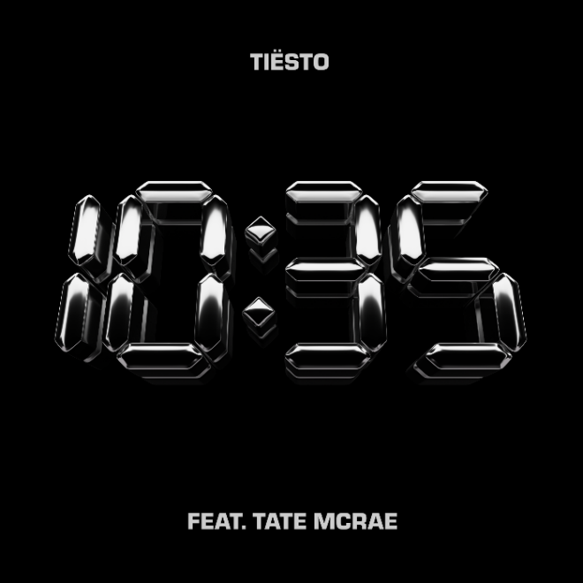
DOWNLOAD ARTWORK HERE

ABOUT TIËSTO:
Tiësto is a GRAMMY® Award-winning, RIAA platinum-certified, international icon. The DJ and producer is the only artist to ever hold the titles of “The Greatest DJ of All Time” courtesy of Mixmag, and “#1 DJ” according to Rolling Stone. From his underground dance floor bangers to his high profile Las Vegas
residency and worldwide crossover success, Tiësto created the blueprint that defines what it means to be a superstar in today’s dance music world. With over 36 million albums sold, 10+ billion cumulative streams, and a social platform with an audience now exceeding 30 million fans around the globe, he continues to revolutionize the dance music landscape. Tiësto’s first single upon signing with Atlantic Records, 2020’s “The Business,” has dominated airplay and charts worldwide since its September 2020 release, hitting #1 at US Dance radio while also garnering over 1.6 billion worldwide streams to date. A top 10 hit in 10 countries, as well as a Top 50 success on Spotify in 31 countries, “The Business” was honored with “Best Dance/Electronic Recording” nomination at the 64th Annual GRAMMY® Awards as well as 15 platinum certifications and eight gold certifications in countries around the world. “Don’t Be Shy” with Karol G followed in 2021, marking Karol G’s first-ever English language song and the first Latin Artist collaboration for Tiësto. The historic track currently boasts over 867 million streams, over 1.2 million TikTok creates, and video views exceeding 290 million. The third single from Tiësto’s upcoming album on Atlantic Records, “The Motto” with Ava Max, proved another blockbuster, reaching the top 5 on Billboard’s “Dance/Electronic Songs” chart while earning more than 929 million worldwide streams to date. This summer saw “Hot In It” with Charli XCX reach the top 10 on Billboard’s “Hot Dance/Electronic Song” chart, fueled in part by over 200 million views across TikTok and IG Reels, and over 122 million streams to date.

ABOUT TATE MCRAE:
Calgary native singer/songwriter/dancer Tate McRae has become the artist to watch with over 4.9 billion career streams, over 765 million video views, a #1 Top 40 hit and multiple #1 dance hits. She’s been featured on Forbes 30 Under 30 list for 2021 as the youngest musician on the list as well as Apple’s Up Next Artist for 2021, Amazon and Pandora’s Artist to Watch list in 2021 and People Magazine’s 2021 One’s to Watch list. Tate was also named one of YouTube’s Artists on the Rise, and MTV’s Push Artist in 2020. She’s been nominated for a 2021 People’s Choice Award, three 2022 iHeartRadio Music Awards and a 2022 Billboard Music Award.

Tate’s #1 RIAA certified 3x Platinum single “you broke me first” has amassed over 1.6 billion streams worldwide since its release in 2020. She has two EPs under her belt, TOO YOUNG TO BE SAD (2021) and ALL THE THINGS I NEVER SAID (2020). She’s collaborated with various artists including Regard & Troye Sivan on their #1 dance hit “You,” along with Khalid on their track “working,” blackbear’s “u love u” and Jeremy Zucker on her viral single “that way.” Tate has performed at various music festivals including Lollapalooza, Bonnaroo, Firefly, The Governor’s Ball, Austin City Limits and more.

Earlier this year, the budding star released her highly anticipated debut album, i used to think i could fly which landed at #1 on Spotify’s Global Top Albums Debut Chart, charted in the top 10 in multiple countries upon release and has garnered over 978 million streams to date. Featuring RIAA certified
Platinum single “she’s all i wanna be” and certified Gold track “feel like shit,” the album showcases Tate at the top of her game with all-star writing collaborators and producers including Greg Kurstin, Finneas, Charlie Puth, Alexander 23, Blake Slatkin, Louis Bell and more. The stunning album received praise from the likes of Billboard who said “…Tate McRae steps into stardom on her long-awaited debut album” while GRAMMY.com stated, “…each track shows McRae is ready to be one of her generation's most raw-and-real superstars.”

Appearing on Variety’s 2022 Power of Young Hollywood list and for the second consecutive year, Billboard’s 21 Under 21 list, Tate was named this year’s brand ambassador for both Maybelline and Essentia.

ABOUT ATLANTIS THE ROYAL:
The new iconic landmark of Dubai, Atlantis The Royal welcomes guests to an experience that will completely redefine their perspective of luxury. Crafted by the world’s leading designers, architects and artists, this is a destination where everything has been designed to challenge the boundaries of imagination. Atlantis The Royal ignites the horizon with a collection of 795 elegant Rooms, Suites and Signature Penthouses. Featuring stunning views of the Dubai skyline and Arabian Sea, 44 of them have private infinity pools. The resort delivers a curated array of awe-inspiring experiences, inviting guests to swim amongst the clouds in sky pools, be dazzled by fountains that breathe fire or dine at more celebrity chef restaurants than anywhere else in the world. Guests are taken on a journey of the impossible, with artful masterpieces, iconic entertainment and beautiful craftsmanship at every turn, where the highest level of service will set a new standard in excellence.

Atlantis The Royal is the place where something incredible happens at every moment.

This is Atlantis The Royal.

This Is It.

https://www.atlantis.com/atlantis-the-royal

CONNECT WITH TIËSTO:
OFFICIAL | FACEBOOK | INSTAGRAM | SPOTIFY | TIKTOK | TWITTER | YOUTUBE

CONNECT WITH TATE MCRAE:
OFFICIAL | FACEBOOK | INSTAGRAM | SPOTIFY | TIKTOK | TWITTER | YOUTUBE

FOR MORE INFORMATION ON TIËSTO:
Paige Rosoff – Atlantic Records
Paige.Rosoff@atlanticrecords.com

FOR MORE INFORMATION ON TATE MCRAE:
Kirsten Mikkelson – RCA Records
kirsten.mikkelson@sonymusic.com

FOR MORE INFORMATION ON ATLANTIS THE ROYAL:
Rebecca Hall – Director, Public Relations
Mobile: (+971) 551100153
rebecca.hall@atlantisdubai.com
atlantistheroyal@freuds.com

