**A BOOGIE WIT DA HOODIE ANNOUNCES THE “ME VS MYSELF” TOUR**

**NYC BRED, MULTI-PLATINUM SUPERSTAR’S TOUR ANNOUNCE COMES DAYS AFTER UPCOMING SHOW AT THE APOLLO THEATER SELLING OUT IN UNDER 10 MINUTES**

**NEW ALBUM ‘ME VS MYSELF’ OUT EVERYWHERE DECEMBER 9**

[**PRE-SAVE *ME VS. MYSELF***](https://nam04.safelinks.protection.outlook.com/?url=https%3A%2F%2Fwww.aboogiehbtl.com%2Fmevsmyself&data=05%7C01%7CTaylor.Apel%40atlanticrecords.com%7C6d8f0023d5f5403d5d8908dac65612ce%7C8367939002ec4ba1ad3d69da3fdd637e%7C0%7C0%7C638040370229393250%7CUnknown%7CTWFpbGZsb3d8eyJWIjoiMC4wLjAwMDAiLCJQIjoiV2luMzIiLCJBTiI6Ik1haWwiLCJXVCI6Mn0%3D%7C3000%7C%7C%7C&sdata=WfYwDo9xFHcCKTFMeopI6aegjO1tZjxJ7O5aCKlifvY%3D&reserved=0)

**LOCAL PRE-SALE STARTING NOVEMBER 16 AT 10AM LOCAL TIME  
PUBLIC ON-SALE STARTING NOVEMBER 18 AT 10AM LOCAL TIME**

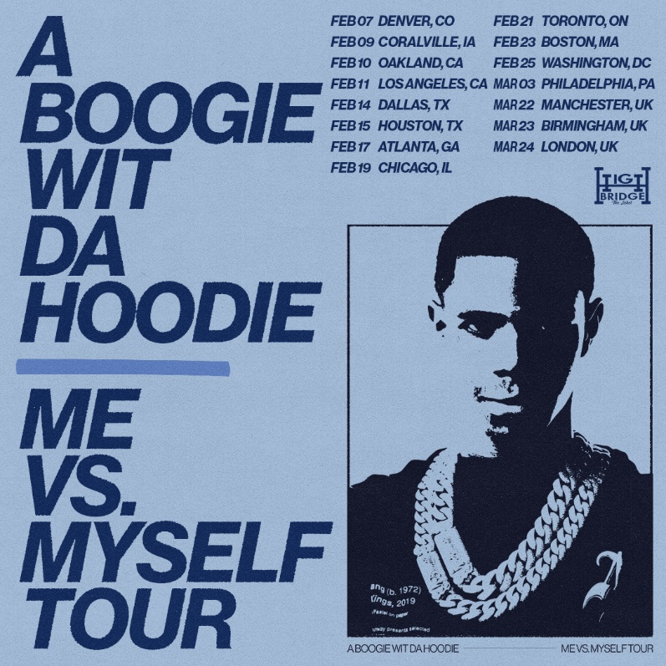

**New York, New York – November 14, 2022 –** Multi-platinum, chart-topping global superstar **A Boogie wit da Hoodie** will hit road for the “**Me Vs Myself”** tour. Kicking off in Denver on February 2nd, the headlining trek will run through March 2023 with stops in Los Angeles, Dallas, Chicago and more. The “Me Vs Myself” tour announcement is on the heels of A Boogie’s **“One Night Only at the Apollo”** show at New York City’s famed Apollo Theater selling out in less than 10 minutes.

**The pre-sale for the “Me Vs Myself” tour will start Wednesday, November 16th at 10am local time and public on-sale will begin Friday, November 18th at 10am local time. Tickets and additional information available at** [https://www.aboogiehbtl.com/mevsmyself](https://nam04.safelinks.protection.outlook.com/?url=https%3A%2F%2Fwww.aboogiehbtl.com%2Fmevsmyself&data=05%7C01%7CTaylor.Apel%40atlanticrecords.com%7C6d8f0023d5f5403d5d8908dac65612ce%7C8367939002ec4ba1ad3d69da3fdd637e%7C0%7C0%7C638040370229393250%7CUnknown%7CTWFpbGZsb3d8eyJWIjoiMC4wLjAwMDAiLCJQIjoiV2luMzIiLCJBTiI6Ik1haWwiLCJXVCI6Mn0%3D%7C3000%7C%7C%7C&sdata=WfYwDo9xFHcCKTFMeopI6aegjO1tZjxJ7O5aCKlifvY%3D&reserved=0)**.**

The upcoming tour will follow the release of A Boogie’s highly anticipated album, ***Me Vs Myself,*** out everywhere **December 9th** via Highbridge The Label/Atlantic Records.

[**PRE-SAVE *ME VS. MYSELF***](https://nam04.safelinks.protection.outlook.com/?url=https%3A%2F%2Fwww.aboogiehbtl.com%2Fmevsmyself&data=05%7C01%7CTaylor.Apel%40atlanticrecords.com%7C6d8f0023d5f5403d5d8908dac65612ce%7C8367939002ec4ba1ad3d69da3fdd637e%7C0%7C0%7C638040370229393250%7CUnknown%7CTWFpbGZsb3d8eyJWIjoiMC4wLjAwMDAiLCJQIjoiV2luMzIiLCJBTiI6Ik1haWwiLCJXVCI6Mn0%3D%7C3000%7C%7C%7C&sdata=WfYwDo9xFHcCKTFMeopI6aegjO1tZjxJ7O5aCKlifvY%3D&reserved=0)

**For all A Boogie wit da Hoodie press inquiries, please contact:**

Jason Davis – [Jason.Davis@atlanticrecords.com](mailto:Jason.Davis@atlanticrecords.com)

Connect with A Boogie wit da Hoodie: [Instagram](https://nam04.safelinks.protection.outlook.com/?url=https%3A%2F%2Fwww.instagram.com%2Faboogievsartist%2F&data=05%7C01%7CTaylor.Apel%40atlanticrecords.com%7C6d8f0023d5f5403d5d8908dac65612ce%7C8367939002ec4ba1ad3d69da3fdd637e%7C0%7C0%7C638040370229393250%7CUnknown%7CTWFpbGZsb3d8eyJWIjoiMC4wLjAwMDAiLCJQIjoiV2luMzIiLCJBTiI6Ik1haWwiLCJXVCI6Mn0%3D%7C3000%7C%7C%7C&sdata=WqUAy1XXGZX5IWdbxhgX1Z68%2BFEV5KetDzdYzrfp084%3D&reserved=0) | [Twitter](https://nam04.safelinks.protection.outlook.com/?url=https%3A%2F%2Ftwitter.com%2FArtistHBTL&data=05%7C01%7CTaylor.Apel%40atlanticrecords.com%7C6d8f0023d5f5403d5d8908dac65612ce%7C8367939002ec4ba1ad3d69da3fdd637e%7C0%7C0%7C638040370229393250%7CUnknown%7CTWFpbGZsb3d8eyJWIjoiMC4wLjAwMDAiLCJQIjoiV2luMzIiLCJBTiI6Ik1haWwiLCJXVCI6Mn0%3D%7C3000%7C%7C%7C&sdata=zCfSiwA043gAYNIjZ2t92UZcLJlG102dk8KC6iSZ%2Fmk%3D&reserved=0) | [Facebook](https://nam04.safelinks.protection.outlook.com/?url=https%3A%2F%2Furldefense.com%2Fv3%2F__https%3A%2F%2Fnam04.safelinks.protection.outlook.com%2F%3Furl%3Dhttps*3A*2F*2Fwww.facebook.com*2FArtistHBTL*2F%26data%3D05*7C01*7CJason.Davis*40atlanticrecords.com*7C2e666ea3a0df41fa9ec808dac1f0a18b*7C8367939002ec4ba1ad3d69da3fdd637e*7C0*7C0*7C638035536490570239*7CUnknown*7CTWFpbGZsb3d8eyJWIjoiMC4wLjAwMDAiLCJQIjoiV2luMzIiLCJBTiI6Ik1haWwiLCJXVCI6Mn0*3D*7C3000*7C*7C*7C%26sdata%3DFIYKD7oEYdmryYwAu8J1TNKGo*2FSJ0f4siAdIsTIwSuQ*3D%26reserved%3D0__%3BJSUlJSUlJSUlJSUlJSUlJSUlJSUlJQ!!FBl7RhjNdtJEi0k!vHu-fIGP8cnFCUN25jBPX1dyX7YIUmTNYb5GTZD7COOAgG-IJA0UAHFcYrOhC_DS1B2QhJSz2wMufmBdxvGGh5AwTegM%24&data=05%7C01%7CTaylor.Apel%40atlanticrecords.com%7C6d8f0023d5f5403d5d8908dac65612ce%7C8367939002ec4ba1ad3d69da3fdd637e%7C0%7C0%7C638040370229393250%7CUnknown%7CTWFpbGZsb3d8eyJWIjoiMC4wLjAwMDAiLCJQIjoiV2luMzIiLCJBTiI6Ik1haWwiLCJXVCI6Mn0%3D%7C3000%7C%7C%7C&sdata=49lmzIs1mCLVpfygC2QfsqjWd7QgAu6hReD9lTQd1V0%3D&reserved=0) | [YouTube](https://nam04.safelinks.protection.outlook.com/?url=https%3A%2F%2Furldefense.com%2Fv3%2F__https%3A%2F%2Fnam04.safelinks.protection.outlook.com%2F%3Furl%3Dhttps*3A*2F*2Fwww.youtube.com*2Fchannel*2FUCfgsFOdVScKetBXYrFNr5LQ%26data%3D05*7C01*7CJason.Davis*40atlanticrecords.com*7C2e666ea3a0df41fa9ec808dac1f0a18b*7C8367939002ec4ba1ad3d69da3fdd637e*7C0*7C0*7C638035536490570239*7CUnknown*7CTWFpbGZsb3d8eyJWIjoiMC4wLjAwMDAiLCJQIjoiV2luMzIiLCJBTiI6Ik1haWwiLCJXVCI6Mn0*3D*7C3000*7C*7C*7C%26sdata%3D*2BGQvqQ7*2FBsdF4Oq6pb85BHrmcxyG5tGzxCaG1TQWW5w*3D%26reserved%3D0__%3BJSUlJSUlJSUlJSUlJSUlJSUlJSUlJSU!!FBl7RhjNdtJEi0k!vHu-fIGP8cnFCUN25jBPX1dyX7YIUmTNYb5GTZD7COOAgG-IJA0UAHFcYrOhC_DS1B2QhJSz2wMufmBdxvGGh8z7bSh3%24&data=05%7C01%7CTaylor.Apel%40atlanticrecords.com%7C6d8f0023d5f5403d5d8908dac65612ce%7C8367939002ec4ba1ad3d69da3fdd637e%7C0%7C0%7C638040370229393250%7CUnknown%7CTWFpbGZsb3d8eyJWIjoiMC4wLjAwMDAiLCJQIjoiV2luMzIiLCJBTiI6Ik1haWwiLCJXVCI6Mn0%3D%7C3000%7C%7C%7C&sdata=keTDYvOTKDpQr6G67aWEk8R5mXXmpKmJV3vsZ9rArx8%3D&reserved=0) | [Website](https://nam04.safelinks.protection.outlook.com/?url=https%3A%2F%2Furldefense.com%2Fv3%2F__https%3A%2F%2Fnam04.safelinks.protection.outlook.com%2F%3Furl%3Dhttps*3A*2F*2Fwww.aboogiehbtl.com*2F%26data%3D05*7C01*7CJason.Davis*40atlanticrecords.com*7C2e666ea3a0df41fa9ec808dac1f0a18b*7C8367939002ec4ba1ad3d69da3fdd637e*7C0*7C0*7C638035536490726456*7CUnknown*7CTWFpbGZsb3d8eyJWIjoiMC4wLjAwMDAiLCJQIjoiV2luMzIiLCJBTiI6Ik1haWwiLCJXVCI6Mn0*3D*7C3000*7C*7C*7C%26sdata%3DDmqhDvxoSZiAN7KzeHzcSZQqLiA5xJ*2BR0fAWkWiqdaM*3D%26reserved%3D0__%3BJSUlJSUlJSUlJSUlJSUlJSUlJSUl!!FBl7RhjNdtJEi0k!vHu-fIGP8cnFCUN25jBPX1dyX7YIUmTNYb5GTZD7COOAgG-IJA0UAHFcYrOhC_DS1B2QhJSz2wMufmBdxvGGh5UnGvvg%24&data=05%7C01%7CTaylor.Apel%40atlanticrecords.com%7C6d8f0023d5f5403d5d8908dac65612ce%7C8367939002ec4ba1ad3d69da3fdd637e%7C0%7C0%7C638040370229393250%7CUnknown%7CTWFpbGZsb3d8eyJWIjoiMC4wLjAwMDAiLCJQIjoiV2luMzIiLCJBTiI6Ik1haWwiLCJXVCI6Mn0%3D%7C3000%7C%7C%7C&sdata=WyQ8tXNE1yi0VeU6CptJbka8HeCzFuhYW%2FuFYW9DK2o%3D&reserved=0)  
  
***

**“ME VS MYSELF” TOUR:   
*(additional dates to be announced)***

2/7 – Denver, CO – The Mission Ballroom   
2/9 – Coralville, IA – Xtreme Arena   
2/10 – Oakland, CA – Fox Theater   
2/11 – Los Angeles, CA – The Novo   
2/14- Dallas, TX – Southside Ballroom  
2/15 – Houston, TX - Bayou Music Center  
2/17 – Atlanta, GA – The Eastern   
2/19 – Chicago, IL – Byline Bank Aragon Ballroom   
2/21 – Toronto, ON – Coca-Cola Coliseum   
2/23 – Boston, MA – MGM Music Hall at Fenway   
2/25 – Washington, DC – Echostage   
3/3 – Philadelphia, PA – Liacouras Center

3/22 – Manchester, UK – Manchester Academy

3/23 – Birmingham, UK – Birmingham Academy

3/24 – London, UK – Alexandra Palace

***

[**DOWNLOAD HI-RES PRESS PHOTOS**](https://warnermusicgroup.app.box.com/s/7617b1w4bkmnzmhk86liqeb5rq14hda3)Photo Credit: Jimmy Fontaine