COLDPLAY’S GLOBAL
LIVE CINEMA BROADCAST
BREAKS RECORD

FANS WATCH IN 81 COUNTRIES AROUND THE WORLD
AS BAND ARE JOINED ONSTAGE BY JIN OF BTS

LAST CHANCE TO WATCH IN CINEMAS TODAY

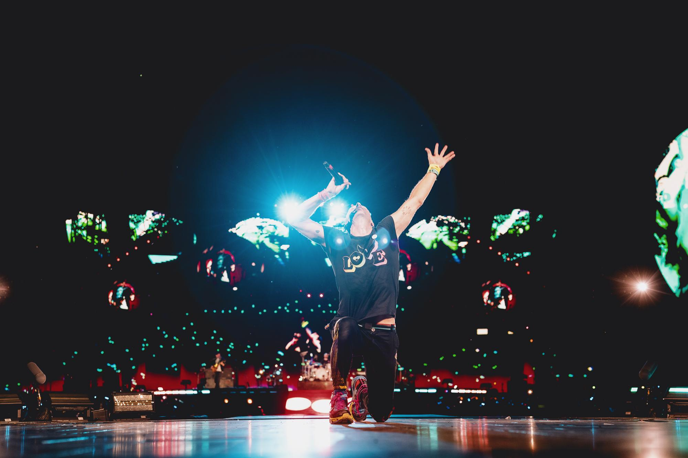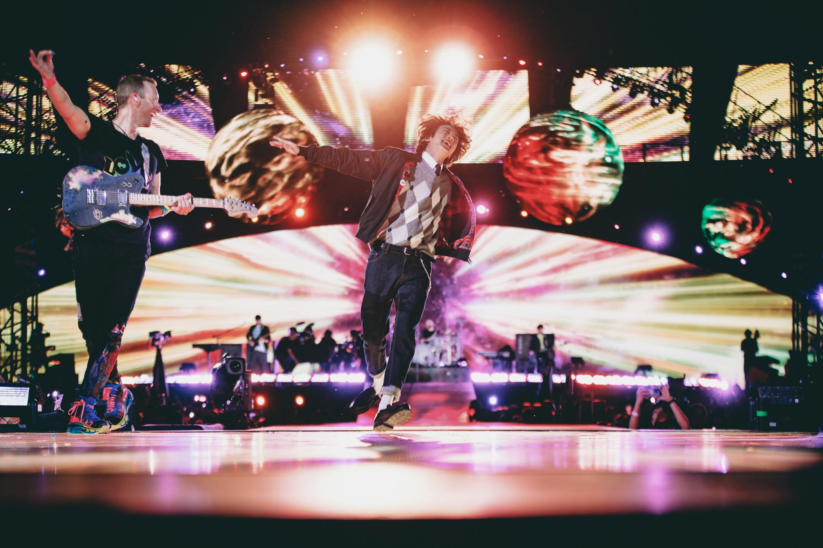
Download hi-res photos here

SAT, OCT 29th, 2022 – Last night, Coldplay’s triumphant show at Buenos Aires’ River Plate stadium - one of ten sold out nights at the venue - was broadcast live to cinema audiences in 81 countries around the world - a record-breaking number of countries for a live cinema event.

Fans have a final chance to catch the performance – presented in partnership with Trafalgar Releasing – on the big screen today, with tickets and local screening times at coldplaycinema.live. See a sizzle reel of the concert on YouTube, HERE.

As well performing classic hits from across their career in a stadium bursting with lights, lasers, fireworks and LED wristbands, Coldplay were joined on stage by Jin of BTS for the debut live performance of The Astronaut - Jin’s new solo single, co-written by Coldplay. The full video of the performance (taken from the cinema presentation) can be seen on YouTube, HERE.

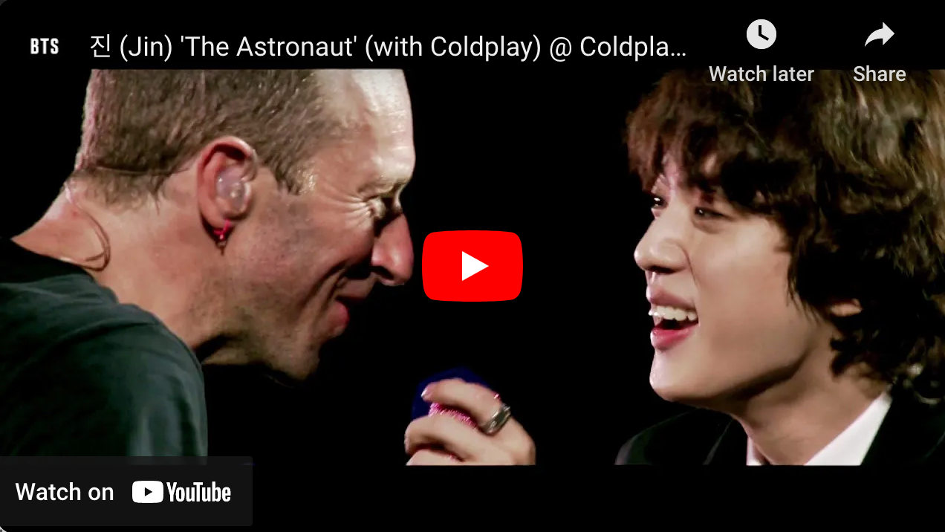

Meanwhile, the audience at one cinema in Burbank, California was surprised with the LED wristbands which are such a highlight of Coldplay’s concerts. Footage of the lucky audience - whose wristbands were synchronised with the performance - can be seen HERE.

The Live Broadcast from Buenos Aires is directed by acclaimed BAFTA-winning and Grammy-nominated director Paul Dugdale and presented in partnership with Trafalgar Releasing, who also executive produce alongside CJ 4DPlex.

For more information please visit Coldplay.com or contact:
Sheila Richman | sheila.richman@atlanticrecords.com
Ted Sullivan | ted.sullivan@atlanticrecords.com
Gabrielle Reese (Tour) | gabrielle.reese@atlanticrecords.com

