FOR IMMEDIATE RELEASE
NOVEMBER 10, 2022
ENCHANTING SHARES “KEEP IT PLAYA”
R&B TRACK OFF RISING 1017 GLOBAL MUSIC STAR’S FORTHCOMING PROJECT
ACCOMPANIED BY OFFICIAL MUSIC VIDEO
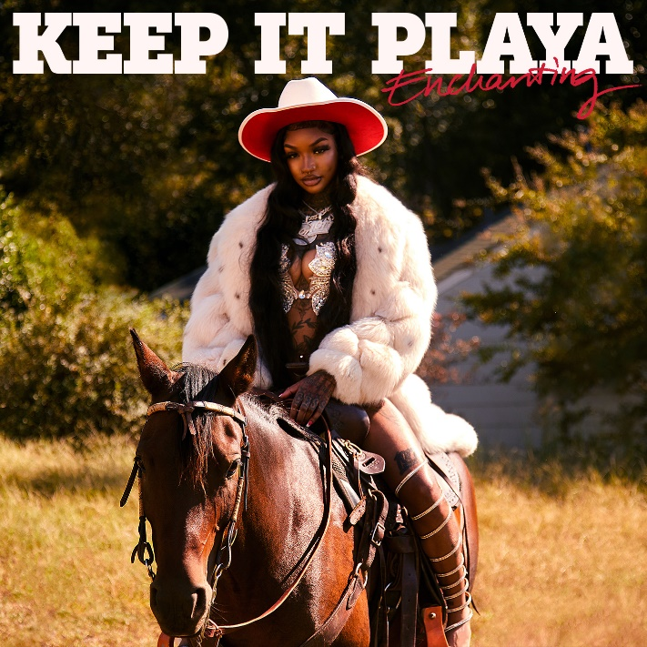
DOWNLOAD ARTWORK HERE
BUY/STREAM: LINK
WATCH VIDEO: LINK
1017 Global Music’s Rap and R&B princess Enchanting has released the charismatic, soulful single “Keep It Playa,” produced by Jetsonmade and Pooh Beatz (Jack Harlow). “Keep It Playa” is the third R&B track to come off her new project that will feature both Chant’s Rap and R&B side.
“Keep It Playa” follows “What I Want” featuring Jacquees and her appearance on the 1017 compilation deluxe extension SO ICY GANG: THE REUP with “Large Amounts (ft. Gucci Mane).” Earlier this year, Chant shared the vulnerable “Take It Back” after a series of hard-hitting collabs in 2021 including “Track & Field (Feat. Kali)” and “Freaky Deaky (Feat. Coi Leray),” adding to her combined 100M global streams to date. Both followed Enchanting’s release of “Want Sum,” a fan favorite that’s surpassed 2.5M official video views and 9M streams to date. The rising Rap and R&B star has garnered 38M+ US Streams and 15M+ YouTube views to date.
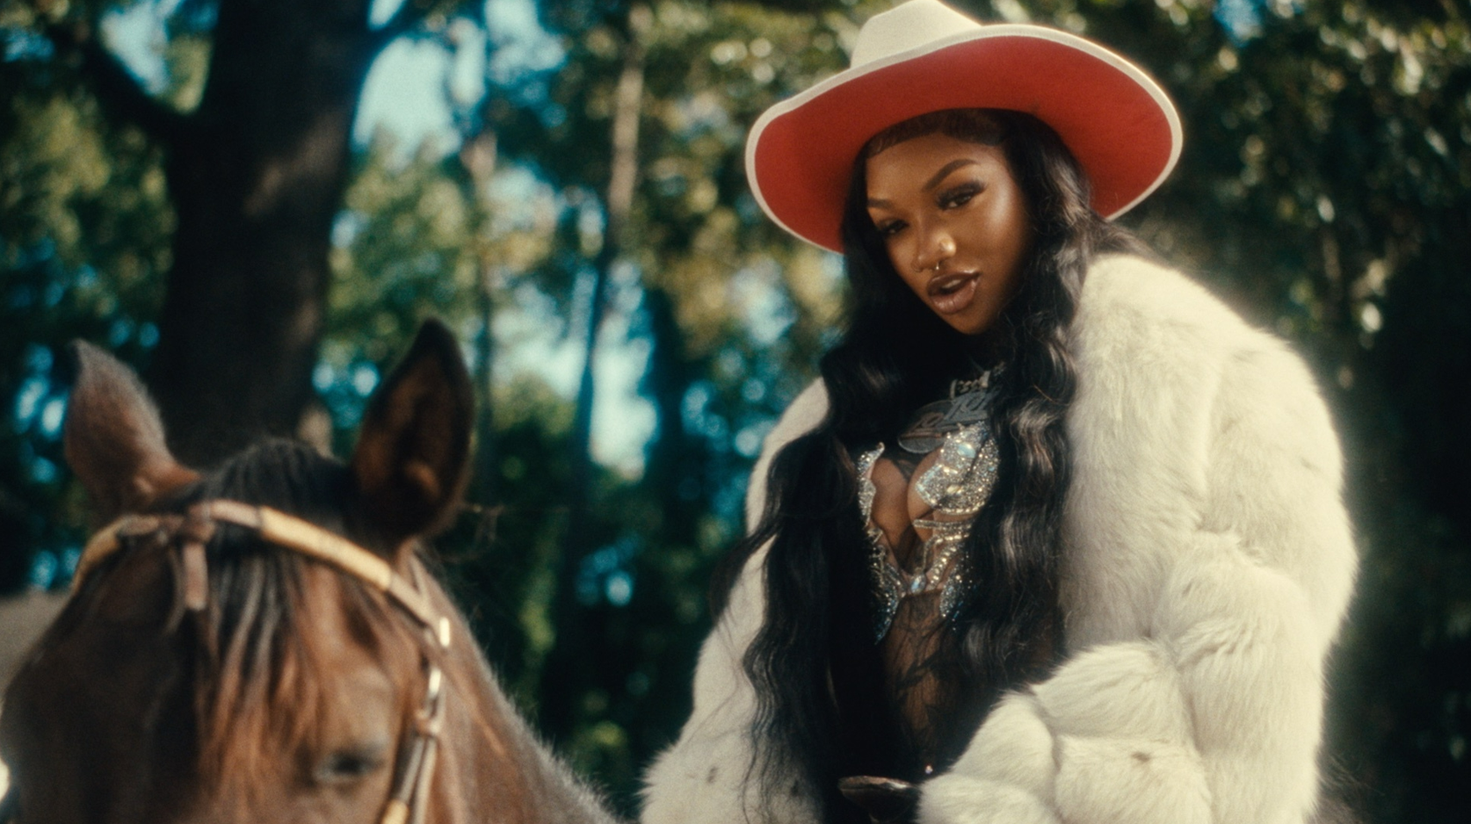
DOWNLOAD PRESS PHOTOS HERE
ABOUT ENCHANTING
Enchanting’s stage name speaks for itself. Pressing play on an Enchanting verse, you’re instantly mesmerized by the ethereal textures the 24-year-old songstress brings to the mic. Coming out of Fort Worth, Texas, Enchanting began to pursue music around the age of 18. She defines her style as something chill with a dash of neo-Soul, a twinge of old school R&B, with some modern trap flavor sprinkled in. “It’s like Trap-n-Blues,” Enchanting expresses. The genre blend is perfect for Enchanting, who uses music as a vehicle of expression, not only for herself but for others.
Enchanting has appeared alongside her 1017 Global Music labelmates on Gucci Mane’s compilation tape Gucci Mane Presents: So Icy Summer, So Icy Christmas, and more. Enchanting credits Dallas’ superproducer J. White Did It for making the connection between herself and Atlanta rap icon Gucci Mane. “I guess he told Gucci about me,” Enchanting explains with excitement and gratitude; “Gucci called me the next day.” Working on her upcoming mixtape, her legacy is one of showing other aspiring artists from her city they can do it too- more than a natural artist, she’s a natural-born motivator with a sterling personality.
###
CONNECT WITH ENCHANTING
TWITTER
INSTAGRAM
YOUTUBE
PRESS CONTACTS
Ted Sullivan | Ted.Sullivan@atlanticrecords.com
Ashley Kalmanowitz | Ashley.Kalmanowitz@atlanticrecords.com

