FOR IMMEDIATE RELEASE

OCTOBER 28, 2022

**Forest Blakk releases *Every Little Detail* EP**

**Acclaimed singer/songwriter soundtracks your love story with 8-track collection,**

**including platinum-certified smash “If You Love Her”**

**2023 North American headline tour kicks off January 26th in Vancouver,**

**tickets on sale next Friday, November 4th**

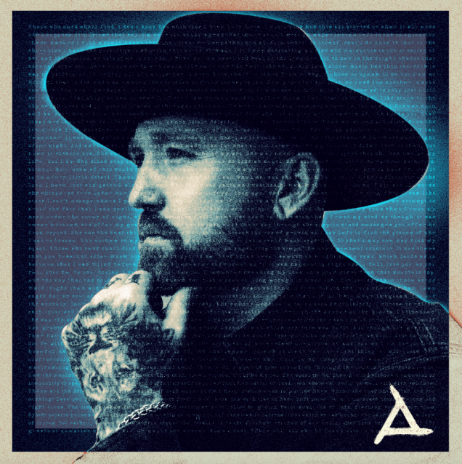

[DOWNLOAD HIGH-RES ARTWORK HERE](http://press.atlanticrecords.com/forest-blakk/)

**STREAM *EVERY LITTLE DETAIL* EP:** [LINK](https://forestblakk.lnk.to/ELD)

Acclaimed singer/songwriter **Forest Blakk** soundtracks your love story on his new ***Every Little Detail*** EP– available now via **Atlantic** **Records**. Equal parts intimate and relatable, the 8-track collection finds Blakk writing from deeply personal experience and sharing some of his most vulnerable moments. The EP arrives with news of a 17-date North American headline tour kicking off January 26th in Vancouver, BC with tickets on sale next Friday, November 4th – for more information please visit [forestblakk.com/tour](https://www.forestblakk.com/tour/).

***Every Little Detail*** features Blakk’s breakout Platinum-certified smash single **“**[**If You Love Her**](https://www.youtube.com/watch?v=wDaiiluanQc),” which alone has amassed over 310 million total global streams, earned Blakk his official US chart debut on **Billboard**’s **Emerging Artists** chart, his national US TV debut on **ABC**’s **Live with Kelly & Ryan,** top 30 placement on the Hot AC radio chart & saw the singer/songwriter collaborate with **Meghan** **Trainor** on a stunning duet version. Since release the song has become a wedding-playlist staple, despite Blakk’s original inspiration for the song stemming from an intense breakup. *“I wrote a song that captured exactly who she is,”* Blakk says proudly, *“(and) it resonated with what seems like every other girl around the world.”*

Soon after, Blakk’s follow-up singles “[**Give You Love**](https://www.youtube.com/watch?v=kuoo4ipaXsk)” and “[**Fall Into Me**](https://www.youtube.com/watch?v=NCUI2ziMzgw) quickly amassed over 86 million streams, with the latter also reaching top 30 on the Hot AC radio chart and Gold-certification status in his native Canada. Co-written alongside **Matchbox Twenty** front man **Rob Thomas** and **Gregg Wattenberg**, “**Fall Into Me**” shares perspective from a more wonderful personal place, inspired by Blakk’s relationship with his now-girlfriend, Tooley. The song continues in his tradition of narrating for a wider audience, currently being featured in a perfectly fitting ad campaign for **Kay Jewelers**.

***Every Little Detail*** also features stand out tracks “**Me**” (a touching ode to finding someone to love your flaws) and “**I Hope You Know**” (a dedication to his grandmother – one of the most impactful people in his life, having gifted him a guitar which later became a mechanism of solace and reprieve during his tumultuous upbring).

Highlighted as one of **PEOPLE Magazine**’s *“talented emerging artists making their mark on the musical landscape”* and deemed an *“artist on the rise”* by **Billboard**, Blakk made his debut with his 2018 EP ***Minutes*** and follow-up 2020 sophomore EP ***Sideways*** – the latter of which saw Blakk collaborate with the likes of **Will** **IDAP** (**Train**, **Florida** **Georgia** **Line**), **Nick Long** (**King Princess**), **Carl Ryden** (**Ricky Martin**, **David Guetta**), **Ollie** **Green** (**Freya** **Ridings**, **Gavin** **James**) & more to tell a love story through an incredibly realistic and candid lens. The 6-track collection featured singles “**I Wish I Knew**” (deemed an *“introspective look at love and love lost”* by **American Songwriter**) and uplifting anthem of resilience “**Put Your Hands Up**,” which debuted on an episode of **ABC**’s ***Grey’s Anatomy***. A compelling live performer, Blakk has toured extensively supporting **NEEDTOBREATHE**, **Gavin James** & most recently this past summer throughout North America with **Dean Lewis**.

***Every Little Detail* EP:**

1. Another Love Song

2. Give You Love

3. I Remember

4. I Hope You Know

5. Me

6. If You Love Her

7. Fall Into Me

8. Every Little Detail

**Forest Blakk Live:**

1/26 – Vancouver, BC @ Fox Cabaret

1/27 – Seattle, WA @ Madame Lou’s

1/28 – Portland, OR @ Doug Fir Lounge

1/31 – San Francisco, CA @ Cafe Du Nord

2/1 – Los Angeles, CA @ The Moroccan Lounge

2/7 – Washington DC @ Union Stage

2/8 – Philadelphia, PA @ World Cafe Live

2/10 – New York, NY @ Mercury Lounge

2/13 – Boston, MA @ Cafe 939 at Berklee

2/16 – Ottawa, ON @ The 27 Club

2/17 – Montreal, QC @ Bar Le Ritz

2/18 – Toronto, ON @ The Rivoli

2/19 – London, ON @ Rum Runners

2/22 – Chicago, IL @ Schubas Tavern

2/23 – Minneapolis, MN @ 7th Street Entry

2/25 – Denver, CO @ Larimer Lounge

2/26 – Salt Lake City, UT @ Kilby Court

CREDIT: JIMMY FONTAINE – [DOWNLOAD HIGH-RES HERE](http://press.atlanticrecords.com/forest-blakk/)

**CONNECT WITH FOREST BLAKK:**

[TIKTOK](https://www.tiktok.com/@forestblakk?lang=en) | [TWITTER](https://twitter.com/forestblakk) | [FACEBOOK](https://www.facebook.com/forestblakk) | [INSTAGRAM](https://www.instagram.com/forestblakk) | [YOUTUBE](https://www.youtube.com/channel/UC9vKX9Hz5dGVrhD5v3-UnAQ) | [FORESTBLAKK.COM](http://forestblakk.com/)

**CONTACT:**

[ted.sullivan@atlanticrecords.com](mailto:ted.sullivan@atlanticrecords.com)