FOR IMMEDIATE RELEASE

NOVEMBER 14, 2022

**INGRID ANDRESS ANNOUNCES ‘THE GOOD PERSON TOUR’**

**CELEBRATING SECOND COUNTRY RADIO #1, “WISHFUL DRINKING (WITH SAM HUNT)”**

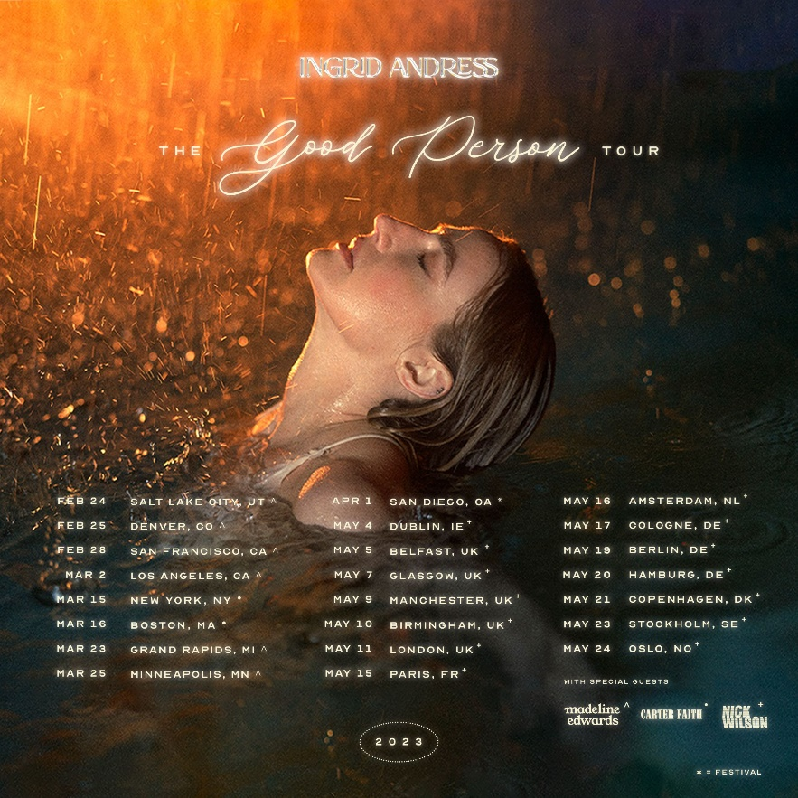

3x GRAMMY-nominee **Ingrid Andress** has just announced US and overseas dates for her headlining *The Good Person Tour*. General on-sale will begin this Friday (11/18) at 10 AM local for the 20+ date trek, which will kick off February 24th in Salt Lake City and make stops in NYC, LA and London before wrapping up in Norway May 24th.

Andress also recently reached the top of the Country Aircheck chart with her Platinum-certified hit “Wishful Drinking (with Sam Hunt),” as seen on ***The Late Show with Stephen Colbert***([LISTEN HERE](https://nam04.safelinks.protection.outlook.com/?url=https%3A%2F%2Fyoutu.be%2FBYm2kIKY8Zg&data=05%7C01%7COlivia.Lee%40atlanticrecords.com%7C11ac40bc0a83457b8f5708dac50fab70%7C8367939002ec4ba1ad3d69da3fdd637e%7C0%7C0%7C638038968363088627%7CUnknown%7CTWFpbGZsb3d8eyJWIjoiMC4wLjAwMDAiLCJQIjoiV2luMzIiLCJBTiI6Ik1haWwiLCJXVCI6Mn0%3D%7C3000%7C%7C%7C&sdata=HGca%2BZVNDf9ES1sKz6T%2B4G%2BcCUFfNgVMVqFXMSd2aww%3D&reserved=0)). The “moving country-pop ballad that perfectly combines Andress’ soft pitch and Hunt’s husky vocals” (*V Magazine*) has been a fan-favorite since day one and is featured on her celebrated sophomore album, *Good Person* ([LISTEN HERE)](https://nam04.safelinks.protection.outlook.com/?url=https%3A%2F%2Fingridandress.lnk.to%2Fgoodperson&data=05%7C01%7COlivia.Lee%40atlanticrecords.com%7C11ac40bc0a83457b8f5708dac50fab70%7C8367939002ec4ba1ad3d69da3fdd637e%7C0%7C0%7C638038968363088627%7CUnknown%7CTWFpbGZsb3d8eyJWIjoiMC4wLjAwMDAiLCJQIjoiV2luMzIiLCJBTiI6Ik1haWwiLCJXVCI6Mn0%3D%7C3000%7C%7C%7C&sdata=NxAzI4O2rDkESHC5YN6AVog%2FKvauNaJ%2BQMAWwYmeaTs%3D&reserved=0). “Wishful Drinking” is Andress’ second career #1 and Hunt’s tenth.

Hailed by ***The New York Times***as “a Nashville outsider who paved her own way in” ([READ HERE](https://nam04.safelinks.protection.outlook.com/?url=https%3A%2F%2Fwww.nytimes.com%2F2022%2F08%2F25%2Farts%2Fmusic%2Fingrid-andress-good-person.html&data=05%7C01%7COlivia.Lee%40atlanticrecords.com%7C11ac40bc0a83457b8f5708dac50fab70%7C8367939002ec4ba1ad3d69da3fdd637e%7C0%7C0%7C638038968363088627%7CUnknown%7CTWFpbGZsb3d8eyJWIjoiMC4wLjAwMDAiLCJQIjoiV2luMzIiLCJBTiI6Ik1haWwiLCJXVCI6Mn0%3D%7C3000%7C%7C%7C&sdata=3a5gwASKQ8GaYfw7Fp0S45eG8rtdJtnFkWGUQjs3OXs%3D&reserved=0)), Andress returns to the reflection and confession at the core of her acclaimed debut, *Lady Like*, and plumbs even deeper on *Good Person*. In the co-producer’s chair once again (alongside Sam Ellis, who played the same role on *Lady Like*), Andress pushed for bold, experimental sounds that blended banjos with vocoders; swung from sweeping orchestration to spare, acoustic-based arrangements; and showcased previously unexplored parts of her vocal range.

Andress also co-wrote every track, including the album’s title-track that she performed on ***The Tonight Show Starring Jimmy Fallon***earlier this summer ([WATCH HERE](https://nam04.safelinks.protection.outlook.com/?url=https%3A%2F%2Fwww.youtube.com%2Fwatch%3Fv%3DsBb2gXP-0vw%26list%3DRDsBb2gXP-0vw%26start_radio%3D1&data=05%7C01%7COlivia.Lee%40atlanticrecords.com%7C11ac40bc0a83457b8f5708dac50fab70%7C8367939002ec4ba1ad3d69da3fdd637e%7C0%7C0%7C638038968363088627%7CUnknown%7CTWFpbGZsb3d8eyJWIjoiMC4wLjAwMDAiLCJQIjoiV2luMzIiLCJBTiI6Ik1haWwiLCJXVCI6Mn0%3D%7C3000%7C%7C%7C&sdata=T0%2B63CuFJmWxYNmYm62hx6EEtJ1py%2B8jPq%2FM3bA5nvU%3D&reserved=0)). Additional album standouts include the “stunning piano ballad” (*Billboard*) “Blue,” the genre-pushing power ballad, “**Seeing Someone Else**,” which explores the complexities and consequences that arise with self-growth and evolution and the explosive “Pain,” as seen on ***Late Night with Seth Meyers***([WATCH HERE](https://nam04.safelinks.protection.outlook.com/?url=https%3A%2F%2Fwww.youtube.com%2Fwatch%3Fv%3DIm-dX9JOQx0&data=05%7C01%7COlivia.Lee%40atlanticrecords.com%7C11ac40bc0a83457b8f5708dac50fab70%7C8367939002ec4ba1ad3d69da3fdd637e%7C0%7C0%7C638038968363088627%7CUnknown%7CTWFpbGZsb3d8eyJWIjoiMC4wLjAwMDAiLCJQIjoiV2luMzIiLCJBTiI6Ik1haWwiLCJXVCI6Mn0%3D%7C3000%7C%7C%7C&sdata=49lAdmgTd0z%2FyKqNOc5D28NtHkuq5N%2BOoDVc8%2BwDkfo%3D&reserved=0)).

*Good Person* sees Andress entering the next chapter of her career following her record-breaking debut, *Lady Like*, named “one of the year’s strongest albums” by ***Associated Press*** and one of *Billboard*’s Top 10 Best Country Albums of 2020. The celebrated LP scored Andress three GRAMMY nominations including Best New Artist, Best Country Album and Best Country Song for the multi-platinum No. 1 radio single “More Hearts Than Mine.” She is also a 4x ACM Award, 3x CMA Award and 2x CMT Music Award nominee.

With over one billion global streams and fans spanning the globe, Andress spent the year out on the road with Keith Urban for his North American “The Speed of Now World Tour,” which wrapped earlier this month.

***THE GOOD PERSON TOUR*DATES**

*^ with special guest Madeline Edwards*

• *with special guest Carter Faith*

*+ with special guest Nick Wilson*

*\* festival date*

Feb 24 – Salt Lake City, UT – Commonwealth ^

Feb 25 – Denver, CO – Bluebird ^

Feb 28 – San Francisco, CA – Great American Music Hall ^

March 2 – Los Angeles, CA – El Rey ^

March 15 – New York City, NY – Gramercy Theatre •

March 16 – Boston, MA – Sinclair •

March 23 – Grand Rapids, MI – Elevation ^

March 25 – Minneapolis, MN – Fine Line ^

April 1 – San Diego, CA – Boots In The Park *

May 4 – Dublin, IRL – Whelans +

May 5 – Belfast, UK – Limelight 2 +

May 7 – Glasgow, UK – St. Luke's +

May 9 – Manchester, UK – Gorilla +

May 10 – Birmingham, UK – O2 Institute 3 +

May 11 – London, UK – Scala +

May 15 – Paris, France – Le Pop Up du Label +

May 16 – Amsterdam, NL – Melkweg OZ +

May 17 – Cologne, DE – Blue Shell +

May 19 – Berlin, DE – Frannz Club +

May 20 – Hamburg, DE – Nochtwache +

May 21 – Copenhagen, DK – Lille Vega +

May 23 – Stockholm, SE – Nalen Club +

May 24 – Oslo, NO – John Dee +

###

**CONNECT WITH INGRID ANDRESS:**

[FACEBOOK](https://nam04.safelinks.protection.outlook.com/?url=https%3A%2F%2Fwww.facebook.com%2FIngridAndress%2F&data=05%7C01%7COlivia.Lee%40atlanticrecords.com%7C36376b982ed640121af208da821457a2%7C8367939002ec4ba1ad3d69da3fdd637e%7C0%7C0%7C637965321131795674%7CUnknown%7CTWFpbGZsb3d8eyJWIjoiMC4wLjAwMDAiLCJQIjoiV2luMzIiLCJBTiI6Ik1haWwiLCJXVCI6Mn0%3D%7C3000%7C%7C%7C&sdata=WC0si8emyHA%2FgNYzZxbI2E8RLaZ6qb4RaKuHRH9Lk9w%3D&reserved=0) | [TWITTER](https://nam04.safelinks.protection.outlook.com/?url=https%3A%2F%2Ftwitter.com%2Fingridandress&data=05%7C01%7COlivia.Lee%40atlanticrecords.com%7C36376b982ed640121af208da821457a2%7C8367939002ec4ba1ad3d69da3fdd637e%7C0%7C0%7C637965321131795674%7CUnknown%7CTWFpbGZsb3d8eyJWIjoiMC4wLjAwMDAiLCJQIjoiV2luMzIiLCJBTiI6Ik1haWwiLCJXVCI6Mn0%3D%7C3000%7C%7C%7C&sdata=5OdGTnf85%2FJ3U5quWBAy9yGYQi3aiyXHPMtncnY4gSs%3D&reserved=0) | [INSTAGRAM](https://nam04.safelinks.protection.outlook.com/?url=https%3A%2F%2Fwww.instagram.com%2Fingridandress%2F&data=05%7C01%7COlivia.Lee%40atlanticrecords.com%7C36376b982ed640121af208da821457a2%7C8367939002ec4ba1ad3d69da3fdd637e%7C0%7C0%7C637965321131795674%7CUnknown%7CTWFpbGZsb3d8eyJWIjoiMC4wLjAwMDAiLCJQIjoiV2luMzIiLCJBTiI6Ik1haWwiLCJXVCI6Mn0%3D%7C3000%7C%7C%7C&sdata=M5nNDAqrNq9eBRCnQVVltvLK7EdZzMEEc6D%2FQxLnrtQ%3D&reserved=0) | [YOUTUBE](https://nam04.safelinks.protection.outlook.com/?url=https%3A%2F%2Fwww.youtube.com%2Fchannel%2FUCztSwKRcz_jZC4KcGVZH69w&data=05%7C01%7COlivia.Lee%40atlanticrecords.com%7C36376b982ed640121af208da821457a2%7C8367939002ec4ba1ad3d69da3fdd637e%7C0%7C0%7C637965321131951887%7CUnknown%7CTWFpbGZsb3d8eyJWIjoiMC4wLjAwMDAiLCJQIjoiV2luMzIiLCJBTiI6Ik1haWwiLCJXVCI6Mn0%3D%7C3000%7C%7C%7C&sdata=ot%2BoGHBhV20a%2BnU6IapT0BQ7jKl8q2iwmIeJph6dD3M%3D&reserved=0)

**PRESS CONTACTS**

Andrew George | Atlantic Records

[Andrew.George@atlanticrecords.com](mailto:Andrew.George@atlanticrecords.com)

Mary Catherine Rebrovick | Warner Music Nashville

[MaryCatherine@wmg.com](mailto:MaryCatherine@wmg.com)