FOR IMMEDIATE RELEASE
NOVEMBER 7, 2022

INGRID ANDRESS IS NUMBER ONE AT COUNTRY RADIO TODAY WITH PLATINUM-CERTIFIED SINGLE “WISHFUL DRINKING (WITH SAM HUNT)”
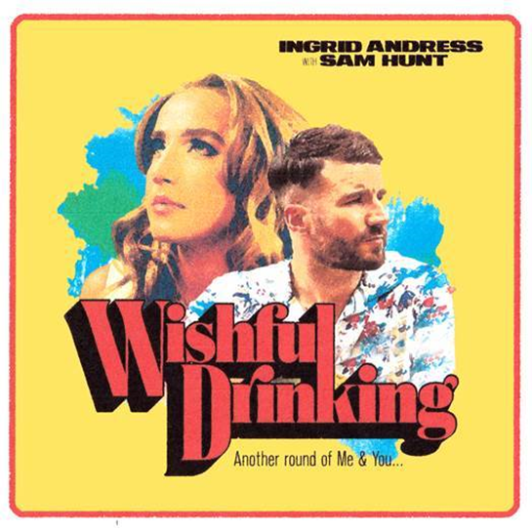

3x GRAMMY-nominee Ingrid Andress has reached the top of the Country Aircheck chart with her Platinum-certified hit “Wishful Drinking (with Sam Hunt),” as seen on The Late Show with Stephen Colbert (LISTEN HERE). The “moving country-pop ballad that perfectly combines Andress’ soft pitch and Hunt’s husky vocals” (V Magazine) has been a fan-favorite since day one and is featured on her celebrated sophomore album, Good Person (LISTEN HERE). “Wishful Drinking” is Andress’ second career #1 and Hunt’s tenth.

Hailed by The New York Times as “a Nashville outsider who paved her own way in” (READ HERE), Andress returns to the reflection and confession at the core of her acclaimed debut, Lady Like, and plumbs even deeper on Good Person. In the co-producer’s chair once again (alongside Sam Ellis, who played the same role on Lady Like), Andress pushed for bold, experimental sounds that blended banjos with vocoders; swung from sweeping orchestration to spare, acoustic-based arrangements; and showcased previously unexplored parts of her vocal range.

Andress also co-wrote every track, including the album’s title-track that she performed on The Tonight Show Starring Jimmy Fallon earlier this summer (WATCH HERE). Additional album standouts include the “stunning piano ballad” (Billboard) “Blue,” the genre-pushing power ballad, “Seeing Someone Else,” which explores the complexities and consequences that arise with self-growth and evolution and the explosive “Pain,” as seen on Late Night with Seth Meyers (WATCH HERE).

Good Person sees Andress entering the next chapter of her career following her record-breaking debut, Lady Like, named “one of the year’s strongest albums” by Associated Press and one of Billboard’s Top 10 Best Country Albums of 2020. The celebrated LP scored Andress three GRAMMY nominations including Best New Artist, Best Country Album and Best Country Song for the multi-platinum No. 1 radio single “More Hearts Than Mine.” She is also a 4x ACM Award, 3x CMA Award and 2x CMT Music Award nominee.

With over one billion global streams and fans spanning the globe, Andress spent the year out on the road with Keith Urban for his 52-date North American “The Speed of Now World Tour,” which wrapped this weekend.

CONNECT WITH INGRID ANDRESS:
FACEBOOK | TWITTER | INSTAGRAM | YOUTUBE

