FOR IMMEDIATE RELEASE
NOVEMBER 17, 2022

R&B SENSATION JOSH LEVI REVEALS MAJESTIC LIVE PERFORMANCE OF “HEAVEN” WITH HARPIST, SARA KAWAI
WATCH HERE

LEVI EARNS FIRST GRAMMY NOMINATION AT
THE 65TH ANNUAL GRAMMY AWARDS

PREVIOUSLY DEBUTED VEVO EXCLUSIVE LIVE TAKES FOR
HIT SINGLES, “VICES” AND “ALL OVER AGAIN”

ACCLAIMED SOPHOMORE EP, DISC TWO, AVAILABLE NOW
VIA RAEDIO/ATLANTIC RECORDS HERE

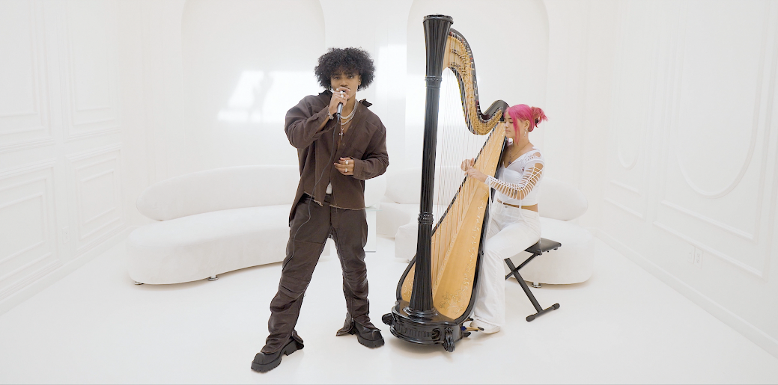
DOWNLOAD THUMBNAIL HERE

Josh Levi continues to add to a series of breathtaking live performances. This week he shares an angelic performance of “Heaven” accompanied by a live harpist, Sara Kawai. Watch HERE. The R&B superstar has also earned his first GRAMMY nomination after yesterday’s announcement for the 2023 GRAMMY Awards. Levi’s featured voice on the soundtrack single “Nobody Like U,” as Aaron Z., a member of the teenage heartthrob boyband 4*Town in Disney/Pixar’s blockbuster Turning Red; landed him in the Best Song Written For Visual Media category. For Josh, 2022 was filled with a series of spectacular live performances, such as show-stopping renditions of Levi’s recent hit singles, “VICES” and “ALL OVER AGAIN,” both filmed exclusively for Vevo and streaming now via YouTube. In addition, Levi recently stopped by the Genius studio to drop a live version of “IF THE WORLD” for the hugely popular Open Mic series, presented by M&M’s. Watch HERE.

As if all that weren’t enough, Levi invited fans behind the scenes of his previously unveiled official music video for “ALL OVER AGAIN,” revealing never-before-seen details of the visual’s intense therapy session and cinematic production. Both “ALL OVER AGAIN” and “ALL OVER AGAIN (BEHIND THE SCENES)” are streaming now at the official Josh Levi YouTube channel HERE.
“ALL OVER AGAIN” is among the highlights featured on Levi’s acclaimed sophomore EP, DISC TWO, available everywhere now HERE. The eight-track collection also includes such powerhouse singles as
“NASA,” “DON’T THEY REMIX (FEAT. NORMANI)” (which exclusively premiered on Apple Music’s The Zane Lowe Show), and “SHE KEEPS COMIN,” the latter joined by an astonishing self-shot live performance video streaming via YouTube HERE.

DISC TWO also includes Levi’s luxurious hit single, “VICES,” a personal favorite of Justin Bieber, who shared the song on his Instagram feed and story. The track is currently featured on GRAMMY.com’s “R&B Is Alive And Well” playlist, accompanied by an exclusive feature which named Levi among the next-gen R&B “Artists Who Are Pushing The Genre Forward,” hailing the gifted new artist for his “soulful and electric sounds.”

Levi marked DISC TWO with his first ever headline tour run to date, “The VICES Tour,” kicking off with a sold-out show at Los Angeles, CA’s Peppermint Club and followed by full houses in San Francisco, Chicago, Houston, New York, Atlanta, and other major markets across the country. Additional dates will be announced soon.

Levi further celebrated the release of DISC TWO with a stunning live rendition of “VICES” on The Terrell Show, as well as an exclusive interview with Rated R&B. What’s more, the rising star displayed his intimate approach to modern R&B with an exhilarating live performance video of “NASA,” streaming HERE.

Josh Levi immediately captivates with each inhale of experience and exhale of emotion. The Houston, TX-raised and Los Angeles-based singer, songwriter, and actor developed a fervent fan base through roles on such hit series as Friday Night Lights as well as a series of viral YouTube covers and consistent touring. Hailed by Earmilk as “an all-encompassing showcase of how much of an anomaly he is,” Levi’s 2020 debut EP, DISC ONE – highlighted by such tracks as “IF THE WORLD,”– earned high profile media attention from the likes of Billboard, Wonderland, and V, which declared him “your classic triple threat.” As a result, Levi caught the attention of Issa Rae's label imprint, Raedio, featuring his 2021 single, “What’s The Use,” on the soundtrack to her critically acclaimed HBO Series, Insecure: Season 5. The track proved an instant smash for Levi, named by Billboard at #6 on their “Tunefind Top TV/Movie Syncs of 2021.”

Named by PEOPLE as one of last year’s “25 Emerging Musical Artists You Should Add to Your Playlist This Fall,” written by GRAMMY® Award-winning singer-songwriters Billie Eilish and Finneas O’Connell, proved an immediate “Hot 100” smash, earning an MTV Movie & TV Awards “Best Musical Moment” nomination while sending Levi’s monthly Spotify listeners to more than 4.5M.

CONNECT WITH JOSH LEVI
OFFICIAL | FACEBOOK | INSTAGRAM | TIKTOK | TWITTER | YOUTUBE

PRESS CONTACT:
Brittany Bell | Brittany.Bell@atlanticrecords.com

