**NIKO RUBIO RETURNS WITH “OLVIDAR DE TI”**

**FIRST SONG OFF FORTHCOMING SOPHOMORE EP**

**ACCOMPANIED BY OFFICIAL MUSIC VIDEO   
DIRECTED BY VOGUE GIAMBRI**

[**DOWNLOAD/STREAM “OLVIDAR DE TI”**](https://nikorubio.lnk.to/OlvidarDeTi)

[**WATCH OFFICIAL MUSIC VIDEO**](https://www.youtube.com/watch?v=H8UNP1VUGIY)

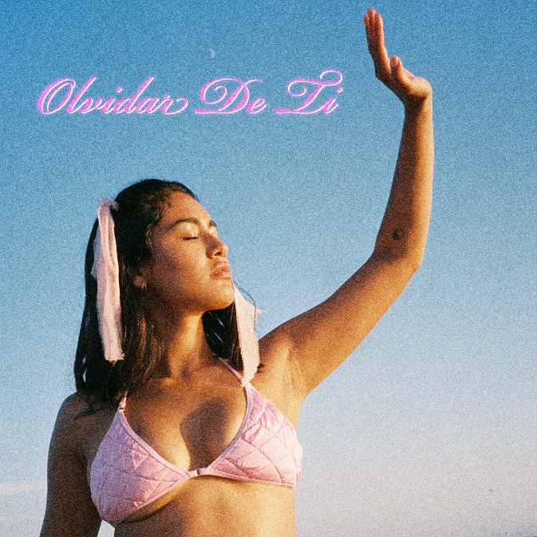  
[DOWNLOAD HI-RES ARTWORK](https://nam04.safelinks.protection.outlook.com/?url=https%3A%2F%2Fpress.atlanticrecords.com%2Fniko-rubio&data=05%7C01%7CTaylor.Apel%40atlanticrecords.com%7Ca5ffbf308b184c4d7d1a08dabdbc8ea7%7C8367939002ec4ba1ad3d69da3fdd637e%7C0%7C0%7C638030914790937032%7CUnknown%7CTWFpbGZsb3d8eyJWIjoiMC4wLjAwMDAiLCJQIjoiV2luMzIiLCJBTiI6Ik1haWwiLCJXVCI6Mn0%3D%7C3000%7C%7C%7C&sdata=4HwOwMg26ueReLDaiVCgCwiVr5Pgt5yLP83GbkRjJUU%3D&reserved=0)

**New York, NY – November 4, 2022** –Rising singer-songwriter and Southern California-native **Niko Rubio** releases new song **“Olvidar De Ti,”** written and produced alongside **Jesse Shatkin (Rihanna, Kelly Clarkson, Sia)** and co-written by Eric Leva and Erick Serna. “Olvidar De Ti” is the first offering from Niko’s forthcoming sophomore EP and available today viaSandlot Records/Atlantic Records.

[**DOWNLOAD/STREAM “OLVIDAR DE TI”**](https://nikorubio.lnk.to/OlvidarDeTi)

*“Olvidar De Ti” is a song about moving on. I thought I was in love but I realized my relationship wasn’t what I thought it was. This song is about taking back your life! I hope you enjoy it and feel empowered when you hear it.”*

**-NIKO RUBIO**

[**WATCH OFFICIAL MUSIC VIDEO**](https://www.youtube.com/watch?v=H8UNP1VUGIY)

**“Olvidar De Ti”** follows recent singles [**“Over For Real,”**](https://nam04.safelinks.protection.outlook.com/?url=https%3A%2F%2Fnikorubio.lnk.to%2FOverForReal&data=05%7C01%7CTaylor.Apel%40atlanticrecords.com%7Ca5ffbf308b184c4d7d1a08dabdbc8ea7%7C8367939002ec4ba1ad3d69da3fdd637e%7C0%7C0%7C638030914790937032%7CUnknown%7CTWFpbGZsb3d8eyJWIjoiMC4wLjAwMDAiLCJQIjoiV2luMzIiLCJBTiI6Ik1haWwiLCJXVCI6Mn0%3D%7C3000%7C%7C%7C&sdata=1FKNmkljF5qkcTUcUKW0u96or%2FBffPHfdTGeXTXu9nI%3D&reserved=0)[**“Love Me Till U Hate Me,”**](https://nam04.safelinks.protection.outlook.com/?url=https%3A%2F%2Fnikorubio.lnk.to%2FLoveMeTillUHateMe&data=05%7C01%7CTaylor.Apel%40atlanticrecords.com%7Ca5ffbf308b184c4d7d1a08dabdbc8ea7%7C8367939002ec4ba1ad3d69da3fdd637e%7C0%7C0%7C638030914790937032%7CUnknown%7CTWFpbGZsb3d8eyJWIjoiMC4wLjAwMDAiLCJQIjoiV2luMzIiLCJBTiI6Ik1haWwiLCJXVCI6Mn0%3D%7C3000%7C%7C%7C&sdata=tIA07yx%2Bi2ZWOMHjnFmJ%2FAHFn4tdggxf834Q6BR8ESk%3D&reserved=0)and a performance at the **BottleRock Music Festival** in **Napa, California**. This year also saw the rising singer-songwriter support 14 dates of **Omar Apollo’s *Desvelado* Tour** and a set at **Lollapalooza** in Chicago.

[**People**](https://nam04.safelinks.protection.outlook.com/?url=https%3A%2F%2Fpeople.com%2Fmusic%2Fmeet-the-talented-spring-2022-emerging-artists%2F&data=05%7C01%7CTaylor.Apel%40atlanticrecords.com%7Ca5ffbf308b184c4d7d1a08dabdbc8ea7%7C8367939002ec4ba1ad3d69da3fdd637e%7C0%7C0%7C638030914790937032%7CUnknown%7CTWFpbGZsb3d8eyJWIjoiMC4wLjAwMDAiLCJQIjoiV2luMzIiLCJBTiI6Ik1haWwiLCJXVCI6Mn0%3D%7C3000%7C%7C%7C&sdata=4QGZNRd8P4f0ZVwpxSDBhS8yffXJYY%2BoqnODQdGsqYU%3D&reserved=0) named Niko one of the *‘Talented Emerging Artists that Should Be on Your Playlists This Spring,’* and she is only getting started with her sophomore EP due out soon.

Niko made her major label debut in 2021 with debut EP, [***Wish You Were Here***](https://nam04.safelinks.protection.outlook.com/?url=https%3A%2F%2Fnikorubio.lnk.to%2FWishYouWereHereID&data=05%7C01%7CTaylor.Apel%40atlanticrecords.com%7Ca5ffbf308b184c4d7d1a08dabdbc8ea7%7C8367939002ec4ba1ad3d69da3fdd637e%7C0%7C0%7C638030914790937032%7CUnknown%7CTWFpbGZsb3d8eyJWIjoiMC4wLjAwMDAiLCJQIjoiV2luMzIiLCJBTiI6Ik1haWwiLCJXVCI6Mn0%3D%7C3000%7C%7C%7C&sdata=GXEO%2BFCV5SLJqZIkEjqXrTvL8SYB4XP4RACwQncljwc%3D&reserved=0),which featured the standout singles [**“Bed,”**](https://nam04.safelinks.protection.outlook.com/?url=https%3A%2F%2Fwww.youtube.com%2Fwatch%3Fv%3D20SZ_bABSMA&data=05%7C01%7CTaylor.Apel%40atlanticrecords.com%7Ca5ffbf308b184c4d7d1a08dabdbc8ea7%7C8367939002ec4ba1ad3d69da3fdd637e%7C0%7C0%7C638030914790937032%7CUnknown%7CTWFpbGZsb3d8eyJWIjoiMC4wLjAwMDAiLCJQIjoiV2luMzIiLCJBTiI6Ik1haWwiLCJXVCI6Mn0%3D%7C3000%7C%7C%7C&sdata=ZDGPoR7alPZ9VQFWRU1t10CBQMOOFEghF2k5IyAM1uc%3D&reserved=0) [**“Saving Me”**](https://nam04.safelinks.protection.outlook.com/?url=https%3A%2F%2Fwww.youtube.com%2Fwatch%3Fv%3DfaXfTsRh61s&data=05%7C01%7CTaylor.Apel%40atlanticrecords.com%7Ca5ffbf308b184c4d7d1a08dabdbc8ea7%7C8367939002ec4ba1ad3d69da3fdd637e%7C0%7C0%7C638030914790937032%7CUnknown%7CTWFpbGZsb3d8eyJWIjoiMC4wLjAwMDAiLCJQIjoiV2luMzIiLCJBTiI6Ik1haWwiLCJXVCI6Mn0%3D%7C3000%7C%7C%7C&sdata=5Sj29BgmAZohz2AQlT1q3Hr%2FFn2S69EL4Uffcvl4Pm8%3D&reserved=0)and **“**[**You Could Be The One.”**](https://nam04.safelinks.protection.outlook.com/?url=https%3A%2F%2Fwww.youtube.com%2Fwatch%3Fv%3Dbm337OC4Nc4&data=05%7C01%7CTaylor.Apel%40atlanticrecords.com%7Ca5ffbf308b184c4d7d1a08dabdbc8ea7%7C8367939002ec4ba1ad3d69da3fdd637e%7C0%7C0%7C638030914790937032%7CUnknown%7CTWFpbGZsb3d8eyJWIjoiMC4wLjAwMDAiLCJQIjoiV2luMzIiLCJBTiI6Ik1haWwiLCJXVCI6Mn0%3D%7C3000%7C%7C%7C&sdata=MHrWVFMxVbIMidaEemrwYInlStrJh3bqle91%2BQTrF9I%3D&reserved=0) ***Billboard*** praised the latter of the three as a, *“captivating showcase for the newcomer,”* adding that, *“the kicky pop-rock track allows Rubio’s tone to sink down low and soar skyward.”* ***PAPER*** also described Niko’s sound as *“…infused with waves of indie-rock and guitar riffs…in the most Californian style, of course.”*

***Latina Magazine*** commended Niko’s music as, *“the perfect soundtrack for riding in a seafoam-green convertible, top down, along the familiar Pacific Coast Highway,”* while also noting that, *“Rubio’s crisp vocals are like the breath of fresh air we all need after the past year-and-a-half…”*



[DOWNLOAD HI-RES PHOTOS HERE](https://warnermusicgroup.app.box.com/s/0k729u9d7ymm0y9yl7jay1xzg22lf3px/folder/180126120339)

**ABOUT NIKO RUBIO:**

When creating her debut project, 21-year-old singer/songwriter Niko Rubio found a never-ending muse in the Pacific Coast Highway: the iconic stretch of road that runs along the ocean for nearly the entire length of California, including the Southern California South Bay area where she grew up. Expansive and euphoric, Niko’s radiant form of songwriting perfectly echoes the pure sense of possibility that accompanies driving down the PCH.  Drawing inspiration from the collage of artists she’s come to admire throughout her life including Vampire Weekend, Lana Del Rey, Erykah Badu & twenty one pilots, as well as the mariachi & banda music her grandparents played at home, Niko’s music is an amalgamation of these influences, but unique in its effervescent melodies and unpredictable textures. Using cinematically detailed references and her effortlessly untamed vocals, Niko is ready to take those who listen to her debut EP *Wish You Were Here* and her subsequent releases on a sonic road trip along the highway where they became a possibility.

**Press Contact:** Jason Davis – [jason.davis@atlanticrecords.com](mailto:jason.davis@atlanticrecords.com)