FOR IMMEDIATE RELEASE
NOVEMBER 4, 2022

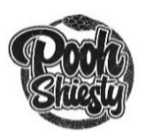

POOH SHIESTY MARKS TWO YEAR ANNIVERSARY OF
4X PLATINUM BREAKTHROUGH, “BACK IN BLOOD (FEAT. LIL DURK),”
WITH BRAND NEW NIGHTCORE REMIX

“BACK IN BLOOD (SPED UP VERSION) AVAILABLE NOW
VIA GUCCI MANE’S THE NEW 1017/ATLANTIC RECORDS

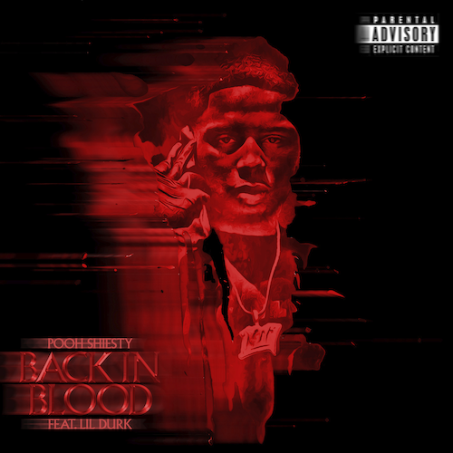
DOWNLOAD HI-RES ARTWORK

Multi-platinum rapper Pooh Shiesty is marking the two-year anniversary of his breakthrough hit single “Back In Blood (Feat. Lil Durk)” with today’s premiere of “Back In Blood (Sped Up Version),” a new nightcore remix available now via Gucci Mane’s The New 1017 and Atlantic Records at all DSPs and streaming services HERE.

Released on November 6, 2020, “Back In Blood (Feat. Lil Durk)” proved an instant smash, ultimately earning 4x RIAA platinum certification for sales in excess of over 4.5M. Currently boasting more than 568M worldwide streams, the track peaked at #1 on Apple Music’s “Hip-Hop/Rap” and “All Genre” charts, reached #4 on Rolling Stone’s “Top 100,” #6 on Billboard’s “Hot R&B/Hip-Hop Songs” and #13 on the overall Billboard 200, while also scoring on Spotify’s “US Viral 50” and “Top 200” tallies. Named by Variety as one of 2021’s Top 25 hits, “Back In Blood” was joined by an official visual which earned 2.4M views on YouTube within its first 24 hours and is now on its way to over 280M views.

“Back In Blood” immediately affirmed Pooh Shiesty as a major force in modern hip-hop, rocketing the Memphis, TN-based rapper to the top of Rolling Stone’s “Breakthrough 25” as well as Billboard’s “Emerging Artists” and “Artist 100” charts. Shiesty – who made his late night TV debut with a performance of “Back In Blood” on NBC’s The Tonight Show Starring Jimmy Fallon – went on to earn a long list of honors and accolades, beginning with a “Best New Artist” nomination from the 2021 BET Awards and followed by multiple nods from the 2021 BET Hip-Hop Awards, including “Best New Hip-Hop Artist,” “Song of the Year,” and “Best Collaboration,” as well as a 2022 Billboard Music Awards nomination for “Top New Artist.” Shiesty was also crowned as “Rookie Of The Year” by RapCaviar, featured among XXL’s 2021 Freshman Class, and named Billboard’s first-ever “Hip-Hop/R&B Rookie of The Month.”

Shiesty has now garnered over 2.3B US audio streams and more than 1B views on YouTube thus far. His monumental, chart-topping, RIAA platinum certified debut mixtape, SHIESTY SEASON now has over 1.5B global streams. The project exploded onto Billboard’s “Top Rap Albums” at #1 upon its February 5, 2021 release while also peaking at #3 on the overall Billboard 200. SHIESTY SEASON also topped Spotify’s “Top US Albums” and both Apple Music’s overall and “Hip-Hop/Rap” charts, while also rising to #3 on Rolling Stone’s “Top 200.” Upon release, all 17 tracks on the mixtape – including includes the RIAA platinum certified “Neighbors (Feat BIG30)“ – hit the top 50 on Apple Music’s overall “Top Songs” chart. He later released the deluxe follow-ups SHIESTY SEASON – SPRING DELUXE and SHIESTY SEASON: CERTIFIED which was accompanied by an exclusive NFT collection in partnership with prominent digital artist Waheed Zai, the co-creator of the web 3 streetwear brand Smilesss, and artist behind the original SHIESTY SEASON cover art .

# # #

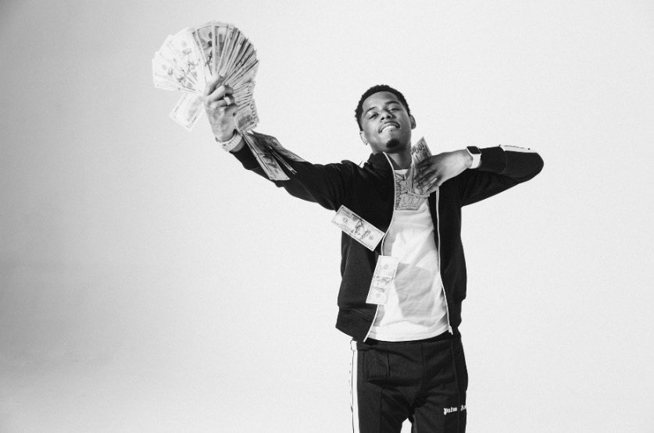
DOWNLOAD HI-RES PRESS IMAGES HERE

CONNECT WITH POOH SHIESTY
WEBSITE | FACEBOOK | INSTAGRAM | TWITTER |

POOH SHIESTY PRESS CONTACT:
SELAM.BELAY@ATLANTICRECORDS.COM

