FOR IMMEDIATE RELEASE
NOVEMBER 23, 2022

corook is being “realistic”

earnest and quirky alt-pop singer-songwriter shares sardonic new track

listen to “realistic”

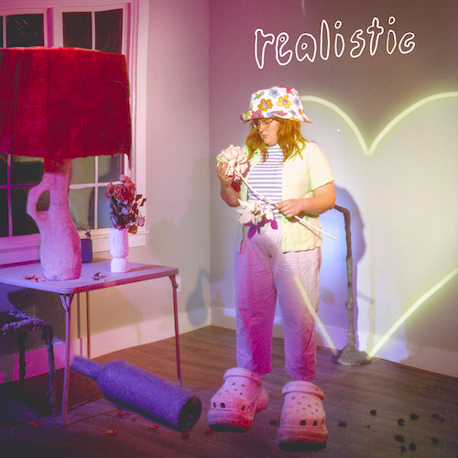
download artwork here

“If specificity is the soul of narrative, then corook is one of the most naturally gifted storytellers in the game.”
– BILLBOARD

“corook is the next thing to bless your music downloads.”
– PEOPLE

Self-described “singer, songwriter, producer, multi-instrumentalist, and huge f*ckin dork” corook [pronounced ‘co-rook’] has shared her sardonic new single, “realistic,” available now via Atlantic Records at all DSPs and streaming services HERE.

“i’ve never understood society’s view of love,” corook says. “movies and songs usually portray love as this exaggerated, self-sacrificing, desperate act that ultimately leaves me feeling underwhelmed and misrepresented. it’s unrealistic. meanwhile my generation was raised by boomers and half of them got divorced. this song is my protest of those expectations and the fears that come with that kind of honesty. it’s a commitment to finding true love in the truest way possible. maybe i’m a skeptic or maybe i’m realistic.”

“realistic” follows corook’s acclaimed ode to realizing your self-worth, “smoothie,” available at all DSPs and streaming services HERE. The track was met by applause from Consequence, which wrote, “The idea of self-image has been discussed at length in music, particular in the last decade, but you’d be hard-pressed to find another song that uses the imagery of blended fruit as the vehicle of choice for the subject. Somehow, corook is the kind of voice that makes it all work – everything sung here feels believable, raw, and true.” “(‘smoothie’) is a deliciously fun pop-rock genre blend,” declared Billboard. “A verified banger.”

Recently named one of The Advocate’s “7 Queer Artists For Your Fall Playlist,” the genre-busting, Nashville-based musician tackles deeply personal themes in her music and visuals through a unique, quirky and humorous lens. This past spring, she blessed the world with her debut achoo! EP, which features surprising and insightful tracks including “idk god,” “degree,” “bad friend,” and “sims,” in addition to the fan favorite, “snakes”. Since release, corook has shared her viral adult lullaby, “it’s ok!,” the unrestrained single “BDSM,” super-hot “hell yeah” and most recently, the heartfelt “your mom.”

corook – who recently travelled to Mexico City for a performance at Mexico’s Festival Corona Capital – has spent much of this past year on the road, including a US tour alongside NYC-based piano pop/rock trio Jukebox the Ghost as well as her debut festival performance at Bonnaroo Music & Arts Festival, featured in Rolling Stone’s Bonnaroo 2022 wrap-up. Earlier this year, she made her first-ever North American live run alongside K.Flay and opened for X Ambassadors at “A Night Benefitting Reproductive Rights” at The Troubadour. New dates will be announced soon. For updates, please visit www.corook.com.

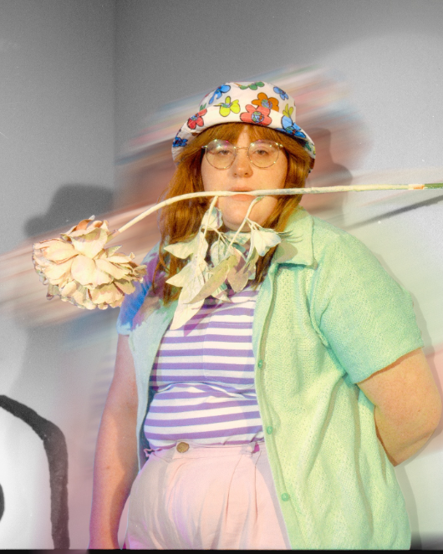
download press photo here / credit: kirsten barnett

corook by corook
corook aka Corinne Savage (yes that’s her real last name) is a singer, songwriter, producer, multi-instrumentalist and a huge fuckin dork. No but seriously. She can solve a Rubix cube in under a minute (depending on how she’s feeling that day.) This ~freckled chubby babe~ was born and raised just outside of downtown Pittsburgh, Pennsylvania, where they grew up listening to Drake, Gwen Stefani and Mac Miller (RIP). She went to a performing arts high school (yes, just like Victorious) where she came out as QUEERAF her senior year. She then went to Berklee College of Music (wow – Owen Wilson voice) and graduated with TWO degrees (barely.) corook currently resides in Nashville, Tennessee (howdy.) She spends most of her time writing and producing music for her artist project “corook” (boop!) locked away in her room, alone (she blames it on Coronavirus but she’s actually just anti-social.) She’s 27 and VERY cute.

connect with corook:
corook.com | instagram | tiktok | press assets

press contact:
andrew.george@atlanticrecords.com

