FOR IMMEDIATE RELEASE
NOVEMBER 25, 2022

QUANDO RONDO AND YOUNGBOY NEVER BROKE AGAIN GIVES FANS SOMETHING TO BE THANKFUL FOR WITH RELEASE OF 3860 MIXTAPE
STREAM/DOWNLOAD 3860
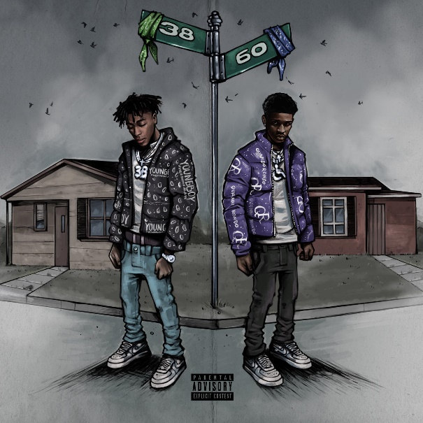
DOWNLOAD HI-RES ARTWORK

Today, Multi-platinum rappers, Quando Rondo and YoungBoy Never Broke Again, release their highly anticipated collab mixtape, 3860, available now at all DSPs. The 16-track project is a mix of assertive and introspective, giving fans a taste of the versatility both artists have to offer. The mixtape comes on the heels of the previously released singles “Keep Me Dry” and “Cream Soda.” “Keep Me Dry,” along with “It’s On” and “Give Me A Sign,” are all featured on the 14-track project.

On Quando and YoungBoy’s collab mixtape 3860, Quando proves his shine as he holds his own and goes bar for bar with his industry big brother and hip-hop heavyweight YoungBoy. On this tape Quando reintroduces himself to the world as an artist to watch with his undeniable, original flow and authentic lyrics that fans gravitate towards. Fans of both Quando and YoungBoy have been anticipating this collab mixtape since the release of YoungBoy’s January 2022 project COLORS which only included one feature from none other than Quando Rondo with their record “Gangsta.” Following the release of this single, conversation began bubbling online around a collab tape and fans have been campaigning for the release since then.

3860 TRACKLIST
- I Swear
- It’s On
- Casket Talk
- Give Me A Sign
- Want Me Dead
- Cream Soda
- No Mercy
- Loaded
- Can’t Compare
- Trophies
- Keep Me Dry
- Million Dollar Kid
- At The Top
- Heat Tucked
- My Friend
- Running Away From Home

The multi-platinum Savannah, GA rapper spits with classic dexterity as he spouts off modern melodies with emotional precision and a head-nodding bounce. Since 2017, he has consistently amplified the spirit of the streets throughout the mainstream on his own terms, translating the struggles of Savannah (and hoods everywhere) into a dynamic documentary-style sound. “Give Me A Sign (Feat. YoungBoy Never Broke Again)” continues the rising star’s high-volume year, following such recently released tracks as “Cream Soda,” “It’s On,” “Give Me A Sign,” “War Baby,” “24,” “10.27,” “Six-0 Business,” “Jakiyah” and his recent guest verse on YoungBoy Never Broke Again’s “Gangsta (Ft. Quando Rondo)” – the only feature on YoungBoy’s chart-topping 2022 mixtape, COLORS. What’s more, YoungBoy shouts out Quando on two of the mixtape’s standout tracks, “Bring It On” and “No Switch.”

Quando officially kicked off his busy 2022 with the previously released single, “Dead Wrong,” available for streaming and download HERE; an official music video is streaming HERE. The creative hot streak commenced with last year’s release of the critically acclaimed album, Still Taking Risks, and was swiftly followed by guest verses on the explosive Never Broke Again: The Compilation Vol. 1. A stunning series of singles also dropped, including “Blueprint,” “The Realest,” “Time Spent,” and “Shine,” all available now with official music videos streaming via YouTube.

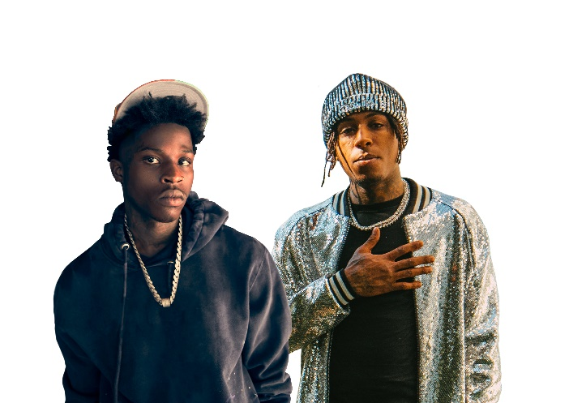

# # #

CONNECT WITH QUANDO RONDO
OFFICIAL | INSTAGRAM | TWITTER | FACEBOOK | YOUTUBE

FOR ALL PRESS INQUIRIES, PLEASE CONTACT:
ARIANA.WHITE@ATLANTICRECORDS.COM

