FOR IMMEDIATE RELEASE
NOVEMBER 14, 2022

RODDY RICCH SHARES “TWIN (FEAT. LIL DURK)”

NEW PROJECT, FEED THA STREETS 3 ARRIVES NOVEMBER 18

RAP SUPERSTAR TEAMS UP WITH BLACK OWNED RESTAURANTS
FIXINS SOUL KITCHEN IN LOS ANGELES,
TRAP KITCHEN IN PORTLAND, & STUFF’D WINGS IN HOUSTON,
FOR SERIES OF “FEED THA STREETS” ACTIVATIONS

EAGERLY AWAITED PROJECT INCLUDES RECENT SINGLES
“ASTON MARTIN TRUCK“ “STOP BREATHING,”
“GHETTO SUPERSTAR (FEAT. G HERBO & DOE BOY),”

SPECIAL GUEST RUN ON POST MALONE’S “TWELVE CARAT TOUR”
WRAPS THIS WEEK WITH TWO-NIGHT STAND IN LOS ANGELES

LISTEN TO “TWIN (FEAT. LIL DURK)” HERE

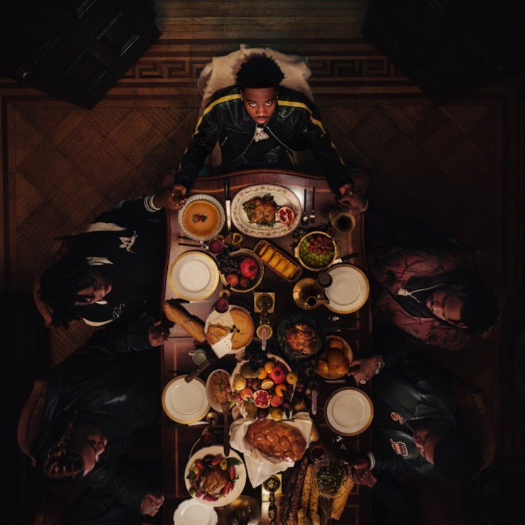

DOWNLOAD HI-RES ARTWORK

RIAA Diamond-certified rap superstar Roddy Ricch has shared “Twin (Feat. Lil Durk),” available now via Atlantic Records at all DSPs and streaming services. Produced by Teddy Walton (Drake, Kendrick Lamar, Nipsey Hussle), Aaron Bow (Post Malone, Kendrick Lamar, Gucci Mane), and Byrd Beatz (Bad Bunny, Nicki Minaj, Gunna), “Twin (Feat. Lil Durk)” marks the latest single from the GRAMMY® Award-winning (and 9x GRAMMY® Award-nominated) artist’s long anticipated new project, FEED THA STREETS 3, due on Friday, November 18, pre-order available now.

First unveiled last month in celebration of Ricch’s 24th birthday, FEED THA STREETS 3 includes critically acclaimed single, “Aston Martin Truck.” Produced by Teddy Walton, Aaron Bow, and Byrd Beatz the driving new track dropped alongside an official music video showcasing Ricch’s world of fame and fortune, filmed on the streets of Queens, NY and streaming at YouTube HERE.

FEED THA STREETS 3 also includes recent track releases such as “Stop Breathing,” available for streaming and download HERE. Produced by Turbo (Travis Scott, Nav, Lil Baby), JetsonMade (DaBaby, Jack Harlow, J. Cole) and Pooh You A Fool (Migos, Symba, NBA YoungBoy), the track arrived alongside an official visual offering fans a glimpse into Ricch’s luxurious life on the road, currently boasting close to 4 million views via YouTube HERE. This summer saw the arrival of the historic “Ghetto Superstar (Feat. G Herbo & Doe Boy),” marking the first ever studio collaboration between superstar producers Mustard and Southside, available at all DSPs and streaming services HERE.

Ricch – who spent much of his summer lighting up such events as Washington, DC’s Something In The Water, Manchester, TN’s Bonnaroo Music & Arts Festival, Concord, CA’s KMEL Summer Jam, East Rutherford, NJ’s annual HOT 97 Summer Jam at MetLife Stadium, and Rolling Loud Toronto – is currently traveling as special guest on Post Malone’s blockbuster “Twelve Carat Tour,” culminating this week with a two-night stand at Los Angeles, CA’s Crypto.com Arena on November 15 and 16. The tour follows Ricch’s performance alongside Post Malone for their joint track, “Cooped Up,” on NBC’s Saturday Night Live (streaming HERE). The original version of “Cooped Up“ – featured on Post Malone’s blockbuster new album, TWELVE CARAT HEARTACHE – is joined by an official music video, now boasting over 41M views via YouTube HERE.

While on tour, Ricch made sure to tap in with the fans throughout different tour stops, including a surprise visit to Brooklyn, NY’s Middle School Of Marketing And Legal Studies, where New York State Assemblywoman Monique Chandler-Waterman presented him with a citation honoring his longtime efforts towards creating positive imagery to inspire young people everywhere. Ricch also joined forces with Black Restaurant Week® and Houston, TX’s STUFF’d Wings to personally “feed tha streets” by offering free meals – including STUFF’d Wings’ signature Stuffed Mac-n-Cheese Wings and Cajun Fries – feeding 200 fans. Roddy continued his string of “feed tha streets” activations by recently stopping at Trap Kitchen in Portland, OR and will head to Fixins Soul Kitchen in Los Angeles, CA on November 17th.

Ricch’s latest EP, THE BIG 3, is available now at all DSPs and streaming services HERE. The three-song collection is highlighted by the smash summer single, “Real Talk,” available now for streaming and download HERE. The Mustard-produced track – which marked Ricch’s first new solo single since last year’s sophomore album, LIVE LIFE FAST – arrived alongside an official music video, directed by Colin Tilley and streaming now via YouTube HERE.

LIVE LIFE FAST – which follows 2019’s 2x RIAA platinum, chart-topping debut album, PLEASE EXCUSE ME FOR BEING ANTISOCIAL, highlighted of course by the historic, 3x GRAMMY® Award-nominated, RIAA diamond certified #1 classic, “The Box“ – arrived in December 2021 and made an explosive #1 debut on Billboard’s “Top R&B/Hip-Hop Albums” chart as well as at #4 on the overall Billboard 200. The album includes such smash singles as “Late At Night“ and “25 million,” both joined by official music videos streaming now at YouTube.

# # #

CONNECT WITH RODDY RICCH
OFFICIAL | FACEBOOK | INSTAGRAM | TWITTER | YOUTUBE

PRESS CONTACT
Brittany Bell | Brittany.Bell@atlanticrecords.com

