FOR IMMEDIATE RELEASE
NOVEMBER 21, 2022

RODDY RICCH SHARES OFFICIAL VIDEO FOR
“TWIN FEAT. LIL DURK”

NEW PROJECT FEED THA STREETS 3 RELEASED LAST MONDAY
INCLUDES ACCLAIMED SINGLES,
“GHETTO SUPERSTAR (FEAT. G HERBO & DOE BOY),” “STOP BREATHING,”
“ASTON MARTIN TRUCK,”

FEED THA STREETS 3 AVAILABLE EVERYWHERE NOW VIA ATLANTIC RECORDS

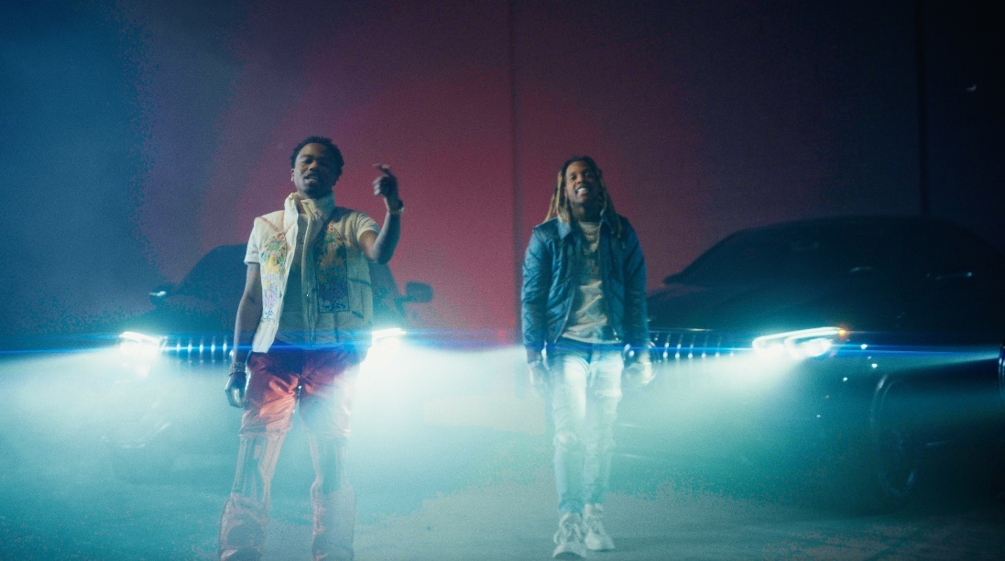
DOWNLOAD THUMBNAIL

Grammy award-winning rap superstar Roddy Ricch shares an official visual for “Twin feat. Lil Durk” which arrived last week off his new project, FEED THA STREETS 3. The Jerry production (G Herbo, Lil Durk, King Von) - directed video is the epitome of when “great minds think alike.” Watch HERE.

Produced by Teddy Walton (Drake, Kendrick Lamar, Nipsey Hussle), Aaron Bow (Post Malone, Kendrick Lamar, Gucci Mane), and Byrd Beatz (Bad Bunny, Nicki Minaj, Gunna), “Twin (Feat. Lil Durk)” arrived ahead of the highly anticipated release of Feed Tha Streets 3. The single received applause from outlets such as HYPEBEAST, which wrote, “The two rappers honor their brotherhood and the lengths they will go to in order to protect each other.” “The booming song sees the two make for a compelling duo,” agreed Complex.

FEED THA STREETS 3 includes such critically acclaimed singles as “Ghetto Superstar (Feat. G Herbo & Doe Boy),” “Stop Breathing” and “Aston Martin Truck,” all available now for streaming and download.

FEED THA STREETS 3 was first heralded this summer with the arrival of the historic “Ghetto Superstar (Feat. G Herbo & Doe Boy),” marking the first ever studio collaboration between superstar producers Mustard and Southside. Produced by Turbo (Travis Scott, Nav, Lil Baby), JetsonMade (DaBaby, Jack Harlow, J. Cole) and Pooh You A Fool (Migos, Symba, NBA YoungBoy), “Stop Breathing” followed, joined by an official visual offering fans a glimpse into Ricch’s luxurious life on the road, currently boasting more than 4.2M views via YouTube HERE. Produced by Teddy Walton, Aaron Bow, and Byrd Beatz, “Aston Martin Truck” dropped next, accompanied by an official music video showcasing Ricch’s world of fame and fortune, filmed on the streets of Queens, NY and streaming at YouTube HERE.

Having just wrapped an epic run as special guest on Post Malone’s blockbuster “Twelve Carat Tour,” Ricch is set to perform at the halftime show for the Los Angeles Chargers vs Kansas City Chiefs NFL game on Sunday 11/20. The tour followed Ricch’s recent performance alongside Post Malone for their joint track, “Cooped Up,” on NBC’s Saturday Night Live (streaming HERE). The original version of “Cooped Up“ – featured on Post Malone’s blockbuster new album, TWELVE CARAT HEARTACHE – is joined by an official music video, now boasting over 43M views via YouTube HERE.

While on tour, Ricch made sure to personally reach out to fans at tour stops across the country , including a surprise visit to Brooklyn, NY’s Middle School Of Marketing And Legal Studies, where New York State Assemblywoman Monique Chandler-Waterman presented him with a citation honoring his longtime efforts towards creating positive imagery to inspire young people everywhere. Ricch also held a series of activations to personally “Feed Tha Streets” by offering free meals and groceries to those in need, including partnerships with such black-owned restaurants as Houston, TX’s STUFF’d Wings, Portland, OR’s Trap Kitchen, and, most recently, Los Angeles, CA’s Fixins Soul Kitchen. This week also saw Ricch hold an additional “Feed Tha Streets” activation in Los Angeles, offering free groceries at Ralphs in the Ladera Center.

FEED THA STREETS 3 follows the release earlier this year of the hit summer EP, THE BIG 3, available now at all DSPs and streaming services HERE. The three-song collection is highlighted by the smash single, “Real Talk,” available now for streaming and download HERE. The Mustard-produced track – which marked Ricch’s first new solo single since last year’s sophomore album, LIVE LIFE FAST – arrived alongside an official music video, directed by Colin Tilley and streaming now via YouTube HERE.

LIVE LIFE FAST – which follows 2019’s 2x RIAA platinum, chart-topping debut album, PLEASE EXCUSE ME FOR BEING ANTISOCIAL, highlighted of course by the historic, 3x GRAMMY® Award-nominated, RIAA diamond certified #1 classic, “The Box“ – arrived in December 2021 and made an explosive #1 debut on Billboard’s “Top R&B/Hip-Hop Albums” chart as well as at #4 on the overall Billboard 200. The album includes such smash singles as “Late At Night“ and “25 million,” both joined by official music videos streaming now at YouTube.

# # #

CONNECT WITH RODDY RICCH
OFFICIAL | FACEBOOK | INSTAGRAM | TWITTER | YOUTUBE

PRESS CONTACT
Brittany Bell | Brittany.Bell@atlanticrecords.com

