FOR IMMEDIATE RELEASE
NOVEMBER 15, 2022

GROUNDBREAKING ALTERNATIVE ARTIST SAM AUSTINS
PAYS TRIBUTE TO THE STROKES ON CHARGED NEW SINGLE,
“DANCING WITH THE DEVIL”

NORTH AMERICAN TOUR SUPPORTING DORA JAR CONTINUES THROUGH SOLD OUT SHOW
AT L.A.’S HISTORIC TROUBADOUR ON NOVEMBER 30

LISTEN TO “DANCING WITH THE DEVIL” HERE | LISTEN HERE

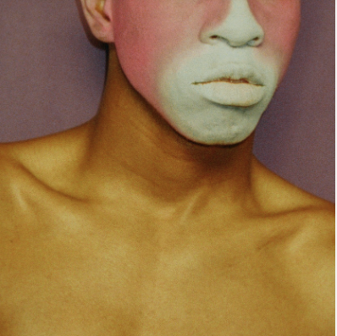
DOWNLOAD HI-RES ARTWORK

“Sam Austins is a boundary-breaker, challenging long-held ideas of what it means to be an alternative artist.”
– BILLBOARD

“An audacious and freewheeling storyteller, Sam Austins is kicking down the doors of genre in carving out his singular artistic point of view.” – NME

Alternative singer-songwriter/model/artist Sam Austins pays tribute to the patron saints of Lower East Side debauchery with “Dancing With The Devil,” his electrifying new paean to The Strokes available now at all DSPs and streaming services HERE and listen HERE. Written in the claustrophobic solitude of an East Hollywood apartment after relocating from NYC to LA, the emotionally and musically charged new track reflects a spiraling psyche torn between the urgency and anxiety of making a name for oneself while simultaneously longing for a place in time where you can never return.

“The Strokes remind me of a time when the only thing that I could afford was bodega meals, living in New York,” says Austins. “The energy of us poor kids from Detroit, running around Manhattan like it was all ours still means the absolute world to me. I wanted to create a song that captured that madness.”

“Dancing With The Devil” marks the latest single from Austins’ eagerly anticipated new EP, due early next year. The project – which follows the Detroit-born, Los Angeles-based artist’s 2021 debut mixtape, HOMELESS STAR – was first heralded with last month’s premiere of the triumphant “Matador,” available for streaming and download HERE. Produced by Rodaidh McDonald (The xx, David Byrne, Hot Chip), the track exemplifies Austins’ paradoxical ability to create ethereal indie pop with a razor-sharp edge, a groundbreaking musical approach tattooed by a creative bravado that lures with a red cape but conceals a devastating sword.

PRAISE FOR SAM AUSTINS + “MATADOR”

“Creating immersive and genre-fluid sonic worlds as conduits for his stories about growing up between the Michigan suburbs and the roaring city of Detroit, Austins’ music buzzes with a propulsive energy and has been described by Pusha T as a mix between My Beautiful Dark Twisted Fantasy and Prince.” – NME

“‘Matador‘ has everything you could want from a pop banger, a catchy chorus, exciting production and an inspiring popstar. Like the trumpets that usher the track in and dramatically see it out, Sam Austin doesn’t mess around. He enters, says what he needs to say and leaves, but not without a few dramatic flourishes to keep us coming back.” – CLUNK

“Love can and is all-consuming. On ‘Matador,’ that raw passion comes to life with unbound expression. Between his own feverish vocal performance, the driving guitars at his side, and the searing trumpet blaring its brassy, buoyant melody, Sam Austins ensures we hang on every moment of this dazzling, dramatic song.” – ATWOOD MAGAZINE

# # #

Austins – who spent his summer stealing the show at such festivals as Chicago, IL’s Lollapalooza and Gonzalez, TX’s Float Fest – is currently traveling North America on a wide ranging tour supporting Dora Jar, with dates set through a sold out November 30 finale at West Hollywood, CA’s historic Troubadour. Additional dates will be announced soon. For complete details and remaining ticket availability, please visit www.samaustins.com.

SAM AUSTINS
ON TOUR 2022

NOVEMBER
15 - Minneapolis, MN - 7th St Entry
19 - Seattle, WA - Barboza
20 - Portland, OR - Polaris Hall
22 - San Francisco, CA - Rickshaw Stop
30 - West Hollywood, CA – Troubadour (SOLD OUT)

* ALL DATES w/DORA JAR

# # #

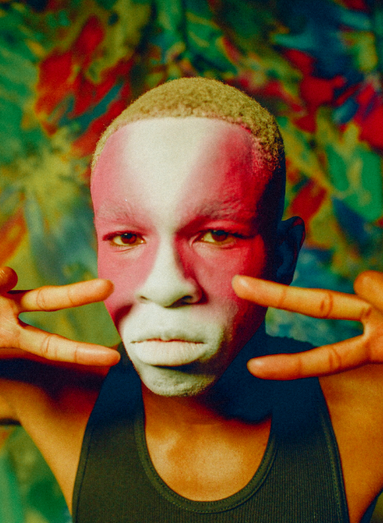
DOWNLOAD PRESS PHOTO HERE

ABOUT SAM AUSTINS:
Sam Austins is quickly rising to the forefront of contemporary art pop with his revolutionary fusion of energies, merging 90s alternative and R&B melodies with the aspirational aesthetics of high fashion and authentic tales of his Detroit youth. A series of increasingly acclaimed releases and performances saw the preternaturally gifted musician and in-demand model earning early acclaim and accolades from such outlets as VOGUE, HYPEBEAST, Pigeons & Planes, and many more.

Austins joined Atlantic Records’ legendary roster in 2021 and quickly unveiled his label debut mixtape, HOMELESS STAR, highlighted by such genre-defying singles as “KILOS,” “MIND ON DRUGS,” “DRIFTING AWAY,” and “JOY FOR YOUTH (with Sir Chloe),” all available now for streaming and download. The 10-track collection was greeted by critical acclaim from the likes of Billboard, which raved, “Austins carries his struggles proudly, channeling his experiences as inspiration for the creative direction and lyrical content of HOMELESS STAR…The avant-garde storyteller paints a picture of Detroit in the summer…he hones in on eclectic influences that manage to achieve synchronicity…part Blood Orange, part Tame Impala, yet entirely Austins.”

CONNECT WITH SAM AUSTINS
WEBSITE | FACEBOOK | INSTAGRAM | TWITTER | YOUTUBE

PRESS CONTACT
Fairley McCaskill | Fairley.McCaskill@atlanticrecords.com

